Can the Sibun River support the Jaguar?
Introduction
The purpose of my research is to survey the Sibun River and surrounding ecosystem to find out if the organisms within it are a part of the food chain of the Jaguar. Also to see if there is a sufficient amount of organisms to support a Jaguar that could use the river and surrounding areas as a source of food. The jaguar being a very large carnivorous mammal requires a very large and diverse diet. So the diversity of organisms as well as population size will have a large impact on whether or not a jaguar can be supported. Are there organisms in the stream that form the basis of the food chain necessary to support the jaguar? And if so is there a sufficient population size?
The jaguar is an obligate carnivore and according to the scholarly journal Comparative Ecology of Jaguars in Brazil written by Samuel Astetel; the jaguar is considered opportunistic in its feeding habits, with more than 85 prey species described so far. It prefers large prey such as: caiman, deer, capybara, tapirs, peccaries, dogs, foxes and sometimes anaconda. However it will eat any small species that can be caught such as frogs, mice, birds, fish, sloths, monkeys and turtles. The jaguar is strongly associated with the presence of water and is notable, along with the tiger, as a feline that enjoys swimming. According to Louise H. Emmon’s paper on Comparative feeding ecology of felids in a neotropical rainforest Jaguar often used waterside habitats, where they captured caiman and river turtles. The jaguar is also recognized as having the second strongest jaw bite in the mammalian world. Not only that but the jaguar is well known for its ability to pierce through turtle shells as well as the brain case of its prey with its incredible jaw strength. Due to this fact most of my survey will be looking for evidence of turtles, fish and frogs that the jaguar could eat. This will include looking for habitat suitable for all the prey species as well as food they would eat. This could be an assortment of things but large turtles and fish would mostly be feeding on small to medium sized fish as well as some invertebrates. So strong producer base is required for all of the above to survive and thrive.
Materials
- Field journal – for taking notes and documentation
- Pencils
- Camera
- Cups for collecting specimens
- Seining net

Methods
In order to get an idea if the Sibun and surrounding ecosystem can support a jaguar I will survey the area looking for members of the food chain that involve the jaguar. I will mostly be searching for evidence of turtles and fish as well as the organisms that would support them.
The experiment will be conducted in several different areas in and around the Sibun River. It is best to survey several different areas of both fast and slow moving water as well as more stagnant or lagoon type water where larger turtles and fish would be. I surveyed a large portion in and around the river traveling through the citrus grove to a bend of the river that was more of a lagoon. I was accompanied by two of the guides who showed me several different organisms that a turtle would consume. I observed thousands of small fish known as the “Mexican tetra” or “baby piranha” that range from very small to about four inches. I observed them in both the fast moving water as well as the slower, more lagoon-like sections. With every area I observed I looked for suitable habitat for the turtles, the lagoon being the most likely spot for them. I also used a seining net in the faster moving water to see if substantially sized invertebrates could be found. I found a well sized hellgrammite and other group members found an abundance of hellgrammites ranging in sizes as well many other species of invertebrates concluding the water quality and producer base of the river was healthy and productive. All of which provide a food base for the fish and the turtles. I also collected one of the small fish as well as a hellgrammite and another unknown invertebrate species that was caught in the seining nets for documentation.
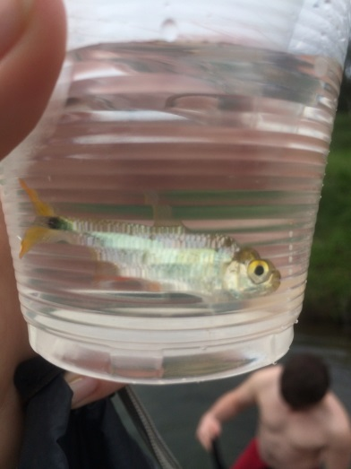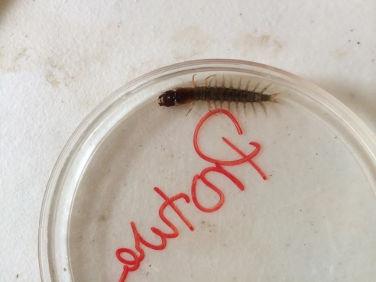
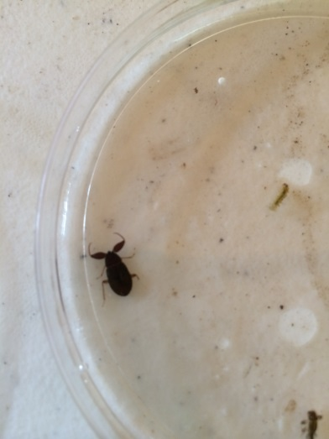
“Baby piranha” Hellgrammite unknown invertebrate
Not only do the turtles and fish provide a meal for the jaguar but the river itself serves as a staple in the ecosystem where the jaguars’ land-based prey roams. They jaguar being a keystone species plays a crucial role in the ecosystem by regulating prey species in the area. The Sibun River and surrounding valleys are potential hunting ground for the jaguar and a source of food and water for al kings of organisms.
Results
My findings were very positive in that they proved that there is a healthy producer base and consumer base all involved in many food chains that eventually make up the diet of the jaguar. With the abundance of smaller fish species in both slow and fast moving water and the healthy population of invertebrates there is a solid base in the food chain for many species especially prey species of the jaguar that aren’t bound to water but require it for survival. Further research follow ups could include an observation of the jaguar’s larger, land-based prey species dependence on the Sibun River. One could also research more into the lagoon and do more observation there as well as some sein netting to see what organisms are there and compare the difference between the slow moving water and the fast pace sections of the Sibun river. Night cameras could also be put to use in several different areas of the river and lowland are to see what prey and predator species can be observed.
Overall I think my hypothesis was mostly relevant. Jaguars are very large carnivorous creatures that need lots of food to survive. They are opportunistic and there is no evidence so far that disproves that jaguars would not use the Sibun as a main hub in their hunting territories. Further research would only help to confirm this hypothesis or possibly disprove it.

Sources
Emmons, Louise H. Comparative Feeding Ecology of Felids in a Neotropical Rainforest - Springer. Comparative Feeding Ecology of Felids in a Neotropical Rainforest - Springer. Springer-Verlag, 01 Apr. 1987. Web. 13 Feb. 2014. <http://link.springer.com/article/10.1007/BF00292180>.
Novak, Anthony J., Martin B. Main, Melvin E. Sunquist, and Ronald F. Libisky. Foraging Ecology of Jaguar (Panthera Onca) and Puma (Puma Concolor) in Hunted and Non-hunted Sites within the Maya Biosphere Reserve, Guatemala. Wiley Online Library. Journal of Zoology, 28 Feb. 2006. Web. 13 Feb. 2014. <http://onlinelibrary.wiley.com/doi/10.1017/S0952836905007338/abstract>.
"Jaguar." Jaguar. N.p., n.d. Web. 13 Feb. 2014. <http://www.sunofbelize.com/en/jaguar.php>.
Astete, Samuel, Rahel Sollmann, and Leandro Silveira. Comparative Ecology of Jaguars in Brazil. Jaguar. Org. N.p., n.d. Web. 2 Feb. 2014. <www.jaguar.org>.
Nogueira, Johnathan. "Jaguar." Animal Diversity Web. Tanya Dewey - University of Michigan, n.d. Web. 13 Feb. 2014.

