Does Gradient Level Affect Soil Fertility?
Johnathan Reeves
Belize Honors Research Project
March 2014

Table of Contents

Introduction…………………………………………………………… . Pg. 1

Materials………………………………………………….……………. . Pg. 6

Method…................................................................................................... Pg. 7

Results……………………….…………………………………………. Pg. 11

Conclusion……………………………………………………………… Pg. 16

Pictures………………………………………………….……………… Pg. 19

Works Cited……………………………………………………………. Pg. 20

Introduction
For my Independent Research Project I will be performing soil tests at 3 “Test Sites” on the Medicinal Plant Trail (bottom, middle, and top), which resides on the Sleeping Giant Lodges property in Belmopan, Belize. “A soil test is a process by which elements (Phosphorus (P), Potassium (K), and Nitrogen (N), from the soil are measured for their "plant available" content within the sample and the quantity of available nutrients in the samples determines the fertility of the soil, also soil tests measure the soil pH, humus matter and exchangeable acidity” (ncagr.gov). I will be performing soil tests for each of these sites to determine whether or not the gradient level (elevation) has an affect on the nutrient levels (pH, Nitrogen, Phosphorus, and Potassium) in the soil; therefore, affecting the soil quality. Also, while I am collecting data I will be observing each test site to determine if there is a variation in plant species at each test site compared to the other test sites, and if so is it due to a variation in the nutrient levels found in the soil at that particular test site.
I should begin by stating what soil quality is, and “since the introduction of the term “soil quality” by Warkentin and Fletcher (1977) there have been multiple variations of the definitions. However, the two of the most accurate and accepted definitions of soil quality are: "Fitness for use" (Larson and Pierce, 1991) and "the capacity of a soil to function” (Karlen et al., 1997). Taken together, these two definitions mean that soil quality is the ability of the soil to perform the functions necessary for its intended use. Probably the most comprehensive definition of soil quality to date was published by the Soil Science Society of America's Ad Hoc Committee on Soil Quality (S-581) as "the capacity of a specific kind of soil to function, within natural or managed ecosystem boundaries, to sustain plant and animal productivity, maintain or enhance water and air quality, and support human health and habitation" (Karlen et al., 1997)” (soilquality.org), and as this statement mentioned, we can see without “good” soil quality, then life in many ecosystems would diminish; therefore, soil quality affects all of man-kinds food and oxygen supply.
So, “it would be natural to infer that tropical soils are very fertile in order to support their high productivity. But, in fact the soils are very thin and the rock below them highly weathered” (University of Michigan). I know people ask, then how is the rainforest so productive, and the answer is, “the combination of high temperatures, light, and rainfall year-round (good growing conditions), coupled with especially efficient nutrient recycling” (University of Michigan).
Furthermore, “because the heavy rainfall tends to carry away nutrients, tropical rainforests have only been able to develop with the "invention" of very efficient nutrient cycling. The warm, moist conditions in the forest are ideal for the decomposers breaking down the remains of dead organisms. This quick decay returns the carbon and oxygen in the decomposing material to the air, and returns nitrogen, phosphorous, calcium, and other minerals to the soil. In the soil, the minerals are almost immediately taken up by a thick mat of plant roots and rootlike fungi. The fungi are known as mycorrhizae (literally "fungus-roots"); many of them form symbiotic relationships with plant roots. The mycorrhizae supply the plant with minerals and water; the plant returns sugars to the fungus. In some cases, the association between the plant and the fungus is so close that the fungal filaments (hyphae) actually penetrate the plant roots” (marietta.edu), as we can see the innovative nutrient cycling and mutualistic relationships are what allows the tropical rainforest to have such a large and diverse plant population, as well as provides the soil with the nutrients it needs in order to maintain the high diversity.
Now, here is a set base line for the accepted levels of pH, Nitrogen (N), Phosphorus (P), and Potassium (K): The average pH of the rainforest is in the range of 4.17-4.94 (mit.edu). The average Nitrogen count in the rainforest is 198 grams per meters squared (g/m^2). The average Phosphorus (P) count in the rainforest is 29 grams per meters squared (g/m^2). The average Potassium count in the rainforest is 182 grams per meters squared (g/m^2) (ufl.edu).
I hypothesize that the gradient level (elevation) on the Medicinal Plant Trail will affect the soil nutrient level at each test site, and as the gradient level (elevation) increases I predict there will be a slight variation in nutrient levels between each site with Test Site #1 (bottom) having a soil nutrient level closest to the base line with 5 grams per meters squared (g/m^2) or less between the base line and Test Site #1 (bottom) on the Medicinal Plant Trail. Next, I predict there will be a moderate variation of 10 grams per meters squared (g/m^2) or less between the base line and Test Site #2 (middle) on the Medicinal Plant Trail. Last, I predict there will be a significant variation of 11 grams per meters squared (g/m^2) or greater between the base line and Test Site #3 (Top) on the Medicinal Plant Trail. Furthermore, I predict due to the differences in soil nutrient levels caused by the differences in the gradient level (elevation) between the top, middle, and the bottom of the Medicinal Plant Trail there will be some differences in the plant species between each test site.

Materials
- Soil Testing Kit (To Include: pH, Nitrogen, Phosphorus, Potassium, Calcium)
- Soil Core Sampler (To Collect Even / Equal Soil Samples)
- 4- Blue Marker Flags (To Mark Test Site)
- 8- Red Marker Flags (To Mark Radius)
- Waterproof Notebook & Pen (To Collect Data)
- 30 Zip-lock Bags (To Hold Soil Samples)
- Black Permanent Marker (To Label Soil Samples with Test Site)
- Book About Plants(For Identification Purposes)
- Water-Proof Tape Measure ( To Measure Radius and Distance)
- Digital Camera (To Record Data i.e. Plants in Test Site)
- Digital Scale (To Weigh Samples)
- G.P.S. (To get Location & Elevation)
- Watch (To Collect Time Data)
- Outside Thermometer & Humidity Tester (To Collect Temperature & Humidity Data)

Method
On the day I begin my independent research project, I will put all my materials in my bookbag, so that I will have them accessible to me while on the trail. I will then stand at the bottom of the Medicinal Plant Trail, and using my G.P.S. I will record the location and elevation into my notebook. I will also check my watch and record the time I begin in my notebook, as well as check my thermometer & humidity tester and record the temperature and humidity in my notebook.
Next, I will hike to the top of the Medicinal Plant Trail and using my G.P.S. I will record the location and elevation in my notebook. I will also check my watch and record the time the data was collected in my notebook, as well as check my thermometer & humidity tester and record the temperature and humidity in my notebook.
Then, once the positions of those 2 locations have been determined, I can then use that data to figure out the third or middle location (Top Elevation – Bottom Elevation / 2, then take that number and add it with bottom elevation that will be the Middle Elevation), then using my G.P.S. I will find that exact location and record the location and elevation in my notebook. I will also check my watch and record the time I collected the data in my notebook, as well as check my thermometer & humidity tester and record the temperature and humidity in my notebook.
Now, that I have all 3 test sites determined I have the total gradient level (elevation) of the Medicinal Plant Trail and I can begin my soil collections. I will move back down to the bottom of the Medicinal Plant Trail and begin collecting soil samples from my 1st location recorded in my notebook. This location will be known as Test Site #1.
I will start off by using the soil core sampler, which will allow me to get even / equal soil samples from each test site. This tool is used by inserting it into the ground, twist it, and then remove it in order to get a viable soil sample, which I will then place the soil sample in a zip lock bag and mark the bag Test Site #1 Sample #1. I will then put the soil sample in my bookbag and get out my marker flags and tape measure to set up my test plot.
In the same location the soil sample was removed from I will place a blue marker flag, and then measure a radius of .5 Meters (1.6 feet) and mark the radius with the red flags. This location will be Test Site #1 Plot #1. I will take multiple photos at various angles of the test plot, in order to identify the plant species in each location and show the correlation between the plants located in a test plot with the nutrients found in the same location.
Once all photos are taken and identifying is complete, I will remove all the red marker flags and put them back into my bookbag. Then, using the tape measure, I will measure from the blue marker flag (Test Site #1 Sample #1) a distance of 1.8 Meters (6 feet) straight across from there on the same elevation and this will be Test Site #1 Sample #2.
Next, I will start off once again using the soil core sampler, in order to remove a soil sample, which I will then place the soil sample in a zip lock bag and mark the bag Test Site #1 Sample #2. I will then put the soil sample in my bookbag and get out my marker flags and tape measure and set up my test plot.
In the same location the soil sample was removed from I will place a blue marker flag, and then measure a radius of .5 Meters (1.6 feet) and mark the radius with the red flags. This location will be Test Site #1 Plot #2. I will take multiple photos at various angles of the test plot, in order to identify the plant species in each location and show the correlation between the plants located in a test plot with the nutrients found in the same location.
Once all photos are taken and identifying is complete, I will remove all the red marker flags and put them back into my bookbag. Then, using the tape measure, I will measure from the blue marker flag (Test Site #1 Sample #2) a distance of 1.8 Meters (6 feet) straight across from there on the same elevation and this will be Test Site #1 Sample #3.
Finally, I will finish up by using the soil core sampler, in order to remove a soil sample, which I will then place the soil sample in a zip lock bag and mark the bag Test Site #1 Sample #3. I will the put the soil sample in my bookbag and get out my marker flags and tape measure and set up my test plot.
In the same location the soil sample was removed from I will place a blue marker flag, and then measure a radius of .5 Meters (1.6 feet) and mark the radius with the red flags. This location will be Test Site #1 Plot #3. I will take multiple photos at various angles of the test plot, in order to identify the plant species in each location and show the correlation between the plants located in a test plot with the nutrients found in the same location.
After all soil samples are collected as well as all the photos taken and plant identification are done at Test Site #1 / Samples & Plots 1,2,3, I will then take the soil samples back to the classroom area at the Sleeping Giant Lodge and test each sample for pH, Nitrogen, Phosphorus, and Potassium, and then record all data into my notebook. I will also transfer the photos onto my computer in their own file to keep all locations and plant photos separate.
Once all that is completed, I will repeat the same exact steps for Test Site #2 (Middle of the Medicinal Plant Trail) Samples & Plots 1,2,3.
Then, repeat the exact same steps one more time for Test Site #3 (Top of the Medicinal Plant Trail) Samples & Plots 1,2,3.
Finally, after all 3 Test Sites, with a total of 9 soil samples and 9 test plots are completed, I will then compare the data recorded in my notebook to determine if there is difference in nutrient levels between any of the test sites due to the gradient level (elevation), as well as correlate specific plants to specific nutrient levels and determine if there is difference in plant species between the test sites.

Results
Test Site #1
Elevation: 93.57 m. (307 Ft.) Accuracy within 6.40 m. (21 Ft.)
Sample #1 | Sample #2 | Sample #3
Date : 3 – 11 – 14 | Date : 3 – 11 – 14 | Date : 3 – 11 – 14
Time and Temp: 3:00 p.m.  29.4° Celsius (85° F) “Sunny”  73% Humidity | Time and Temp: 3:21 p.m.  29.4° Celsius (85° F) “Sunny  70% Humidity | Time and Temp: 3:44 p.m.  28.3 Celsius (83° F) “Sunny”  70% Humidity
Weight: 59 g. – 2.3 g. (Bag)  Total Weight: 56.7 g. | Weight: 50.2 g. – 2.3 g. (Bag)  Total Weight: 47.9 g. | Weight: 63.3 g. – 2.3 g. (Bag)  Total Weight: 61 g.
pH: 4.0 | pH: 4.0 | pH: 6.5
Phosphorus: Trace | Phosphorus: Trace | Phosphorus: Trace
Nitrogen: Trace | Nitrogen: Trace | Nitrogen: Trace
Potassium: 18 Drops – Low | Potassium: 16 Drops –  Med. – Low | Potassium: 12 Drops –  Med – High

Averages for Test Site #1 – pH 4.8, Phosphorus Trace, Nitrogen Trace, Potassium 15 Drops - Medium

Test Site #2
Elevation: 142.64 m. (468 Ft.) Accuracy within 20.73 m. (68 Ft.)
Sample #1 | Sample #2 | Sample #3
Date : 3 – 12 – 14 | Date : 3 – 12 – 14 | Date : 3 – 12 – 14
Time and Temp: 11:00 a.m.  30.6° Celsius (87° F) “Sunny”  73% Humidity | Time and Temp: 11:23 a.m.  31.7° Celsius (89° F) “Sunny  75% Humidity | Time and Temp: 11:51 a.m.  31.7° Celsius (89° F) “Sunny”  75% Humidity
Weight: 35.4 g. – 2.3 g. (Bag)  Total Weight: 33.1 g. | Weight: 33.2 g. – 2.3 g. (Bag)  Total Weight: 30.9 g. | Weight: 40.5 g. – 2.3 g. (Bag)  Total Weight: 38.2 g.
pH: 7.0 | pH: 6.0 | pH: 7.0
Phosphorus: Low | Phosphorus: Trace | Phosphorus: Low
Nitrogen: Trace | Nitrogen: Trace | Nitrogen: Trace
Potassium: 18 Drops – Low | Potassium: 12 Drops –  Med. – High | Potassium: 14 Drops – Med.

Averages for Test Site #2 – pH 6.7, Phosphorus Low, Nitrogen Trace, Potassium 15 Drops - Medium

Test Site #3
Elevation: 191.72 m. (629 Ft.) Accuracy within 48.77 m. (160 Ft.)
Sample #1 | Sample #2 | Sample #3
Date : 3 – 12 – 14 | Date : 3 – 12 – 14 | Date : 3 – 12 – 14
Time and Temp: 12:05 p.m.  31.7° Celsius (89° F) “Sunny”  75% Humidity | Time and Temp: 12:26 p.m.  31.7° Celsius (89° F) “Sunny  76% Humidity | Time and Temp: 12:47 p.m.  31.7° Celsius (89° F) “Sunny”  76% Humidity
Weight: 37.8 g. – 2.3 g. (Bag)  Total Weight: 35.5 g. | Weight: 34.6 g. – 2.3 g. (Bag)  Total Weight: 32.3 g. | Weight: 30.5 g. – 2.3 g. (Bag)  Total Weight: 28.2 g.
pH: 7.5 | pH: 7.5 | pH: 8.0
Phosphorus: Trace | Phosphorus: Low | Phosphorus: Trace
Nitrogen: Trace | Nitrogen: Trace | Nitrogen: Trace
Potassium: 16 Drops –  Med – Low | Potassium: 16 Drops –  Med. – Low | Potassium: 14 Drops – Med.

Averages for Test Site #3 – pH 7.7, Phosphorus Trace, Nitrogen Trace, Potassium 15 Drops - Medium

pH

One Way Analysis of Variance (ANOVA) Thursday, April 10, 2014, 11:46:24 AM

Data source: Data 1 in Notebook2

Normality Test (Shapiro-Wilk) Passed (P = 0.151)

Equal Variance Test: Passed (P = 1.000)

Group Name N Missing Mean Std Dev SEM
Col 1 3 0 4.833 1.443 0.833
Col 2 3 0 6.667 0.577 0.333
Col 3 3 0 7.667 0.289 0.167

Source of Variation DF SS MS F P
Between Groups 2 12.389 6.194 7.433 0.024
Residual 6 5.000 0.833
Total 8 17.389

The differences in the mean values among the treatment groups are greater than would be expected by chance; there is a statistically significant difference (P = 0.024).

Power of performed test with alpha = 0.050: 0.693

All Pairwise Multiple Comparison Procedures (Holm-Sidak method):
Overall significance level = 0.05

Comparisons for factor:
Comparison Diff of Means t Unadjusted P Critical Level Significant?
Col 3 vs. Col 1 2.833 3.801 0.009 0.017 Yes
Col 2 vs. Col 1 1.833 2.460 0.049 0.025 No
Col 3 vs. Col 2 1.000 1.342 0.228 0.050 No

POTASSIUM

One Way Analysis of Variance (ANOVA) Thursday, April 10, 2014, 11:50:01 AM

Data source: Data 1 in Notebook3

Normality Test (Shapiro-Wilk) Passed (P = 0.733)

Equal Variance Test: Passed (P = 0.592)

Group Name N Missing Mean Std Dev SEM
Col 1 3 0 15.333 3.055 1.764
Col 2 3 0 14.667 3.055 1.764
Col 3 3 0 15.333 1.155 0.667

Source of Variation DF SS MS F P
Between Groups 2 0.889 0.444 0.0667 0.936
Residual 6 40.000 6.667
Total 8 40.889

The differences in the mean values among the treatment groups are not great enough to exclude the possibility that the difference is due to random sampling variability; there is not a statistically significant difference (P = 0.936).

Power of performed test with alpha = 0.050: 0.050

The power of the performed test (0.050) is below the desired power of 0.800.
Less than desired power indicates you are less likely to detect a difference when one actually exists. Negative results should be interpreted cautiously.

Statistical Analysis Provided by Professor Anthony Tate

Conclusion
In conclusion, after all the tests were completed I have learned that the averages for Test Site #1 were: pH 4.8, Phosphorus Trace, Nitrogen Trace, Potassium 15 Drops – Medium, the averages for Test Site #2 were: pH 6.7, Phosphorus Low, Nitrogen Trace, Potassium 15 Drops – Medium, and the averages for Test Site #3 were: pH 7.7, Phosphorus Trace, Nitrogen Trace, Potassium 15 Drops – Medium. These averages represent that as the gradient level increased on the Medicinal Plant Trail, so did the pH levels. However, remembering that my research is to determine if gradient levels affect the fertility of the soil; then I would have to say my results were inconclusive because I do not have any quantitative results other than pH levels to compare data to between each test site or against my base line which was an average pH in the range of 4.17-4.94 (mit.edu), an average Nitrogen count of 198 grams per meters squared (g/m^2), an average Phosphorus (P) count of 29 grams per meters squared (g/m^2), and an average Potassium count of 182 grams per meters squared (g/m^2) (ufl.edu).
Fortunately, all of my time and effort was not a complete loss because I can draw a partial conclusion to my research. Luckily enough, with the data results from the test samples I collected, along with the statistical analysis provided by Professor Anthony Tate, I was able to truly prove that there were significant quantitative differences in the pH levels between Test Site #1 and Test Site #3, with Test Site #1 having the closest pH compared to my baseline; therefore, allowing me to prove that gradient level does in fact affect the soil fertility, or at least the pH.
However, due to the testing equipment that was provided to me for use during my research project I was unable to collect extensive quantitative data about the Nitrogen, Phosphorus, and Potassium. This could be an idea for a great follow-up project. By using better testing equipment which provides more precise data, a researcher would be able to check for exact counts of Nitrogen, Phosphorus, and Potassium, and then compare that data for the total nutrient levels, which would ultimately prove the soil fertility. Other follow-up projects could be to test at different points throughout the year to determine if the amount of rainfall can affect the soil nutrients, or even test the soil to check for the amount of living organisms in the soil for a particular area compared to another area.
During my research, I observed many pioneer plant species not only along the Medicinal Plant Trail, but in my testing sites as well. There were many of the same species of plants in all 3 test sites; I did not observe any major variance between any of the test sites. Some of the species of plants I observed included, Sensitivity Plants, Roster Tail Plants, and various Ferns. Another thing I observed was the amount of plants that formed a mutualistic relationship with either funguses or insects (i.e. Termites) to allow the plants to collect the proper amount of nutrients in order to thrive. As I discussed earlier, this innovative nutrient cycling and mutualistic relationships are what allows the tropical rainforest to have such a large and diverse plant population, as well as provides the soil with the nutrients it needs in order to maintain the high diversity.
Soil fertility and nutrient cycling is of vital importance to all living organisms, not only in the rainforest ecosystem, but in most of our ecosystems here on Earth. Not only does the quality of the soil affect the plants, but it has some kind of effect on all the species in that particular ecosystem. Also, the more nutrients provided to the plants through the soil; the more oxygen that particular plant can produce, which benefits all. For example, in the rainforest plants can draw nutrients out of the soil, then other various species of herbivores eat the vegetation produced from these plants, and are then eaten by larger carnivores. Another example are the insects that live in the soil, because they can draw their nutrients out of the soil and are then eaten by other various species, which can include birds, amphibians, reptiles, or even other insects. The rainforest ecosystem is a really amazing and diverse place, which truly represents how nutrient cycling works, the importance of soil quality, as well as how species survive together through mutualistic relationships.

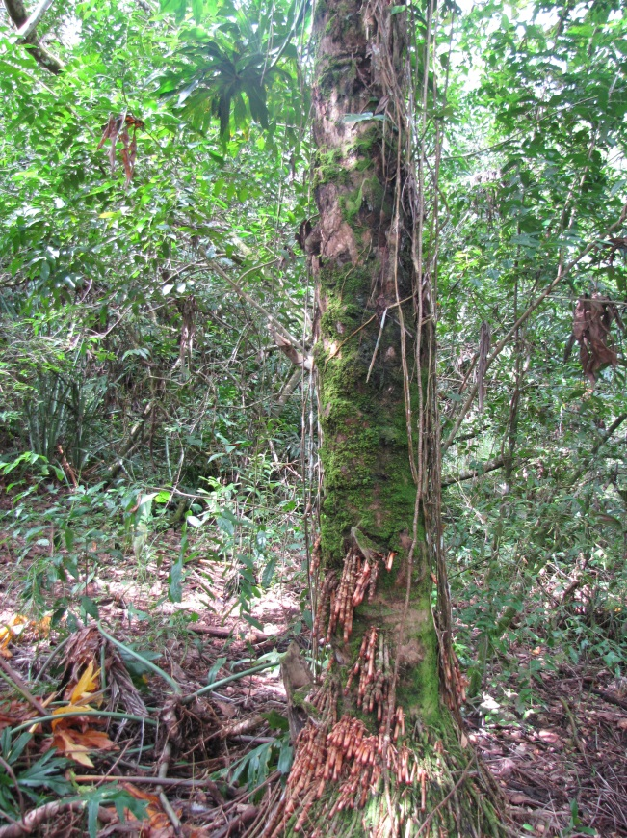
A Great Representation of Mutualistic Relationships & Nutrient Cycling

Pictures
Medicinal Plant Trail - Mountain View (Left), Trail View (Bottom)
My Research Lab!
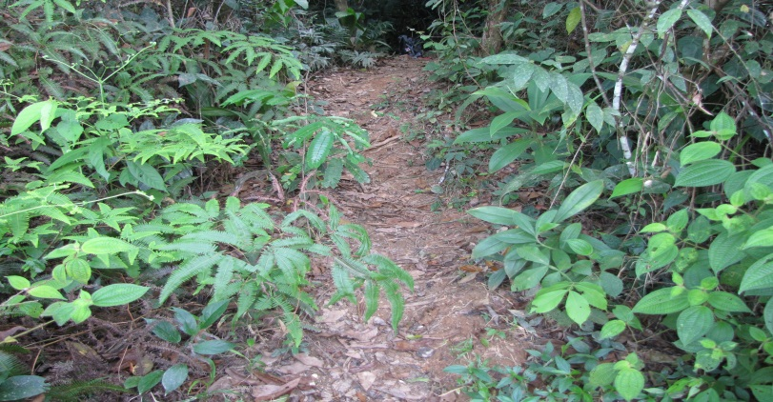
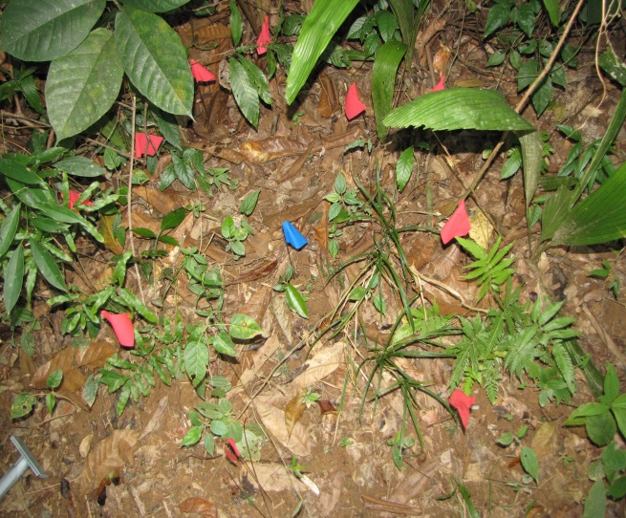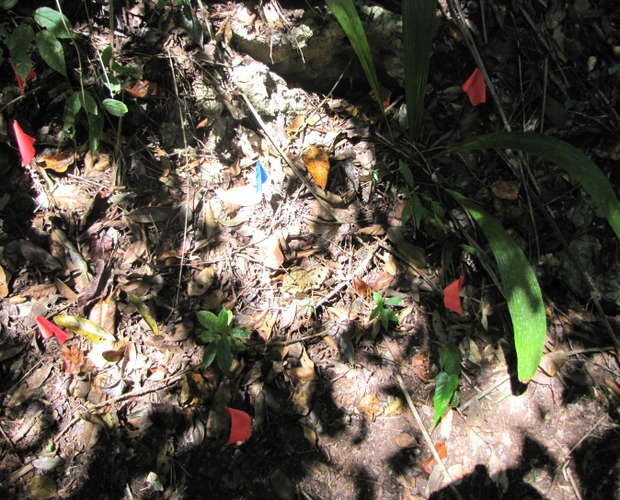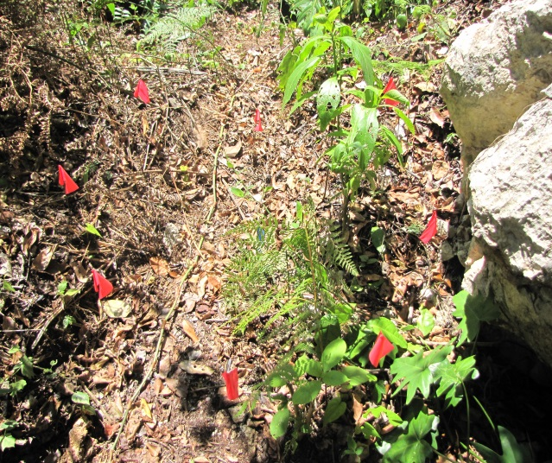
My Test Sites: #1 (Right), #2 (Bottom Left), #3 (Bottom Right)

Works Cited
Environmental Biology - Tropical Rain Forests. Web. Feb. 27 2014. http://www.marietta.edu/~biol/102/rainfor.html
Nutrient Cycling in Moist Tropical Forest - Department of Biology. Web March 1 2014.
http://www.biology.ufl.edu/COURSES/pcb5356/2010Spring/Kitajima/vitousek86.pdf
Soil Quality: Basics: Definitions. Web. Feb. 27 2014.

http://soilquality.org/basics/definitions.html

Soil – MIT. Web. March 2 2014.

http://web.mit.edu/12.000/www/m2006/final/monitoring/soil.html

Soil Testing. Web. Feb. 25 2014
http://www.ncagr.gov/cyber/kidswrld/plant/soiltest.htm

The Tropical Rain Forest - Global Change - University of Michigan. Web. Feb. 28 2014.
http://www.globalchange.umich.edu/globalchange1/current/lectures/kling/rainforest/rainforest.html

