Heather Parsons
BIO 209
Prof. Cox & Tate
Biodiversity of Belize Frog Pop.
Introduction
Bordered by Mexico to the north and Guatemala to the west and south, Belize is a small country lying in the heart of Central America. This area is a hotspot of biodiversity and contains upwards of 50% of the world’s biodiversity in its rainforests. Belize houses over thirty different species of amphibians, some of the most well-known being the various species of frogs including the red-eyed tree frog and the large cane toad. Due to Chytrid fungal outbreaks over the last few decades the amphibian population worldwide is on a severe decline and Belize is no exception.
Belizean frogs are needed both as a source of food as well as a part of the normal ecosystem as a consumer and predator to many problematic insects. Reptiles, birds, tarantulas, small mammals, and all species of big cats in Central America will feast on the hopping amphibians when in search of a meal. The reliance on frogs as a food source means that a strong decline in the amphibian population could potentially lead to a decline in other species in the area.
With this background information in mind, I chose to look at the biodiversity of the frog population of Belize in early March. When studying biodiversity, one must be mindful that multiple factors can affect the results of the study including the weather conditions, temperature, time of year, breeding season of different species, location, and others. I hypothesized that a minimum of 3 species would be found on this trip.

Methods and Materials
The methods I utilized were quite simple. I followed the protocol set forward through the FrogWatch USA program that is used in the United States as a citizen science program to monitor frog biodiversity. My initial materials included: (1) Sony digital tape recorder, (1) camera, (1) laptop, (1) flashlight, and collection at (3) sites containing a total of (8) hours of recordings which were analyzed by ear and compared to previously documented recordings found online.
The protocol of the FrogWatch USA program requests that sites first be registered if data is going to be turned into the program. I was unable to do this due to my collection sites being outside of the United States. Shortly after sunset, for three nights, at three different locations, I set out my recorder in an area that seemed promising.
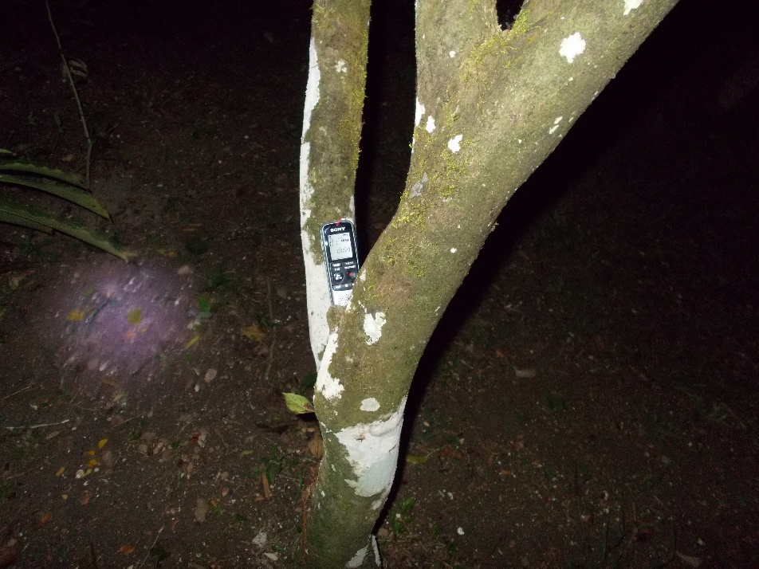
Location one: In the crook of a tree near a tributary of the Sibun River outside of Casita one on the Sleeping Giant grounds

I selected this location for my first night’s study at the recommendation of our guide, Neko, before beginning our night hike. He suggested I place my recorder here as we could readily hear the call of the red-eyed tree frog and he said that it was not uncommon to hear the Rio Grande Leopard frog near the same area.
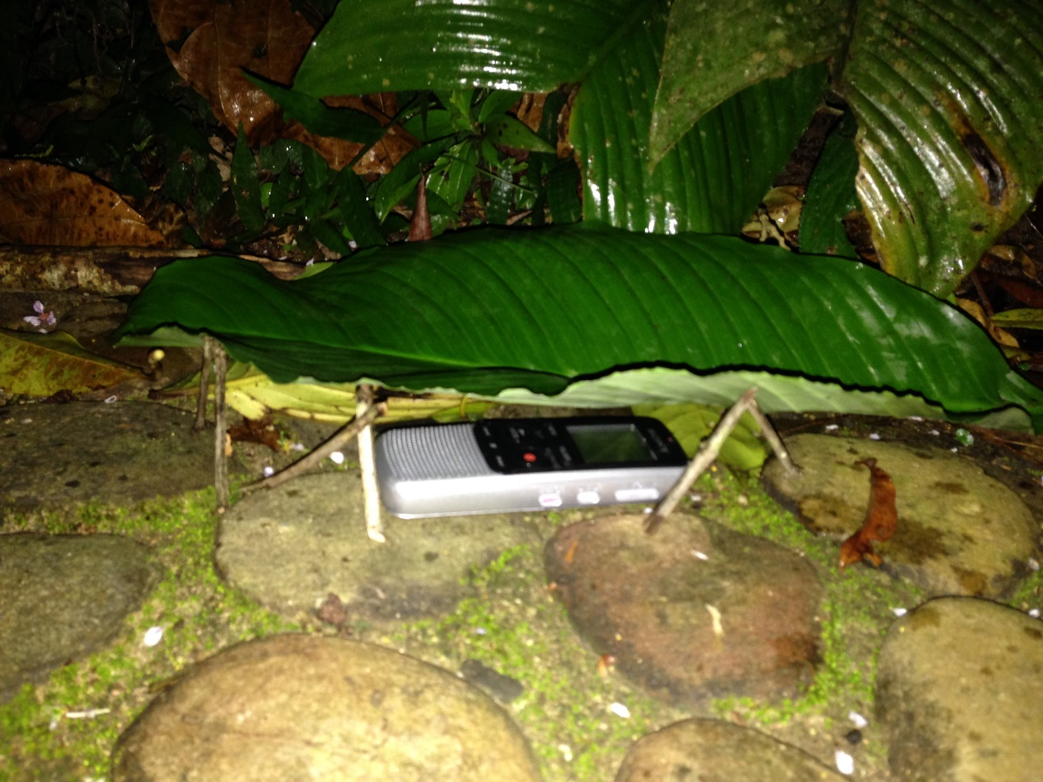
Location two: On the bank of the Sibun River, entry point down-hill from the pool on the Sleeping Giant grounds

I selected this location for my second night of recording due to the fact that it seemed likely that since frogs are amphibians, needing water to reproduce and survive, the Sibun River and its banks would be a good place to find multiple species of frogs. It had also been suggested to me by a fellow student, Lauren Crocker, who had made a trip to another segment of the river the previous night and had stated that she heard various frogs as well as photographed two species of toads.
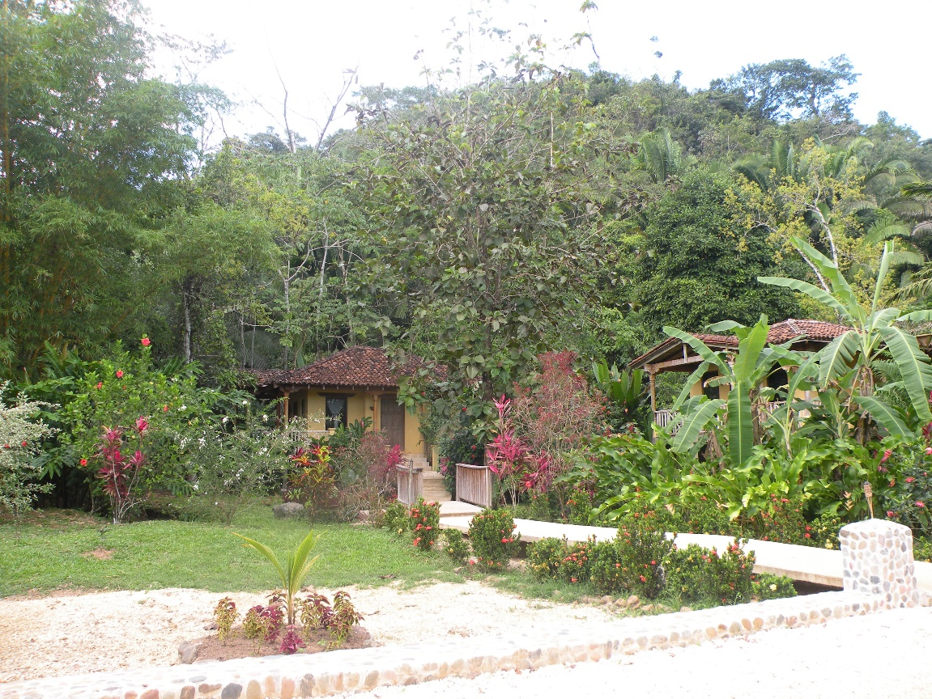
Location three: Bridge over the Sibun tributary running in front of Casita 1 on Sleeping Giant grounds.

I selected this area for my third set of data in hopes that I would have results that were somewhat similar but better than my first night.
At all three locations, I followed the FrogWatch protocol and began my recording shortly after sunset each night and ensured that I collected my recorders before 1a.m. as well. There were no major temperature or weather differences to report on any given night except for the second. The night that I put my recorder on the banks of the river, it was sprinkling lightly.

Results
The first night I recorded a total of 2.5hrs. During this time, the primary call that was recorded was that of the red-eyed tree frog. The call of the red-eyed tree frog is similar in sound to a chirping bird. Before I set my recorder out, our guide, Neko, pointed out that the red-eyed tree frog could be heard in abundance that night just after sunset. I also have a few calls of the Rio Grande Leopard from my first night of recordings as well. We saw one of these small frogs on our night hike. While remaining one of the smaller frog species in Belize, the Rio Grande makes one of the loudest calls.
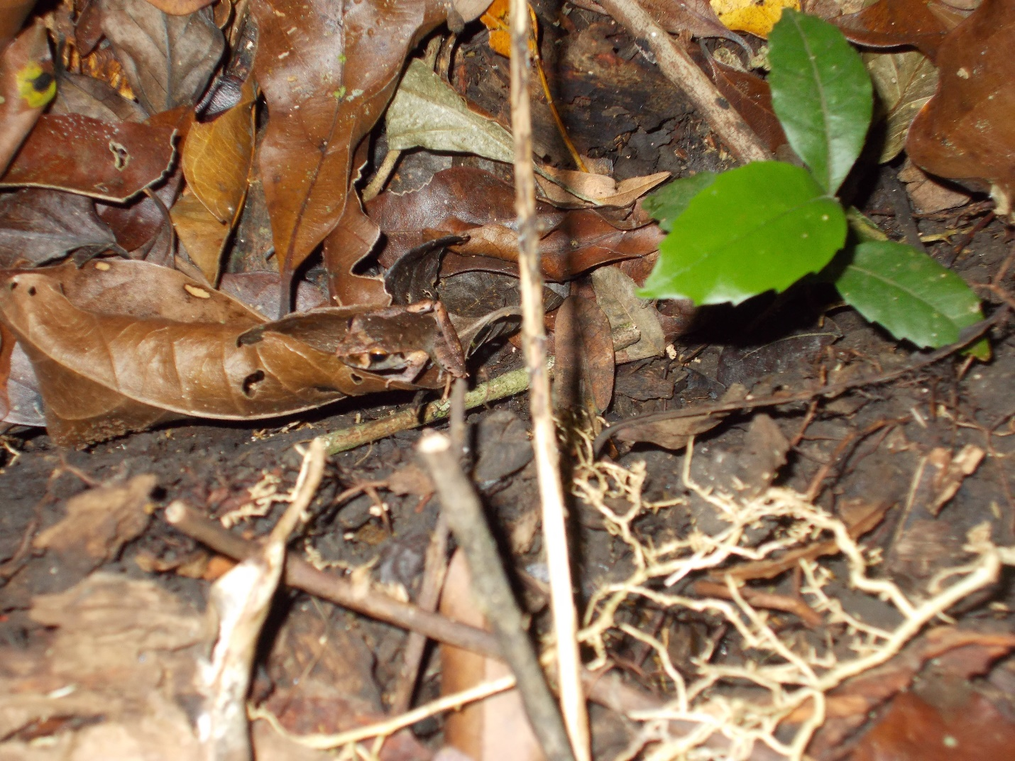
During the second night, when my recorder was placed on the banks of a wider section of the Sibun, my results were as to be expected; significantly better. I recorded a total of 4hrs between the hours of 9:30 and 1:30 when I concluded my recording just a little bit late. The recordings caught a variety of species including the red-eyed tree frog, the Rio Grande Leopard frog, the Cane Toad, and a few species that I was unable to separate out and identify. This was largely disappointing. I believe one of the species may be the Mexican tree frog but I cannot be sure enough of this to make a definitive statement.
The third night of my research was disappointing in comparison to the other two. The calls were essentially the same as the first night, though I noticed a steep decline in the overall amount. This could, in theory, be due to the amount of foot traffic that was passing by our casita that night as it was our final night in Belize and everyone was out and about. I did hear a greater amount of Rio Grande Leopard frogs than I did on the first night I recorded. This could suggest that this particular species preferred the slight cool down that followed the rain of the previous day, or that red-eyed tree frogs are slightly more sensitive to what is going on in their surroundings.
Conclusion
I found my research to be inconclusive for a wide array of reasons. Currently, there is no proper protocol in place to study the biodiversity of tropical amphibians. There are significantly more species of amphibians in the tropics than in Midwestern U.S.A. I found it to be incredibly difficult to follow the FrogWatch protocol after night two since it calls manual analyzing of the various calls recorded. I believe one of my biggest mistakes made was underestimating the difficulty of analyzing the calls by ear as instructed by the FrogWatch protocol. I feel that by attempting to follow the United States procedure and analyze all of these calls individually by ear, my results may not all be accurate, and certainly not as accurate as they would be if there was a protocol in place either to help identify the various calls or to establish a nightly ‘routine’ for recording them. Perhaps a call separating software program development would be widely beneficial.
Another alternative to make this project more extensive and accurate would be to study these areas in more depth during other times of year and other various weather conditions. Many frogs and toads have behavior that is extremely related to the weather and breeding seasons. For the intentions of my hypothesis, I was proven correct in that I did identify 3 species of frog/toad during this trip, and there were others recorded that I was not able to analyze and identify. In the future, it would be interesting to see a more extensive continuation of this project.

Works Cited
Savethefrogs.com used for various pages

