Jute Snail Shell Thickness in Three Bodies of Water near Sleeping Giant Lodge

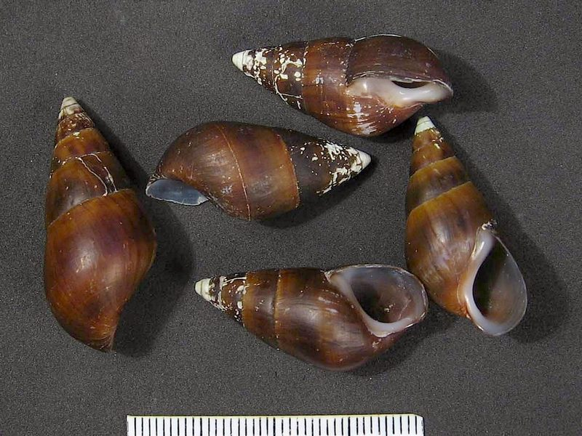

By Jacob Liebman

January 2014

Introduction:

When I began formulating this research project I intended to continue the research conducted in “The Thickness of the Calcium Deposits and its Effects on the Snail Population in the Streams Located Near The Sleeping Giant Lodge”. This project looked at the unusual calcium build up on snails in one local steam and hypothesized that the snails had thicker shells due to the high calcium content of the water. The snails that were tested in both this research are and the earlier one are commonly know as “Jute snails” and scientifically known as Pachychilus indiorum.
To make this project my own I branched out my collection areas by gathering snails from two other bodies of water, in which snail shell thicknesses had not yet been measured. The two other bodies of water that I tested were the Sibun River and another local stream, which flows through of the orange grove and into the Sibun River. The stream from the original test was also used and it too feeds into the Sibun River. I hypothesized that the snails found in the Sibun River will have less calcification on their shells than the snails from the stream originally tested. However I was curious to what information I would receive from the stream near the orange grove, because like the original stream it came out of the mountains and there for would likely have a high calcium content. I also was interested in looking at the snails found in the caves, and their shells because the caves are limestone and would likely have high calcium content. With the cave snails I expected them to not only have very thick shell but also be white in color, due to a lack of exposure to sun.

Materials:

- Water Hardness testing kit
- Three collection containers (pint size)
- One pair Calipers
- Note book
- Pencil

Methods:

Step 1: Selecting collection locations. To select these sites I went to the top of the observation tower where I could see all three of my bodies of water that I tested. The locations I chose to collect were the Sibun River, down stream from the Bridge of the Hummingbird Highway, the orange grove stream, down stream from the Sleeping Giant Road Bridge, and the original stream tested in all locations tested in the first test.

Step 2: Test the water hardness of all three bodies of water make sure to follow close the instructions provided in the kit to yield the best results.

Step 3: Collect a sample of 100 Jute snails from each body of water. During this collection place each snail into the container assigned for the body of water in which it was found. Also make sure the snails collected are Jute snails, Jute snails have long spiral bodies with their rear ends coming to a point

Step 4: Using the calipers measure each of the snails shell thickness at the end of the spiral in the foot side of the snails shell. To do this one should open the calipers place one tip on the inside of the shell next to the foot, and the other on the outside of the shell. Then slide the caliper tips together until snug. After that remove the snail from the calipers observe the measurement and record it into a note book numbered and 1-100 for each collection location

Step 5: Return the snails to the body of water in which they were collected. Clean up measurement station and equipment used to conduct the measurements and collection.

Step 6: Review the data yielded from the measurements taken of the snails collected from each body of water and enter the data into an excel spread sheet. After reviewing the data evaluate the hypothesis and develop a conclusion statement form the results of the experiment.

Results:

The Following Data tables display the results of the experiment
Sibun River  Calcium  160mg/L | Original Test Site  Calcium  320mg/L | Orange Grove Stream Test Site  Calcium  175mg/L
0.5 | 4 | 0.75
0.5 | 3 | 1.25
1 | 3.5 | 0.25
2 | 4.5 | 1
1.5 | 3 | 0.5
1 | 5.5 | 0.5
0.75 | 3.5 | 1.5
1.25 | 4 | 0.25
1.5 | 2.5 | 1
1.75 | 2.5 | 1.75
1.25 | 2.5 | 1
1 | 4 | 1
1 | 6 | 0.75
0.75 | 3.5 | 0.5
0.25 | 5.5 | 0.75
1 | 3 | 1.5
1.5 | 3.25 | 0.5
0.5 | 4 | 1
2 | 4 | 1.25
1 | 4.5 | 1.75
1.25 | 4 | 1
1.25 | 4.25 | 0.5
1 | 4 | 0.75
1.5 | 3.5 | 0.75
1.75 | 6 | 0.5
1 | 3.75
2 | 5
1 | 5
1 | 4.5
0.75 | 3
0.5 | 4
2.5 | 5
1.5 | 5.25
0.5 | 4.5
0.75 | 2.5
1 | 5
1.25 | 4.25
1 | 4
2 | 3.75
1 | 5
0.25 | 6
1 | 4
0.75 | 3.5
1.25 | 4.5
0.5 | 3.5
1.75 | 3
0.5 | 3.25
0.75 | 6
2 | 4
0.75 | 3.75
1.5 | 2.5
1 | 4
1.25 | 3.5
1 | 3.5
2 | 3
1.25 | 4.5
0.75 | 2
1 | 3
1.25 | 4
1.25 | 4.5
0.5 | 4.5
1 | 3.5
1.5 | 3
2.25 | 4
1.5 | 2
1.25 | 4
1.25 | 3
1 | 2.5
1 | 4
1.75 | 4.5
1.25 | 2.5
1 | 4
1.25 | 4.5
1 | 2.5
2.5 | 4
0.5 | 3
1 | 1.75
1 | 4.5
1.5 | 3
1 | 2.25
1.25 | 3
1 | 1.75
1 | 4.5
0.5 | 2.5
2 | 3
1 | 6
1 | 4.5
0.75 | 3.5
1 | 2.25
1 | 3.5
0.25 | 2.25
0.25 | 3.5
0.75 | 4
1.25 | 3
1 | 5
1.25 | 1.5
1 | 2.5
1.5 | 3.5
1 | 4
1.25 | 5.5
1.1325 | 3.7475 | 0.89

The chart above that list the shell thickness of each snail tested numbering 1-100 the final numbers at the bottom are the averages of shell thickness in each testing location. In the Sibun River the average shell thickness was 1.1325 millimeters thick and the calcium content in that body of water was 160 mg/L. In the original stream tested in the earlier project the average shell thickness was 3.7475 millimeters thick and its calcium content was 320mg/L. In the Orange grove stream I was only able to collect 25 snails but found their average to be .89 millimeters thick with a calcium content of 170 mg/L. All of three bodies of water are considered hard by water hardness standard any thing over 120 is considered “hard water”.

Map of testing sites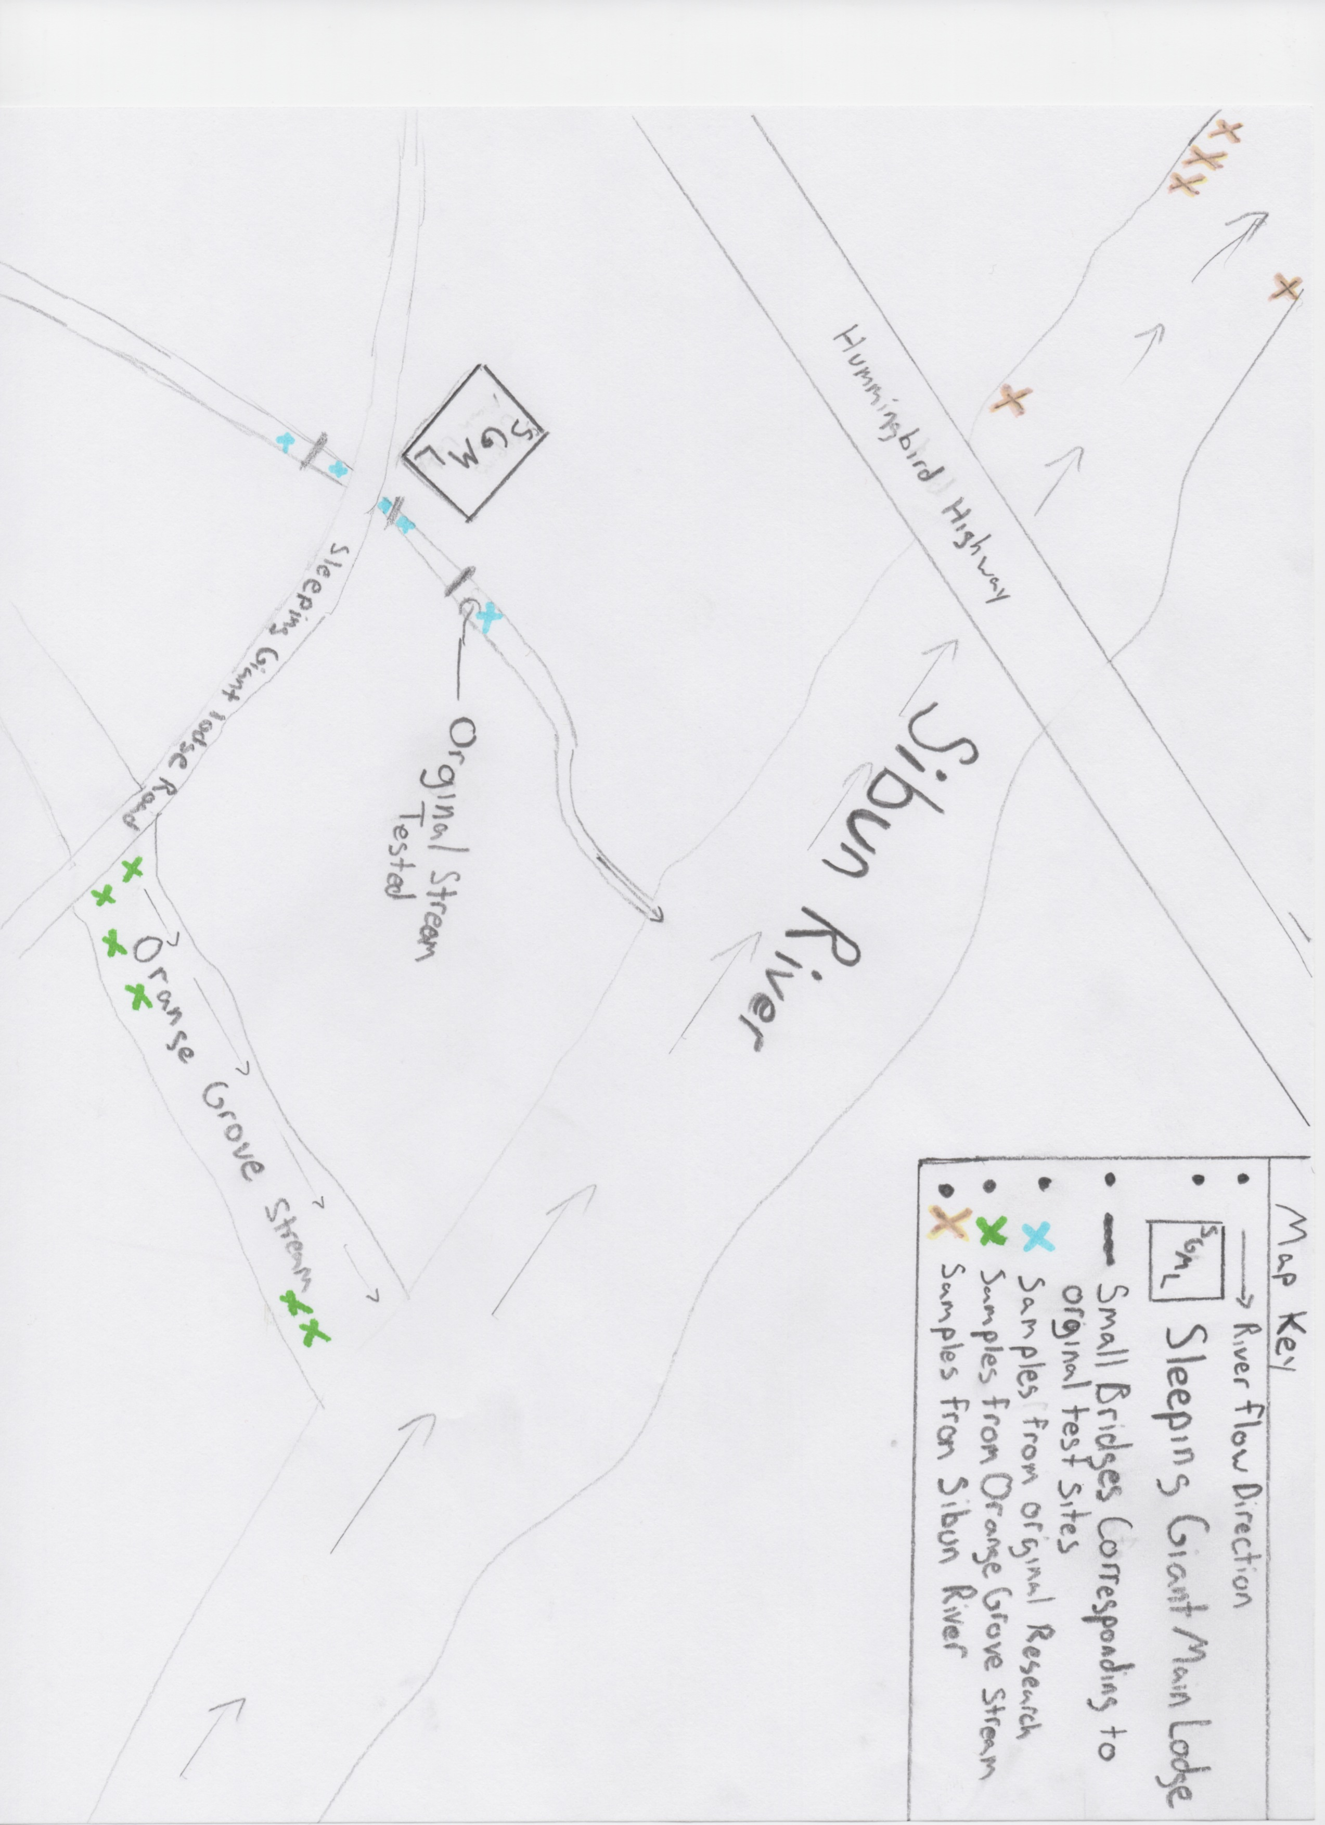

Conclusion:

In conclusion the collections yielded several unpredicted results. The first unpredicted result was that the snails that were collected in the orange grove creek had the thinnest shells of the three sites tested. Although the calcium levels were higher in the orange grove stream the average shell thick ness was 0.89 millimeters thick. The snails in the orange grove stream were also much less abundant which leads me to believe that the water there may have been polluted from some type of runoff from the orange grove. The second unusual observation I made was that there were no snails to be found in the cave so there for I was not able to make any observations on what effects the absence of sun light would have on jute snails. The final and most important conclusion that I came to was that the calcium content of a body of water is not directly dependent on the thickness of the snail’s shell. This leads me to believe that there are must be many factors contribution to snail shell thickness than just the calcium content, possibly pollution, water speed and maybe even sun exposure. To further this research I would look at the other factors in these bodies of water such as pollution water speed and possibly water temperature and depth anything that would limit effect the survival rate of snails and the thickness of their shells. It also might be helpful to visit many more bodies of water where jute snails are found to determine if the high calcium concentrations in the water are affecting the snail’s shell thickness. Lastly you might want to look more in depth at the snails found in the original stream because I believe that the calcium build up on their shells is increasing, I also noticed that many of those snails had calcium deposits on their feet. Looking at how this build up of rock on their could lead to a better understanding of the life span of these snails does the rock buildup shorten their life span?

Sources:

"Calcium Testing Scale." BioLib. N.p., n.d. Web. 15 Feb. 2014.
Kesl, Michael. "Image." BioLib. N.p., Feb. 2007. Web. 15 Feb. 2014.
Meerman, Jan. “Some Interesting Invertebrates of Belize.” Biological Diversity In Belize. 2004. Web
Oschwald, Morgan. The Thickness of the Calcium Deposits and Its Effects on the Snail Population in the Streams Located Near "The Sleeping Giant Lodge" Rep. N.p.: n.p., n.d. Print.

Starling, Tara. The Affect of Water Health on Snails in the Sibun River. Rep. N.p.: n.p., n.d. Print.

