Ashley Holshouser
BIO 209
Belize Research Project
Final Draft

Introduction
Water is a finite and vulnerable natural resource, essential to sustain life, the environment, the economy and national development.
According to Belizean Journeys, “the Sibun River drains a major portion of the northeastern section of the Maya Mountains . . . Though the river travels a little over fifty miles from source to mouth, the many twists and turns translates into over 100 miles of actual river.” The Sibun River is very important to the people of Belize. They depend on the river for a reliable source of drinking water, fishing, and recreational activities. When the people wash their clothes in the water, they could be contaminating the water. According to Belizean Journeys, “Farms grow a variety of crops on the wide flood plains and highly rich limestone soils” (“The Ecology of the Sibun River”). The runoff from the fields could also be very contaminating. The abundance of wildlife in the Sibun River Watershed involves “healthy populations of mammals and birds, including two species of monkey, all six species of wildcats, and over 500 species of birds” (“The Sibun River”).
Just as the Sibun River is important to the Belizean people, the Mississippi River is equally important to people that live in the U.S. According to the US Geological Survey Circular, “The Mississippi River Basin extends from western Montana to eastern Pennsylvania, from southern Canada to the Gulf of Mexico. It drains 41% of the US and contains 27% of the US population. It encompasses part of 27 states and 2 Canadian provinces. The Mississippi River serves as a water supply for 70 towns and cities” (“Water Quality of the Mississippi River”). Over 18 million people depend on the Mississippi River for reliable drinking water, fishing, swimming, and other recreational activities. The Mississippi River is contaminated by runoff from fields just like the Sibun River. However, the Mississippi River is also contaminated by all the runoff from the municipalities along the way. The only difference is that the EPA has set standards for waste dumping in the Mississippi, which has gradually improved the health of the water, according to The US Geological Survey Circular (Goolsby).
My experiment will focus on the health and water quality of both the Sibun and Mississippi Rivers. Even though the EPA has set standards for waste dumping into the Mississippi River, my null hypothesis is that there will be a difference in how healthy the Sibun River is compared to the Mississippi River because the Mississippi River has many municipalities that drain into it. If the Sibun and Mississippi Rivers’ pH, dissolved oxygen, biochemical oxygen demand, turbidity, nitrates, phosphates, and coliform bacteria levels (as described in the Materials section) have a significant difference, I will be proven right. The alternative hypotheses would be that there is no difference between the levels in the Sibun River versus the Mississippi River. If the null hypothesis is proven correct, I would suggest that the unhealthy rivers should establish better and more efficient water quality standards.

Chemical Tests
pH level
“pH is a measurement of the activity of hydrogen ions in a water sample. The pH scale ranges from 0 to 14. Water samples with a pH below 7.0 are considered acidic, those above 7.0 are basic, with 7.0 considered neutral. A pH range of 6.5 to 8.2 is optimal for most organisms” (LaMotte). Pure water would have a pH level of 7. Acidic substance would be like battery acid or lemon juice. Basic substances would be ammonia and laundry detergent.
Dissolved oxygen
“Aquatic animals need dissolved oxygen to live. Fish, invertebrates, plants, and aerobic bacteria all require oxygen for respiration. Oxygen dissolves readily into water from the atmosphere until the water is saturated. Once dissolved in water, the oxygen diffuses very slowly and distribution depends on the movement of the aerated water. Oxygen is also produced by aquatic plants, algae, and phytoplankton as a by-product of photosynthesis. The amount of oxygen required varies according to species and stage of life. Dissolved oxygen levels below 3 ppm are stressful to most aquatic organisms. Dissolved Oxygen levels below 2 or 1 ppm will not support fish. Levels of 5 to 6 ppm are usually required for growth and activity” (LaMotte). Dissolved oxygen levels should be between 4-10mg/L but the more saturated the oxygen levels, the better. However, if the concentration gets too high, an abundance of algae will bloom, which will use up all the dissolved oxygen and suffocate other life.

Biochemical Oxygen Demand
“Biochemical Oxygen Demand (BOD) is a measure of the quantity of dissolved oxygen used by bacteria as they break down organic wastes. In slow moving and polluted waters, much of the available dissolved oxygen is consumed by bacteria, robbing other aquatic organisms of the dissolved oxygen needed to live” (LaMotte).
Nitrates
“Nitrogen is a nutrient that acts as a fertilizer for aquatic plants. When nutrient levels are high, excessive plant and algae growth creates water quality problems. Nitrogen enters the water from human and animal waste, decomposing organic matter, and run-off of fertilizer from lawns and crops. Unpolluted waters usually have a nitrate level below 4 ppm. Nitrate levels above 40 ppm are considered unsafe for drinking water. Drinking water containing high nitrate levels can affect the ability of our blood to carry oxygen. This is especially true for infants who drink formula made with water containing high levels of nitrate” (LaMotte).
Phosphates
“Phosphorus is a nutrient that acts as a fertilizer for aquatic plants. When nutrient levels are high, excessive plant and algae growth creates water quality problems. Over half of the phosphate in lakes, streams and rivers come from detergents. Phosphate levels higher than 0.03 ppm contribute to increased plant growth” (LaMotte). Phosphates also come from farm drainage, animal manure runoff, wastewater treatment plants, and industrial discharges.

Coliform Bacteria
“Coliform bacteria are naturally present in the human digestive tract but are rare or absent in unpolluted waters. Coliform bacteria should not be found in drinking water. Their presence in water serves as a reliable indication of sewage or fecal contamination. If coliform bacteria are present, then pathogenic bacteria, viruses, and protozoans that also live in fecal matter might be present as well” (LaMotte).
Turbidity
“Turbidity is the measurement of the relative clarity of water. Turbid water is caused by suspended and colloidal matter such as clay, silt, organic and inorganic matter, and microscopic organisms. Turbidity should not be confused with color, since darkly colored water can still be clear and not turbid. Turbid water may be the result of soil erosion, urban run-off, algal blooms, and bottom sediment disturbances which can be caused by boat traffic and abundant bottom feeders” (LaMotte). A score between 0-40 JTU would be considered a good score.

Materials
I will use LaMotte’s Low Coast Water Monitoring Kit. This kit includes the test tubes and testing tablets for each of my areas of interest (Nitrates, Phosphates, pH, Dissolved Oxygen, Coliform Bacteria, Biochemical Oxygen Demand, and Turbidity). I will need aluminum foil to wrap around my Biochemical Oxygen Demand vials for their incubation time. I will also need 1 pipette to add the exact amount of water to each test tube and purified water to rinse out my pipette and test tubes for reuse. I will use my cell phone as a timer to make sure everything has incubated for the exact amount of time. I will use my camera to take pictures of my results. Finally I will need a pen and paper to record my results.

Methods
I tested three different sites of both the Sibun River and the Mississippi River. For the Sibun River, I tested where the Hummingbird Highway intersects with the river, the tributary stream that runs by the lodge, and upstream from the tributary where it crosses the trail surrounding the lodge. For the Mississippi River, I tested where the Eads Bridge runs over the river in St. Louis, MO, the Missouri River, which is a tributary to the Mississippi River just north of St. Louis, MO, and just north of where the Missouri River drains into the Mississippi River. I took nine samples from each location to get the averages at each of these sights. The tributaries play a big role in testing for the health of the river because you can possibly trace where the contaminants are coming from. The first thing I did when I got to my sites was collect my nine samples of water. Once I had my samples I went back to my workplace (classroom at the lodge in Belize or my home in Springfield, IL). Once there I conducted all of my testing all at once. I was only given two test tubes for each area (nitrates, phosphates, etc.), so I had to rinse out my test tubes after each use with the purified water. The kit came with all the necessary testing tablets that had to be dissolved in the water samples. The Biochemical Oxygen Demand and Coliform Bacteria tests are the only ones that require incubation, so all other tests were done at one sitting.
All of the Belize samples were taken on March 11, 2014. The Coliform Bacteria and Biochemical Oxygen Demand tests started incubating at 9:53am and 10:22am respectively. It took me the rest of the day to complete all the other tests since most of them required sitting for five minutes before recording the results. The Coliform Bacteria results were recorded on March 13, 2014 at 9:55am. The Biochemical Oxygen Demand results were recorded on March 14, 2014 at 10:30pm. The samples from the Mississippi River were taken on April 8, 2014. The Coliform Bacteria and Biochemical Oxygen Demand tests started incubating at 11:08am and 11:15am respectively. Again the rest of the tests took up the rest of the day. The Coliform Bacteria results were recorded on April 10, 2014 at 10:45am. The Biochemical Oxygen Demand results were recorded on April 11, 2014 at 11:05pm. I used my cell phone to make sure I mixed the solutions for the exact amount of time that the kit required. I recorded all of my results and took pictures of the colors. Professor Tate kindly performed my statistical analysis for me.
Appendix B provides sample pictures of all the tests.

Results
Site: Sibun River

Site: Mississippi River

Conclusion
Professor Tate used the Analysis of Variance (ANOVA) test because I was comparing water parameters of three or more independent groups. All of the statistical data provided to me by Professor Tate can be found in Appendix A (pages 13-20). Translation: If the P-value is greater than 0.1, then there is no evidence against the null hypothesis. If the P-value is greater than 0.05 but less than 0.1 then the results provide weak evidence against the null hypothesis. If the P-value is greater than 0.01 but less than 0.05 then there is moderate evidence against the null hypothesis. If the P-value is less than 0.01 then there is strong evidence against the null hypothesis.
The results do show that there is a significant difference between the Mississippi River and the Sibun River. My null hypothesis was correct.

Problems Encountered
Due to time constraints and not having the ability to take the active chemicals back home on the airplane, I had to cut the incubation time short for the Biochemical Oxygen Demand tests. The incubation period is supposed to be five days. I could only allow them to incubate for three and a half days. This may have skewed my results. Since the Biochemical Oxygen Demand tests in Belize only incubated for three and a half days, I incubated the tests from the Mississippi River for the exact amount of time so that at least the results from the two rivers could be compared.

Future Use
If someone were to follow my research, I have a couple suggestions. First, I would suggest creating ample time to incubate the Biochemical Oxygen Demand tests to get the best accuracy. Second, I would suggest taking larger sample sizes to get more significant results.

Works Cited
Goolsby, Donald A. and Wilfred E. Pereira. “Pesticides in the Mississippi River.” U.S. Geological Survey Circular 1133. U.S. Geological Survey Circular 1133. 01 Oct. 1996. Web. 23 Feb. 2014.
Low Cost Water Monitoring Kit. LaMotte. Earth Force. www.lamotte.com
Postel, Sandra. “Stronger Efforts Needed to Reduce Nitrate Pollution in Mississippi River Basin.” National Geographic. National Geographic. 01 Nov 2013. Web. 23 Feb. 2014.
“Summary of the Clean Water Act.” EPA. EPA. Web. 23 Feb. 2014.
“The Ecology of the Sibun River.” Belizean Journeys. MET. Web. 23 Feb. 2014
“The Sibun River.” Belizean Journeys. MET. Web. 23 Feb. 2014.
“Water Quality.” 1Mississippi. 1Mississippi. Web. 23 Feb. 2014.
“Water Quality of the Mississippi River.” Southern Illinois University. Southern Illinois University. 6 Mar. 1997. Web. 23 Feb. 2014.

Appendix A
NITRATE
Two Way Analysis of Variance Saturday, April 12, 2014, 7:18:18 PM

Data source: Data 1 in Notebook3

Balanced Design

Dependent Variable: NITRATE

Normality Test (Shapiro-Wilk) Failed (P < 0.050)

Equal Variance Test: Passed (P = 1.000)

Source of Variation DF SS MS F P
LOCATION 2 3.704 1.852 1.143 0.327
SITE 1 7.407 7.407 4.571 0.038
LOCATION x SITE 2 3.704 1.852 1.143 0.327
Residual 48 77.778 1.620
Total 53 92.593 1.747

The difference in the mean values among the different levels of LOCATION is not great enough to exclude the possibility that the difference is just due to random sampling variability after allowing for the effects of differences in SITE. There is not a statistically significant difference (P = 0.327).

The difference in the mean values among the different levels of SITE is greater than would be expected by chance after allowing for effects of differences in LOCATION. There is a statistically significant difference (P = 0.038). To isolate which group(s) differ from the others use a multiple comparison procedure.

The effect of different levels of LOCATION does not depend on what level of SITE is present. There is not a statistically significant interaction between LOCATION and SITE. (P = 0.327)

Power of performed test with alpha = 0.0500: for LOCATION : 0.0689
Power of performed test with alpha = 0.0500: for SITE : 0.445
Power of performed test with alpha = 0.0500: for LOCATION x SITE : 0.0689

Least square means for LOCATION :
Group Mean
HW 5.556
Trib 5.556
Upstream 5.000
Std Err of LS Mean = 0.300

Least square means for SITE :
Group Mean
BELIZE 5.741
MISSISSIPPI 5.000
Std Err of LS Mean = 0.245

Least square means for LOCATION x SITE :
Group Mean
HW x BELIZE 6.111
HW x MISSISSIPPI 5.000
Trib x BELIZE 6.111
Trib x MISSISSIPPI 5.000
Upstream x BELIZE 5.000
Upstream x MISSISSIPPI 5.000
Std Err of LS Mean = 0.424

All Pairwise Multiple Comparison Procedures (Holm-Sidak method):
Overall significance level = 0.05

Comparisons for factor: SITE
Comparison Diff of Means t Unadjusted P Critical Level Significant?
BELIZE vs. MISSISSIPPI 0.741 2.138 0.038 0.050 Yes

PHOSPHATE
Two Way Analysis of Variance Saturday, April 12, 2014, 7:22:52 PM

Data source: Data 1 in Notebook3

Balanced Design

Dependent Variable: PHOSPHATE

Normality Test (Shapiro-Wilk) Failed (P < 0.050)

Equal Variance Test: Failed (P < 0.050)

Source of Variation DF SS MS F P
LOCATION 2 1.148 0.574 1.192 0.312
SITE 1 26.741 26.741 55.538 <0.001
LOCATION x SITE 2 4.704 2.352 4.885 0.012
Residual 48 23.111 0.481
Total 53 55.704 1.051

Main effects cannot be properly interpreted if significant interaction is determined. This is because the size of a factor's effect depends upon the level of the other factor.

The effect of different levels of LOCATION depends on what level of SITE is present. There is a statistically significant interaction between LOCATION and SITE. (P = 0.012)

Power of performed test with alpha = 0.0500: for LOCATION : 0.0761
Power of performed test with alpha = 0.0500: for SITE : 1.000
Power of performed test with alpha = 0.0500: for LOCATION x SITE : 0.675

Least square means for LOCATION :
Group Mean
HW 3.056
Trib 2.722
Upstream 3.000
Std Err of LS Mean = 0.164

Least square means for SITE :
Group Mean
BELIZE 3.630
MISSISSIPPI 2.222
Std Err of LS Mean = 0.134

Least square means for LOCATION x SITE :
Group Mean
HW x BELIZE 3.778
HW x MISSISSIPPI 2.333
Trib x BELIZE 3.778
Trib x MISSISSIPPI 1.667
Upstream x BELIZE 3.333
Upstream x MISSISSIPPI 2.667
Std Err of LS Mean = 0.231

All Pairwise Multiple Comparison Procedures (Holm-Sidak method):
Overall significance level = 0.05

Comparisons for factor: SITE within HW
Comparison Diff of Means t Unadjusted P Critical Level Significant?
BELIZE vs. MISSISSIPPI 1.444 4.416 <0.001 0.050 Yes

Comparisons for factor: SITE within Trib
Comparison Diff of Means t Unadjusted P Critical Level Significant?
BELIZE vs. MISSISSIPPI 2.111 6.454 <0.001 0.050 Yes

Comparisons for factor: SITE within Upstream
Comparison Diff of Means t Unadjusted P Critical Level Significant?
BELIZE vs. MISSISSIPPI 0.667 2.038 0.047 0.050 Yes

Comparisons for factor: LOCATION within BELIZE
Comparison Diff of Means t Unadjusted P Critical Level Significant?
HW vs. Upstream 0.444 1.359 0.181 0.017 No
Trib vs. Upstream 0.444 1.359 0.181 0.025 No
HW vs. Trib 0.000 0.000 1.000 0.050 No

Comparisons for factor: LOCATION within MISSISSIPPI
Comparison Diff of Means t Unadjusted P Critical Level Significant?
Upstream vs. Trib 1.000 3.057 0.004 0.017 Yes
HW vs. Trib 0.667 2.038 0.047 0.025 No
Upstream vs. HW 0.333 1.019 0.313 0.050 No

COLIFORM
Two Way Analysis of Variance Saturday, April 12, 2014, 7:24:07 PM

Data source: Data 1 in Notebook3

Balanced Design (No Interactions)

Dependent Variable: COLIFORM

Normality Test (Shapiro-Wilk) Failed (P < 0.050)

Equal Variance Test: Passed (P = 1.000)

Source of Variation DF SS MS F P
LOCATION 2 0.000 0.000 0.000 1.000
SITE 1 0.000 0.000 0.000 1.000
Residual 50 0.000 0.000
Total 53 0.000 0.000

The difference in the mean values among the different levels of LOCATION is not great enough to exclude the possibility that the difference is just due to random sampling variability after allowing for the effects of differences in SITE. There is not a statistically significant difference (P = 1.000).

The difference in the mean values among the different levels of SITE is not great enough to exclude the possibility that the difference is just due to random sampling variability after allowing for the effects of differences in LOCATION. There is not a statistically significant difference (P = 1.000).

Power of performed test with alpha = 0.0500: for LOCATION : 0.0500
Power of performed test with alpha = 0.0500: for SITE : 0.0500

Least square means for LOCATION :
Group Mean
HW 1.000
Trib 1.000
Upstream 1.000
Std Err of LS Mean = 0.000

D.O.
Two Way Analysis of Variance Saturday, April 12, 2014, 7:25:01 PM

Data source: Data 1 in Notebook3

Balanced Design

Dependent Variable: D.O.

Normality Test (Shapiro-Wilk) Failed (P < 0.050)

Equal Variance Test: Passed (P = 0.171)

Source of Variation DF SS MS F P
LOCATION 2 37.444 18.722 30.179 <0.001
SITE 1 2.241 2.241 3.612 0.063
LOCATION x SITE 2 3.370 1.685 2.716 0.076
Residual 48 29.778 0.620
Total 53 72.833 1.374

The difference in the mean values among the different levels of LOCATION is greater than would be expected by chance after allowing for effects of differences in SITE. There is a statistically significant difference (P = <0.001). To isolate which group(s) differ from the others use a multiple comparison procedure.

The difference in the mean values among the different levels of SITE is not great enough to exclude the possibility that the difference is just due to random sampling variability after allowing for the effects of differences in LOCATION. There is not a statistically significant difference (P = 0.063).

The effect of different levels of LOCATION does not depend on what level of SITE is present. There is not a statistically significant interaction between LOCATION and SITE. (P = 0.076)

Power of performed test with alpha = 0.0500: for LOCATION : 1.000
Power of performed test with alpha = 0.0500: for SITE : 0.338
Power of performed test with alpha = 0.0500: for LOCATION x SITE : 0.331

Least square means for LOCATION :
Group Mean
HW 8.000
Trib 6.111
Upstream 7.722
Std Err of LS Mean = 0.186

Least square means for SITE :
Group Mean
BELIZE 7.074
MISSISSIPPI 7.481
Std Err of LS Mean = 0.152

Least square means for LOCATION x SITE :
Group Mean
HW x BELIZE 8.000
HW x MISSISSIPPI 8.000
Trib x BELIZE 5.556
Trib x MISSISSIPPI 6.667
Upstream x BELIZE 7.667
Upstream x MISSISSIPPI 7.778
Std Err of LS Mean = 0.263

All Pairwise Multiple Comparison Procedures (Holm-Sidak method):
Overall significance level = 0.05

Comparisons for factor: LOCATION
Comparison Diff of Means t Unadjusted P Critical Level Significant?
HW vs. Trib 1.889 7.195 <0.001 0.017 Yes
Upstream vs. Trib 1.611 6.137 <0.001 0.025 Yes
HW vs. Upstream 0.278 1.058 0.295 0.050 No

Ph
Two Way Analysis of Variance Saturday, April 12, 2014, 7:25:43 PM

Data source: Data 1 in Notebook3

Balanced Design

Dependent Variable: pH

Normality Test (Shapiro-Wilk) Failed (P < 0.050)

Equal Variance Test: Passed (P = 1.000)

Source of Variation DF SS MS F P
LOCATION 2 0.148 0.0741 2.286 0.113
SITE 1 0.0741 0.0741 2.286 0.137
LOCATION x SITE 2 0.148 0.0741 2.286 0.113
Residual 48 1.556 0.0324
Total 53 1.926 0.0363

The difference in the mean values among the different levels of LOCATION is not great enough to exclude the possibility that the difference is just due to random sampling variability after allowing for the effects of differences in SITE. There is not a statistically significant difference (P = 0.113).

The difference in the mean values among the different levels of SITE is not great enough to exclude the possibility that the difference is just due to random sampling variability after allowing for the effects of differences in LOCATION. There is not a statistically significant difference (P = 0.137).

The effect of different levels of LOCATION does not depend on what level of SITE is present. There is not a statistically significant interaction between LOCATION and SITE. (P = 0.113)

Power of performed test with alpha = 0.0500: for LOCATION : 0.255
Power of performed test with alpha = 0.0500: for SITE : 0.186
Power of performed test with alpha = 0.0500: for LOCATION x SITE : 0.255

Least square means for LOCATION :
Group Mean
HW 8.000
Trib 8.000
Upstream 8.111
Std Err of LS Mean = 0.0424

Least square means for SITE :
Group Mean
BELIZE 8.074
MISSISSIPPI 8.000
Std Err of LS Mean = 0.0346

Least square means for LOCATION x SITE :
Group Mean
HW x BELIZE 8.000
HW x MISSISSIPPI 8.000
Trib x BELIZE 8.000
Trib x MISSISSIPPI 8.000
Upstream x BELIZE 8.222
Upstream x MISSISSIPPI 8.000
Std Err of LS Mean = 0.0600

TURBIDITY
Two Way Analysis of Variance Saturday, April 12, 2014, 7:26:34 PM

Data source: Data 1 in Notebook3

Balanced Design (No Interactions)

Dependent Variable: TURBIDITY

Normality Test (Shapiro-Wilk) Failed (P < 0.050)

Equal Variance Test: Passed (P = 1.000)

Source of Variation DF SS MS F P
LOCATION 2 1200.000 600.000 (+inf) <0.001
SITE 1 93750.000 93750.000 (+inf) <0.001
Residual 50 0.000 0.000
Total 53 96150.000 1814.151

The difference in the mean values among the different levels of LOCATION is greater than would be expected by chance after allowing for effects of differences in SITE. There is a statistically significant difference (P = <0.001). To isolate which group(s) differ from the others use a multiple comparison procedure.

The difference in the mean values among the different levels of SITE is greater than would be expected by chance after allowing for effects of differences in LOCATION. There is a statistically significant difference (P = <0.001). To isolate which group(s) differ from the others use a multiple comparison procedure.

Power of performed test with alpha = 0.0500: for LOCATION : 1.000
Power of performed test with alpha = 0.0500: for SITE : 1.000

Least square means for LOCATION :
Group Mean
HW 55.000
Trib 45.000
Upstream 55.000
Std Err of LS Mean = 0.000

Least square means for SITE :
Group Mean
BELIZE 10.000
MISSISSIPPI 93.333
Std Err of LS Mean = 0.000

All Pairwise Multiple Comparison Procedures (Holm-Sidak method):
Overall significance level = 0.05

Comparisons for factor: LOCATION
Comparison Diff of Means t Unadjusted P Critical Level Significant?
HW vs. Trib 10.000 (+inf) <0.001 0.017 Yes
HW vs. Upstream 0.000 -- -- 0.025 Yes
Upstream vs. Trib 10.000 (+inf) <0.001 0.050 Yes

Comparisons for factor: SITE
Comparison Diff of Means t Unadjusted P Critical Level Significant?
MISSISSIPPI vs. BELIZE 83.333 (+inf) <0.001 0.050 Yes

B.O.D.
Two Way Analysis of Variance Saturday, April 12, 2014, 7:27:28 PM

Data source: Data 1 in Notebook3

Balanced Design (No Interactions)

Dependent Variable: B.O.D.

Normality Test (Shapiro-Wilk) Failed (P < 0.050)

Equal Variance Test: Passed (P = 1.000)

Source of Variation DF SS MS F P
LOCATION 2 0.000 0.000 0.000 1.000
SITE 1 0.000 0.000 0.000 1.000
Residual 50 0.000 0.000
Total 53 0.000 0.000

The difference in the mean values among the different levels of LOCATION is not great enough to exclude the possibility that the difference is just due to random sampling variability after allowing for the effects of differences in SITE. There is not a statistically significant difference (P = 1.000).

The difference in the mean values among the different levels of SITE is not great enough to exclude the possibility that the difference is just due to random sampling variability after allowing for the effects of differences in LOCATION. There is not a statistically significant difference (P = 1.000).

Power of performed test with alpha = 0.0500: for LOCATION : 0.0500
Power of performed test with alpha = 0.0500: for SITE : 0.0500

Least square means for LOCATION :
Group Mean
HW 4.000
Trib 4.000
Upstream 4.000
Std Err of LS Mean = 0.000

Least square means for SITE :
Group Mean
BELIZE 4.000
MISSISSIPPI 4.000
Std Err of LS Mean = 0.000

Appendix B
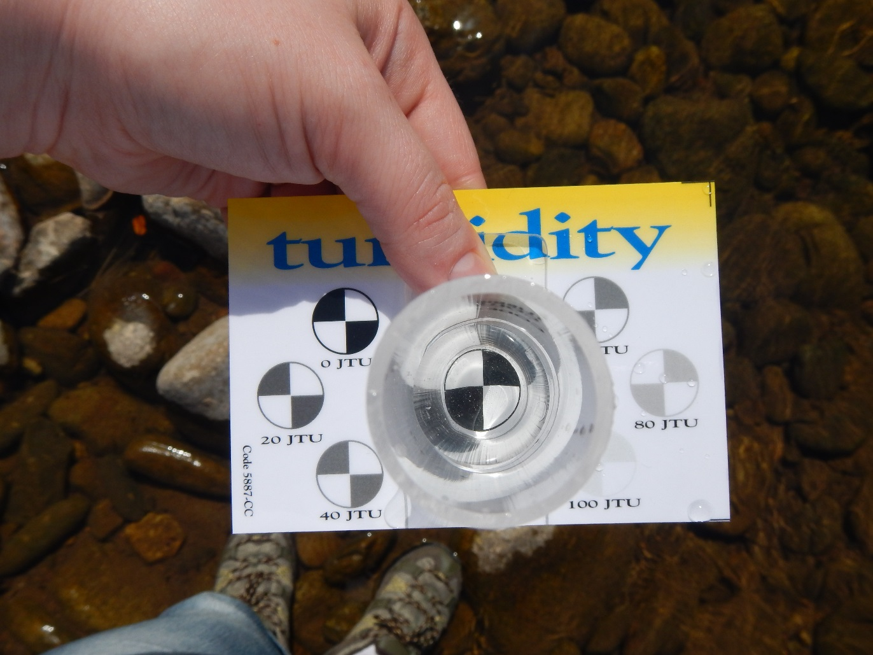
Turbidity test. This was recorded as 10 JTU.
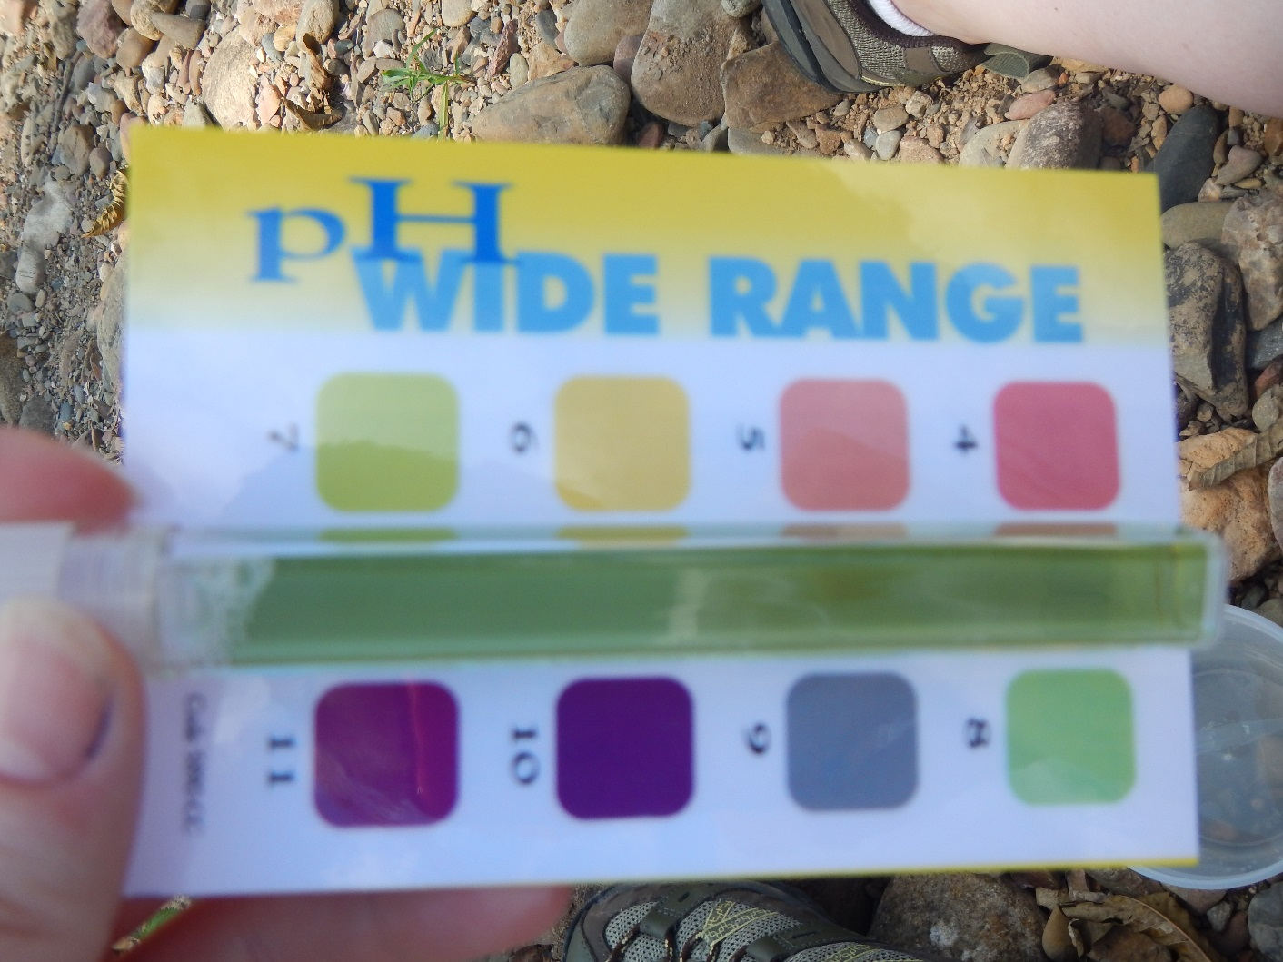
pH test. This was recorded as 8 ppm.
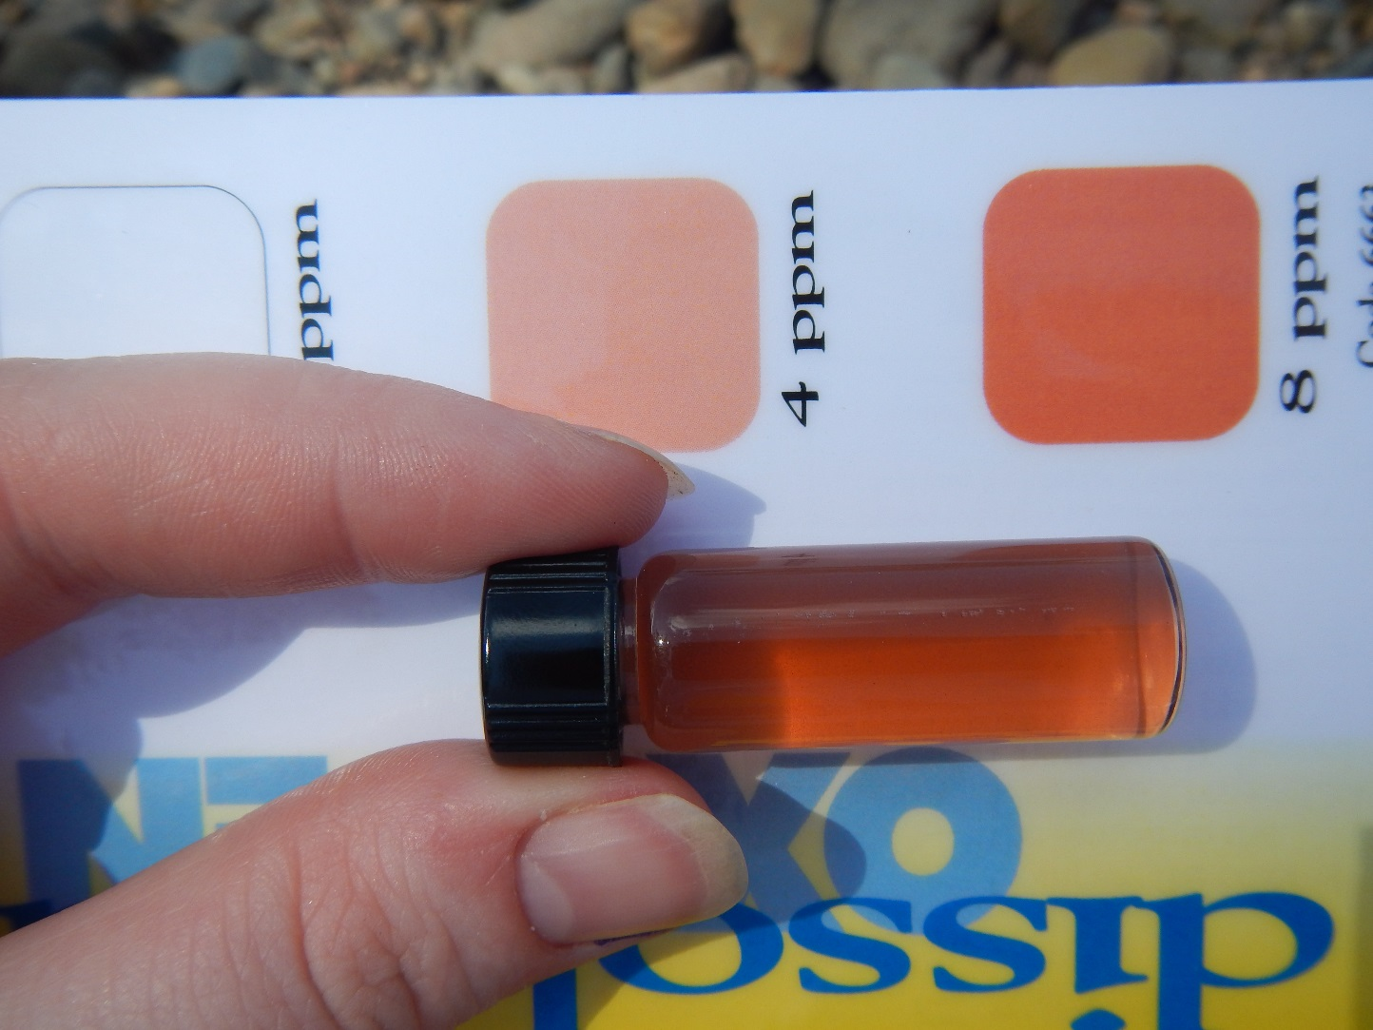
Dissolved Oxygen test. This was recorded as 8 ppm.
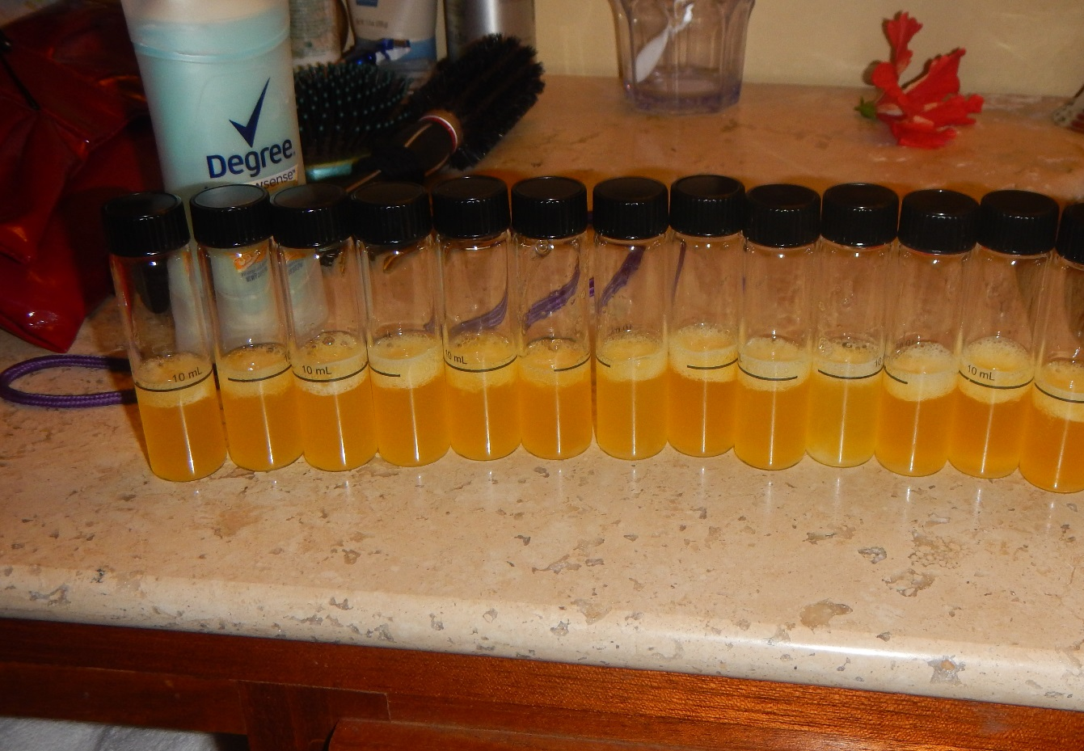
Coliform Bacteria test. These were recorded as positive.
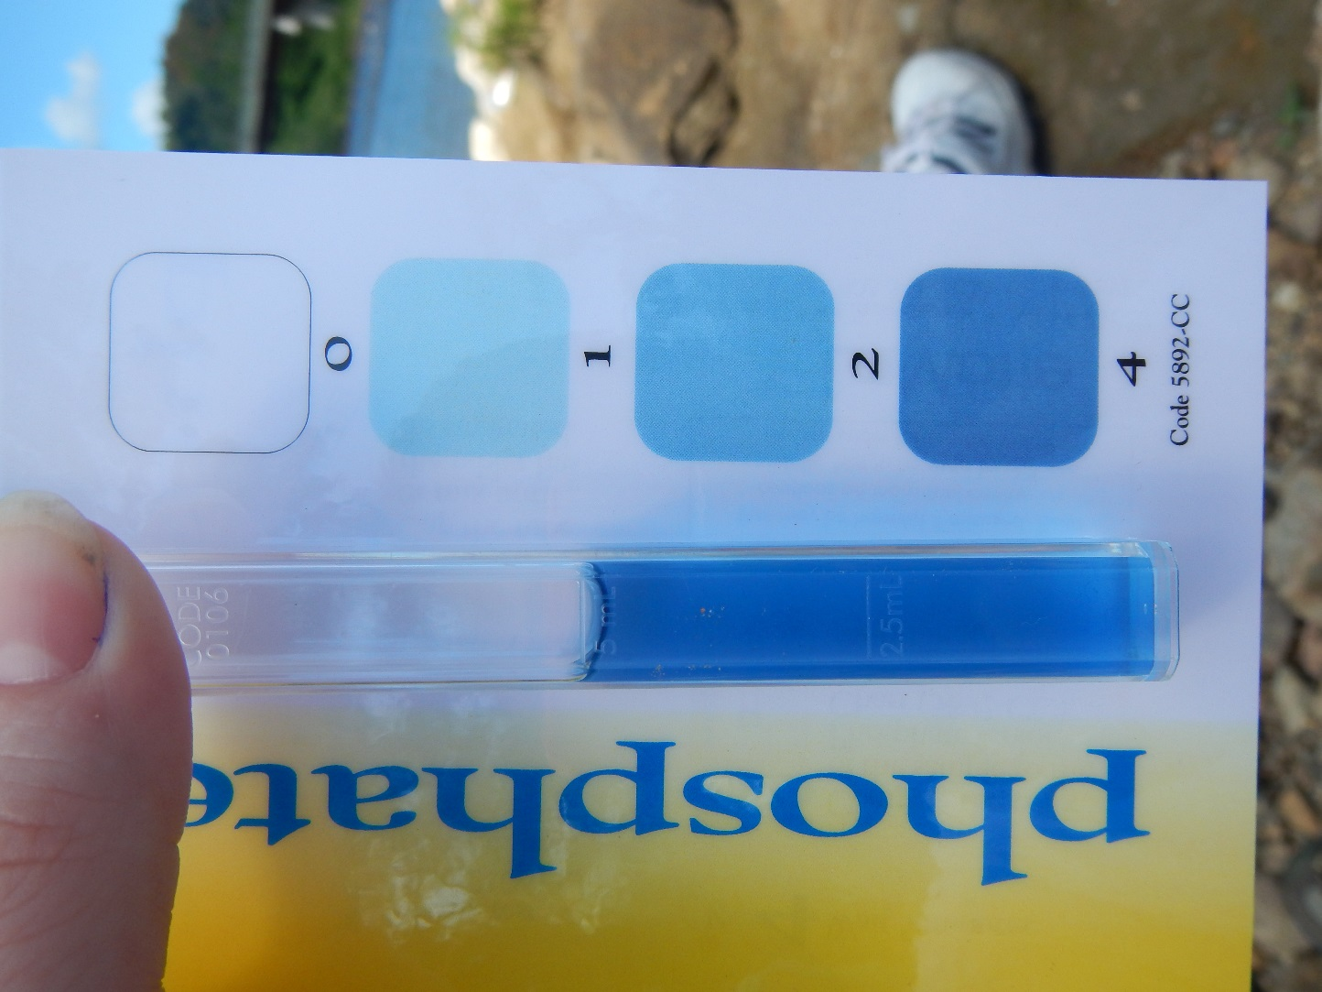
Phosphate test. This was recorded as 4 ppm.
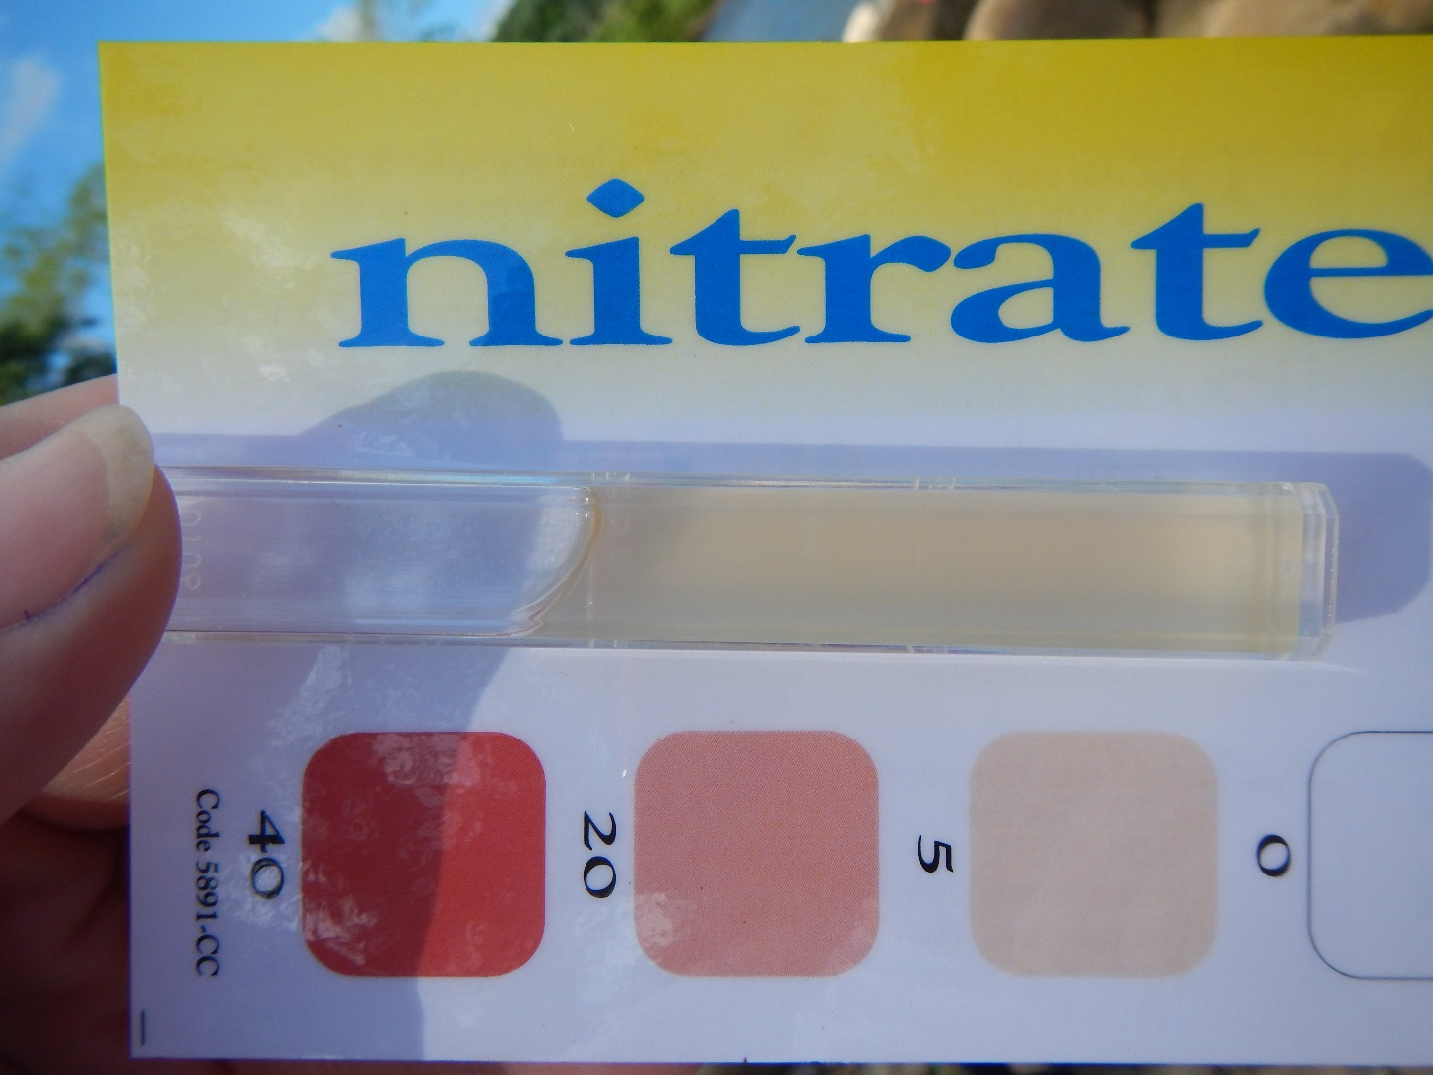
Nitrate test. This was recorded as 5 ppm.

