Bacterial Content in the Sibun River
February 15, 2014
By Taylor Harper

Introduction
The purpose of this research is to determine the presence of coliform bacteria within the Sibun River; site of research will be in Cayo District, Belize where the Hummingbird Highway intersects the river. The Sibun River is one of Belize’s major river systems that are over a 100 miles long and drains a major portion of the Maya Mountains. Belize is known for the variety of crops that grow along the flood plains and within the rich limestone soils. As the Sibun River flows throughout Belize it reaches varies points in which it comes into contact with limestone hills, caves, the Sibun River Valley, coastal roads, and eventually ends near the south end of Belize City (The Sibun Expedition).
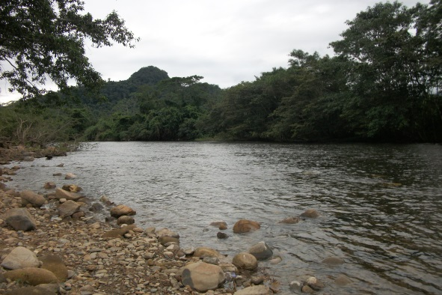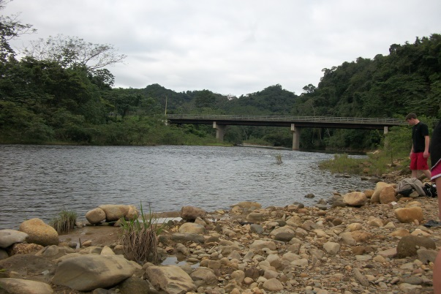(Sibun River)
The Sibun River provides its people with a natural access for many necessities in life. Not only is the river a source of drinking but the people who rely on this river may also use it as a way for washing or farming. Coliform bacteria are present in most water supplies, human/animal digestive tracts, and soil. According to the Department of Health in New York, most coliform bacteria do not cause disease, however some rare strains of E. coli (strain 0157:H7) can cause serious illness (Coliform Bacteria in Drinking Water Supplies). The presence of coliform bacteria usually means that there was some type of sewage or fecal contamination within the water. Typically, coliform testing should be done about once every year around late spring, early summer. Luckily, in Belize during the time frame from January 3, 2014 to January 8, 2014 there was constant wet weather. My hypothesis is that there will be a presence of coliform bacteria at all locations samples will be taken from.
Materials & Methods
Materials Needed: Black Sharpe marker, cottage cheese container (to hold tubes in), 6 coliform TesTabs in the provided tubes, 1 coliform bacteria color chart with instructions, and 1 coliform bacteria flash card (all of which are included in LaMotte Coliform Bacteria Code 5850 safety pack)
According to the LaMotte Coliform Bacteria pack flash cards, the coliform tablets within each test tube contain nutrients to support the growth of coliform bacteria, a gelling substance, and pH indicator. If there is a presence of coliform bacteria the organisms will react with the tablet, generate a gas, causing the gel to rise to the surface, and change the water color. Many gas bubbles, gel rises to surface, liquid below gel is cloudy, and indicator (water) turns yellow means a positive result for coliform bacteria. If liquid above gel is clear, indicator (water) turns red or yellow with no gas bubbles, and gel remains at bottom of the tube means a negative result for coliform bacteria.

Methods: January 5, 2014
- Use Sharpe marker to label each test tube A1, A2, B1, B2, C1, C2
- A1 and A2 samples will be taken directly from the Sibun River site
- B1 and B2 samples will be taken from a nearby stream located by Sleeping Giant Lodge that runs off into the Sibun River
- C1 and C2 samples will be taken from a swimming area near Sleeping Giant Lodge that is part of the Sibun River
- For each sample taken
- Fill the tube to the 10 ml line
- Replace cap
- Keep tubes upright, with tablet flat at bottom
- Incubate the tubes upright at room temperature, for 48 hours. Store out of direct sunlight
- After 48 hours compare contents in tubes to Coliform Bacteria Color Chart

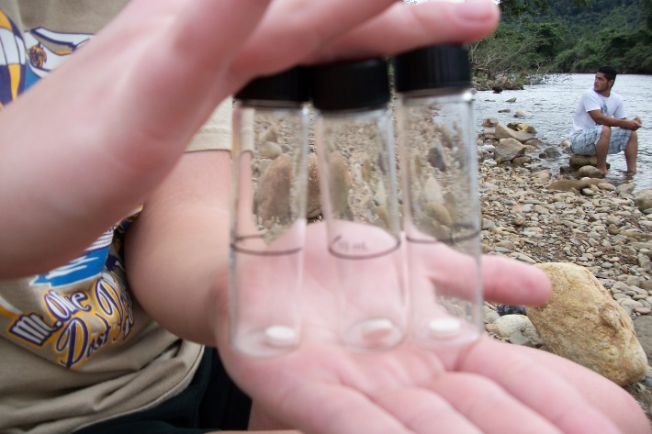 (Test tubes before water sample)

Results
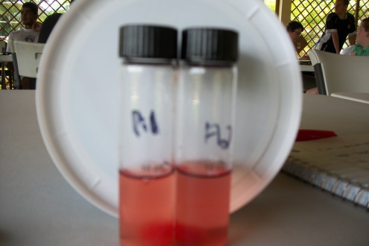 (Samples taken at Sibun River site)
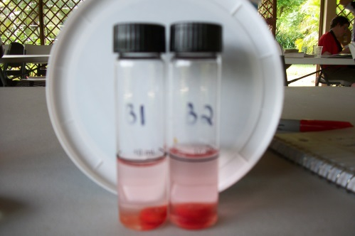
(Samples taken from a nearby stream Near Sleeping Giant Lodge that runs off into the Sibun River)
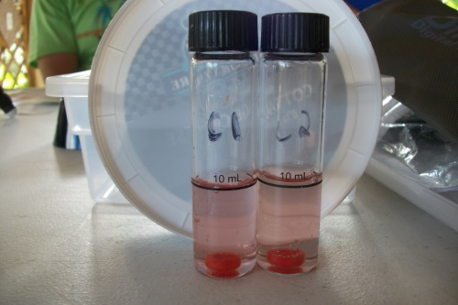
(Samples taken from swimming hole near Sleeping Giant Lodge that is part of Sibun River)
Within taking the sample and 1 hour all samples taken were turning the water and tablet red.

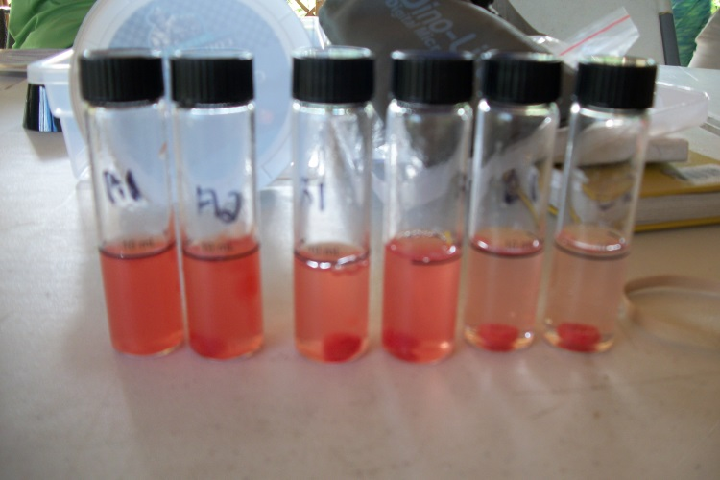

After 48 hours of sitting outside in the warm Belizean air, inside the tubes appeared to have many gas bubbles present, the gel from the tablet rose to the surface, the liquid below was very cloudy, and the color of the water was yellow-dark yellow.
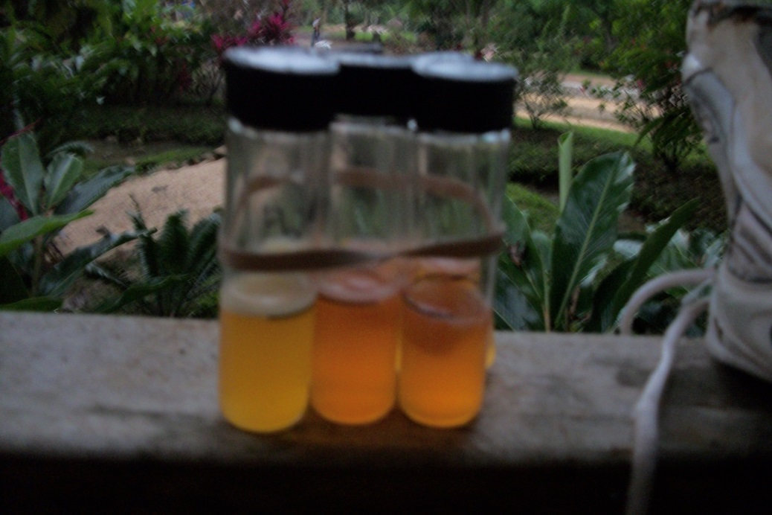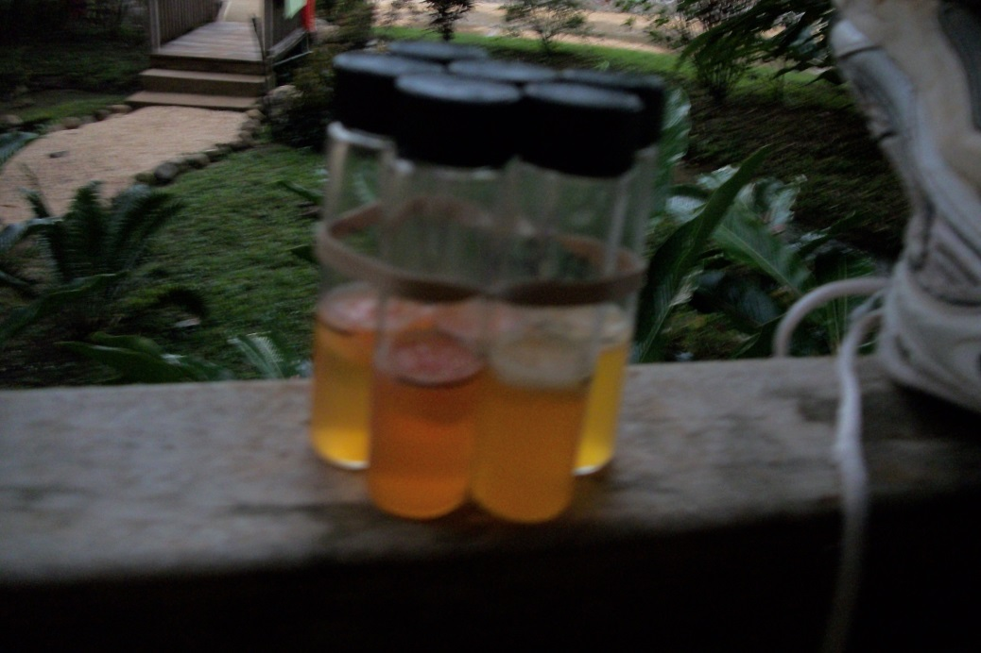
(Back Side)
(Front Side)

Conclusion
In conclusion, after incubating the test tubes for 48 hours the results indicated that there was a positive sign for coliform bacteria at all three location sights. What this means is that somewhere along the Sibun River there must have been either a sewage or fecal contamination that was present at that specific location or drained into the location from some other source. According to Washington State Department of Health, public water systems must deliver safe and reliable drinking water to their consumers 24 hours a day, 365 days a year (Coliform Bacteria and Drinking Water). Unfortunately, Belize is a developing country and cannot afford hundreds of public water systems that purify the water, thus why most locals looks towards the Sibun River for their supply. A helpful tip for locals is trying their best to limit the use of the Sibun River for drinking or try and boil the water to kill off the coliform bacteria. As for travelers, the Centers for Disease Control and Prevention (CDC) recommend that most travelers receive a Typhoid and Hepatitis A vaccination because one can become susceptible to these diseases through contaminated water or food (Health Information for Travelers to Belize). If experiencing any type of diarrhea, gastroenteritis, or a urinary tract infection contact medical assistance (Symptoms for Drinking Coliform Bacteria in Water).
Overall, the results confirmed my hypothesis that there will be presence of coliform bacteria at all locations. If to do this experiment over or someone else preform this experiment I would recommend traveling to a village/city with a higher population or around a school area where there would be more local interaction with the water. Also, preform a survey within the new area to see how common diseases like Typhoid and Hepatitis A, which are caused through contaminated water or food, are within the area.
Works Cited
“Coliform Bacteria and Drinking Water”. Washington State Department of Health Environmental Public Health Office of Drinking Water. Aug. 2011. Web. 10 Feb. 2014. http://www.doh.wa.gov/Portals/1/Documents/Pubs/331-181.pdf
“Coliform Bacteria in Drinking Water Supplies.” New York State Department of Health. June 2011. Web. 10 Feb. 2014. http://www.health.ny.gov/environmental/water/drinking/coliform_bacteria.htm
Elisabeth Kilmaren. “Symptoms of Drinking Coliform Bacteria Water.” Livestrong.com. 16 Aug. 2013. Web. 11 Feb 2014. http://www.livestrong.com/article/123179-symptoms-drinking-coliform-bacteria-water/
“Health Information for Travelers to Belize”. Traveler’s Health. Centers for Disease Control and Prevention. 2014. Web. 10 Feb. 2014. http://wwwnc.cdc.gov/travel/destinations/traveler/none/belize
“The Sibun River”. The Sibun Expeditions. MET. Naturalight Productions. Web. 30 Oct. 2013. http://www.belizeanjourneys.com/sibun/river.html

