Sibun River Water Testing

Brian Harmony

January 2013

Table of Contents

Page
Introduction…………………………………………………………………….. 3

Method Utilized When Testing …………………………………………………4

Chemicals or Elements Tested..………………………………………………....5-7

Photos of Collections Sites………………………………………………………8-9

Results
River and Stream………………………………………………………..10-11

Conclusion……………………………………………………………………..12-13

Sources Cited…………………………………………………………………….14

Introduction

The Sibun River is centrally located in the Country of Belize. It is the main drainage source for the Mayan Mountain Range to the Caribbean Sea. It begins in the Mayan Mountains where it is known as the Caves Branch River. It becomes the Sibun River somewhere upstream from Hummingbird highway. It is 90 miles long and the mouth of the river is 10 miles south of Belize City.
The purpose for this testing will be to run a comparison to previous years testing’s and see if there is significant change in chemical levels. I realize this is a backward way of looking at a scientific hypothesis, but I found it difficult to accomplish much in testing for various chemicals or contaminates in the one day allotted for water testing. Not to jump to the hypotheses, the fecal matter test requires 48 hours for the test to be completed. This would have greatly assisted in understanding if this was the cause for the increase in phosphate levels discovered with this year’s testing. Being as there are no known communities upstream from the testing site it would have been beneficial to have been able to run this test. The communities downstream from the test site rely heavily on the river for their water supply. Testing for additional contaminates would assist in discovering out why the phosphate level had increased
The test water was pulled from locations on the Sibun River and the stream on site at the Sleeping Giant Resort, in the Cayo District of Belize. In viewing Google Map from the location of the test site to the mountains to the north east there appeared to be no settlements upstream from the testing site. The locals working at the resort in which we stayed verified that outside of their citrus groves and sustainment farming on location, there were no known farms or settlements upstream towards the Mayan Mountains.

Locations and Method Utilized When testing

There were three testing sites on the river and one in a stream located on the grounds of the Sleeping Giant Resort, for a total of four sites. The river was high and fast flowing, not totally out of its banks, but in some areas was beyond the edge of the banks. The first area tested was under the bridge at mile 36 ½ Hummingbird Highway, 17 miles south of Belmopan about a quarter mile from the entrance to the resort. The second was approximately 150 yards downstream from the bridge. The third river test site was roughly an additional 100 yards further downstream from the second site. The location of the stream was on site at the Sleeping Giant Resort next to the building the ladies were housed.
Two individual water samples were removed from the river at each identified sites. The first two pictures enclosed show the river shows the tests sites. Note the white caps on the river. The current was very strong and the river level was higher than normal for the dry season. However upon our arrival in Belize we were greeted with rain every day for the first four days and there was a lot of rain in the mountains around the resort. This was not atypical of a normal January for this area. The third picture shows the location of the on grounds test site. Two additional samples were taken from the stream on the resorts grounds. The samples were placed in small plastic lab bottles with a screw cap.
The test kit utilized was the LaMotte, low cost, Estaury Water Quality Monitoring Kit. As mentioned above, the four chemicals tested were PH Balance, dissolved oxygen, nitrates and phosphates. Each site was tested three times with the bridge sample being tested a fourth time because of an apparent botched test.
Both the river and stream were mainly rock and gravel both. Both had rapid current movement due to the recent non-seasonal moderate rainfall.
Chemicals Tested

The focuses of this test will PH balance, dissolved oxygen, nitrates and phosphates. There will be a comparison to previous tests ran by former Students of Lincoln Land Community College, through the Biology 209 Course. By utilizing previous results this would be able to allow the ability to establish a baseline to generate a current status on the chemical balance of the river water. The goal will be to see if the levels of the four chemicals remained the same over a period of time or if there has been a significant change in any of the levels tested. Any change can be addressed at the next field study and monitored closely thereafter.

PH

PH is a test that measures the concentration of the hydrogen ion. This concentration is closely related to and is often written as PH. Pure water has a PH of seven (7). The test kit utilizes a numbering system from zero (0) to fourteen (14). Zero level is high acid with fourteen being high alkaline and seven being neutral. Ideal PH levels for a river should range from 6.5 to 8, (US EPA). This allows for a healthy environment for plant and animal life to survive in the river. Several factors can affect the PH level; Industrial or animal waste, run off from agricultural areas and pollution.
Dissolved Oxygen
Dissolved oxygen comes from photosynthesis of the waters plants as well as the turbidity of the water. Oxygen is important for the overall health of the ecosystem in bodies of water. Changes in oxygen levels can come from agricultural runoff as well as animal waste which would create an overabundance of bacteria which would deplete the oxygen levels and cause a die off of the oxygen reliant organisms in the water. Levels below 5 ppm would begin to have an adverse effect on the organisms and above 14ppm would classify as saturated with oxygen. An ideal level would be somewhere between 6-12ppm. (US EPA).
Nitrate
Nitrate is a natural occurring element from decomposition of plant and animal life as well as man generated. Nitrogen/Nitrates are an essential plant nutrient. Elevated or high levels of nitrates in the water can be reflective of excessive runoff from agricultural lands, failing septic systems, untreated raw sewage and runoff from animal storage areas or feed lots. Although some level of nitrates can be found in just about every body of water, the preferred level would be zero. An elevated level of nitrates in itself doesn’t have a direct result in animal die off but along with an increase or elevated level of phosphorus can lead to rapid plant growth which can lead to a body of water having a decreased level of dissolved oxygen that in turn could kill off the fish and other aquatic organisms that rely on the oxygen. As stated above, nitrates in the water are not necessarily dangerous, but once it reaches a level of 40 mg/L it becomes hazardous for drinking. The Sibun River is the main source of water for many villages downstream from where the testing sites are located. Any levels of nitrates or phosphorus should bring concern.
Phosphate
As with nitrates, phosphorous is an essential nutrient for plant life. The main source of phosphorus in the environment is from soil and rock weathering. In nature, phosphorus usually exists as part of a phosphate molecule (PO4). Phosphorus in aquatic systems occurs as organic and inorganic phosphate. Organic phosphate consists of a phosphate molecule associated with a carbon-based molecule, as in plant or animal tissue. Phosphate that is not associated with organic molecule is considered inorganic phosphorus. Inorganic phosphorus is the form required by plants. Animals can use either organic or inorganic phosphate. Both organic and inorganic phosphorus can either be dissolved in the water or suspended (attached to particles in the water column). The term "orthophosphate" refers to the phosphate molecule all by itself. "Reactive phosphorus" is a corresponding method-based term that describes what you are actually measuring when you perform the test for orthophosphate. Because the phosphorus analysis procedure isn't quite perfect yet, you get mostly orthophosphate but you also get a small fraction of some other forms. Sources of phosphorus contamination in the environment include industrial and municipal wastewater discharges, runoff from fertilized lawns and farmland. In addition, phosphorus can be derived from disturbed land areas, drained wetlands, water treatment, and commercial cleaning preparations. The Sibun River is drainage from the Mayan Mountains to the NE of the Sleeping Giant Resort. The mountains are mostly granite. Any level of phosphorous would be a concern.

Photos of Collection Sites

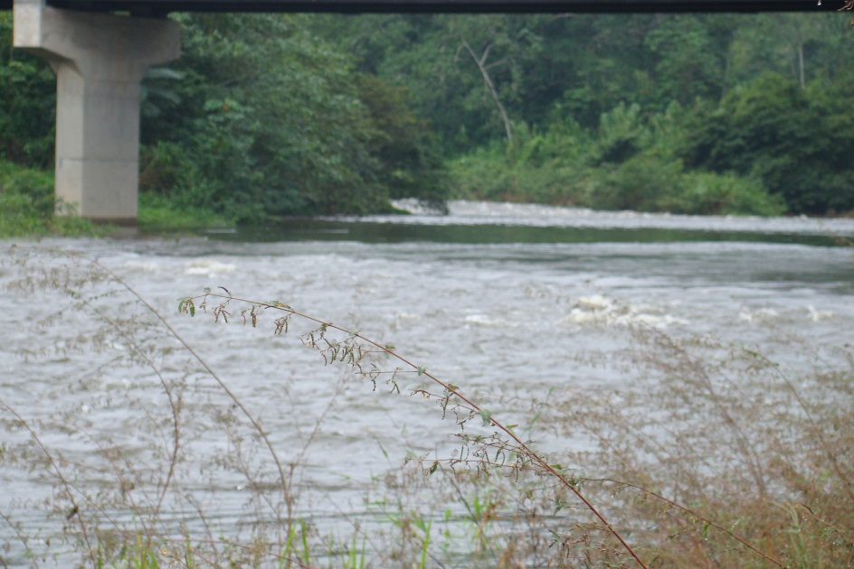

Bridge Site

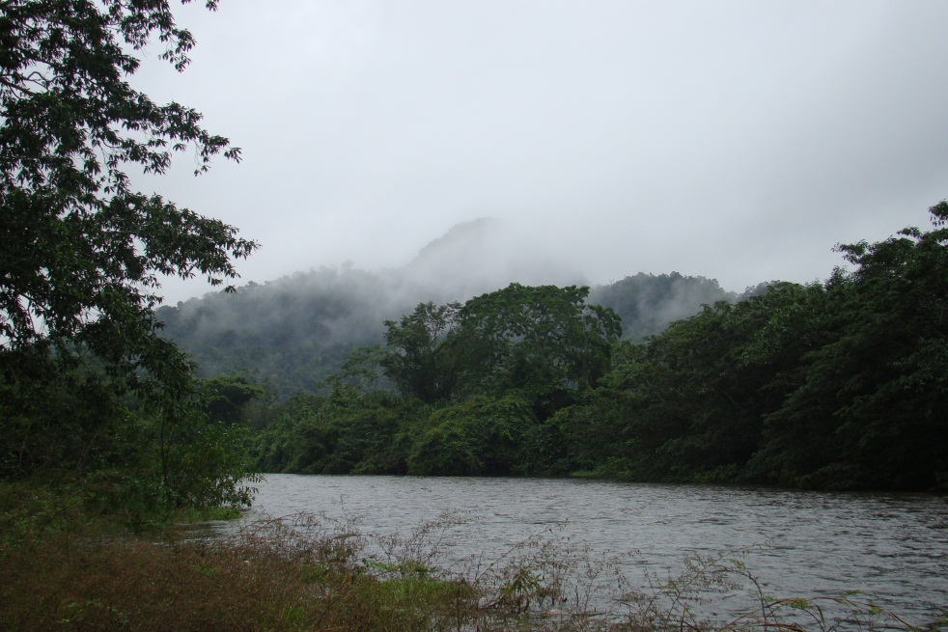

Second site is in the foreground with the third being at the outcrops of trees on the left side of the picture.

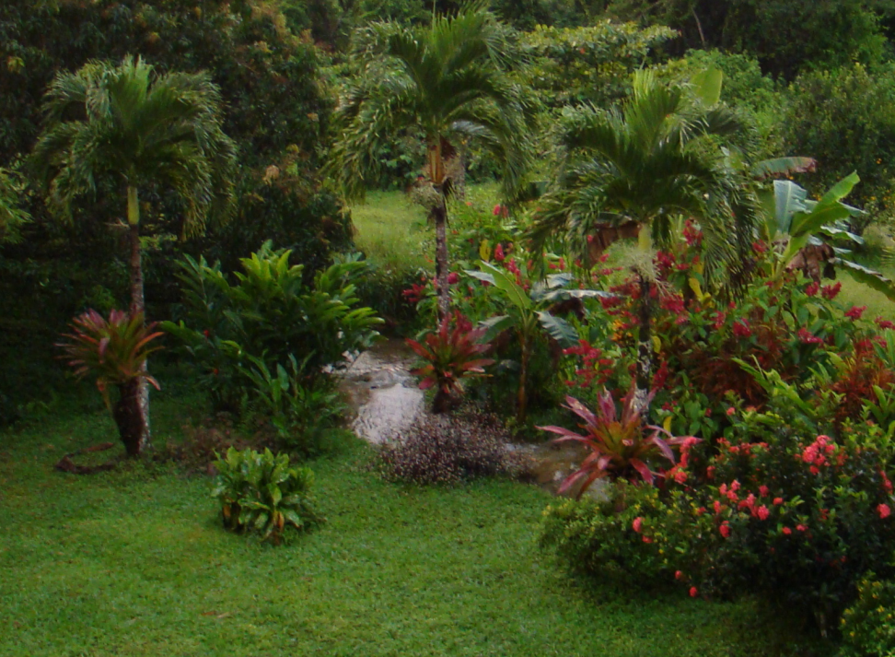

Stream Site

Results

2010 results by the Justin Bradley tests are as follows:

Sibun River Test
 | pH | Nitrate ppm | Phosphate ppm | Dissolved Oxygen ppm
Test 1 | 7.5 | 0 | 0 | 8
Test 2 | 7.5 | 0 | 0 | 8
Average | 7.5 | 0 | 0 | 8

Stream Test
 | pH | Nitrate ppm | Phosphate ppm | Dissolved oxygen ppm
Test 1 | 7.5 | 0 | 1 | 8
Test 2 | 8.0 | 0 | 0 | 8
Test 3 | 7.0 | n/a | n/a | n/a
Average | 7.5 | 0 | .05 | 8

Results from January 2013 Testing

Sibun River Test Bridge
 | pH | Nitrate ppm | Phosphate ppm | Dissolved Oxygen ppm
Test 1 | 8 | 0 | 3 | 8
Test 2 | 7.5 | .05 | 4 | 7.5
Test 3 | 7.5 | 0 | 4 | 7.5
Average | 7.66 | 0 | 3.66 | 7.66

Sibun River 150 Yards Downstream from Bridge
 | pH | Nitrate ppm | Phosphate ppm | Dissolved Oxygen ppm
Test 1 | 8 | .05 | 1 | 8
Test 2 | 8 | 0 | 1 | 8
Test 3 | 8 | 0 | 1 | 8
Average | 8 | 0 | 1 | 8

Sibun River 250 Yards Downstream from Bridge
 | pH | Nitrate ppm | Phosphate ppm | Dissolved Oxygen ppm
Test 1 | 8 | .05 | 1 | 8
Test 2 | 6 | 0 | 1 | 8
Test 3 | 7 | 0 | 1 | 8
Average | 7 | 0 | 1 | 8

Stream Test
 | pH | Nitrate ppm | Phosphate ppm | Dissolved Oxygen ppm
Test 1 | 8 | 0 | 1 | 8
Test 2 | 7.5 | 0 | 1 | 7.5
Test 3 | 7.5 | 0 | 2 | 7.5
Average | 7.66 | 0 | 1.3 | 7.66

Conclusion

Bradley’s testing in 2010, the level of pH was the same in the river as well as the stream at 7.5 average. In 2013 the pH balance ranged between 7 to 8 at both the river and the stream. Not a significant increase or decrease.
The dissolved oxygen in 2010 was 8 for both the river and stream. The dissolved oxygen level in 2013 ranged between from 7 to 8 for both the stream and river. Close enough to say it remained the same.
The nitrate level in 2010 was 0 ppm in both the stream and well as the river. The nitrate level remained the same in 2013 at zero.
The Phosphorus level between the two years brings about the only difference or anomaly. In 2010 the phosphate levels were 0 ppm for both the river and .05 ppm for the stream. In 2013 the level for the stream was 1 ppm and the river ranged between 1-4 ppm. In the first test for the Sibun River the Phosphate it was 1 ppm, but the second test created a 4ppm. To be sure that it wasn’t a fluke, the test was ran three more times to make sure the reading was correct. The 150 and 250 yard test sites remained consistent at 1ppm as well as did the stream tests. The bridge test site brought about a phosphate higher level at 3-4 ppm than the other three test sites. The two other river sites were downstream from the bridge. Between the multiple testing of each site the chemical used for testing for phosphate was exhausted from the available kit. This precluded any additional tests being made from the site under the bridge. The river under the bridge was curving and the test site was in an area that wasn’t moving as fast as the water at the other two sites. This may have made a difference with the water standing a bit more still under the bridge. In viewing the results it doesn’t make sense how the bridge could have a much higher level of phosphate versus the downstream tasting’s. There are several hypotheses on how and why the phosphate level was four times higher than any other location tested. This is where the test for fecal matter in the water would have been important to run. There was not enough time left in the trip to accomplish this test. The water testing was run on the second to the last day of the trip. The fecal matter test required two days to complete the process. The higher level of phosphates could have resulted from someone dumping at that site and the water had been caught in a swirl based on the location where the sample was pulled. It may have come from runoff from the ditches above the bridge and where the sample was pulled from just happened to be at the location where the runoff went into the river. It could also have been a result of erosion from the heavier than usual rain fall for this time of year and as with proposed explanation of the ditch drainage that this was the location of where the particles of erosion drained into the river. The sustainment farming for the lodge and some of the employees working the citrus grove on the grounds of the resort was also just up the hill from the bridge location.. There are several different factors that could have resulted in such a difference in phosphate levels. There was just not enough time allotted to run additional tests nor were there enough chemicals available to get additional samples and run more phosphate testing.
Suggestions if there is a trip next year would be to take these results and run comparisons by pulling several samples under the bridge and run additional chemical analyses to see if it can be determined what caused this year’s spike for phosphate. Additionally, before taking the test, look around the area just above the bridge for telltale sign of dumping, erosion or if there seems to be a small gully going back to the resort where the waste, sewage or chemicals used (if any) on the crops and citrus grove that would allow for chemicals to drain into the river at the bridge site.

Sources Cited

Justin Bradley. Sibun River Water Quality Monitoring Project, Lincoln Land Community

College, January 2010

The Conservation Atlas of Tropical Rain Forests, The America’s, Simon and Schuster, Academic

Reference Division, Macmillan Library Reference, 1996

Wikipedia, <http://en.wikipedia.org/wiki/Sibun_River>

(US EPA) Drinking Water Contaminants – US Environmental Protection Agency

<www.epa.gov/ogwdw/mcl.html>

<www.water-research.net/Watershed/phosphates.htm>

