Heath Garner

Belize research
Introduction
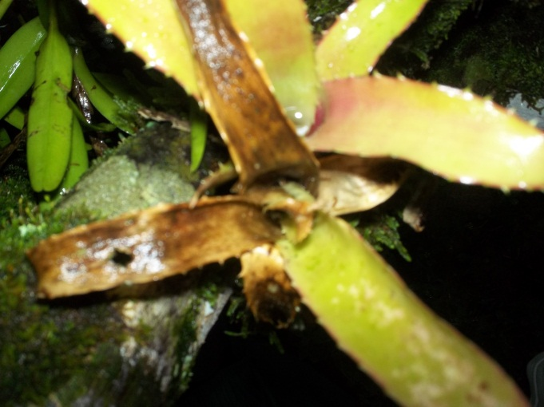
My interest in bromeliads began when I started talking to Dan Bittner about the research he performed while he was in Belize. Bromeliads are plants that have a crista which holds water. The plants also have invertebrate organisms which depend on this water for survival. It was interesting to consider this interdependent lifestyle of the invertebrate organisms and the plant. This relationship has to have many variables to survive successfully. The medium that both organisms need is water. If water becomes to contaminate it would be unlivable for any organism. To survive the organisms must work together and maintain a livable environment for both species. I hypothesized that the health of the plan and the amount of invertebrate organisms living in the plan would directly correlate to a more acidic environment for healthier species. Acidic comes from the Ph. scale which is a system to measure how acidic or basic a solution may be. The scale ranges from 0-14 with 0 being the most acidic and 14 being the most basic. The average stream is near a neutral Ph. of 7. The Ph. scale is logarithmic meaning that each time it goes up or down a number it is by x10 more or less than the previous. Most plants that grow in foliage tend to grow in a Ph. range of 5.5 to 6.5. In my experiment I will study 7 plants and use approximately 10 ml of water from the crista of each plant , then count the number of invertebrate organisms, and test the Ph.
Materials and Method
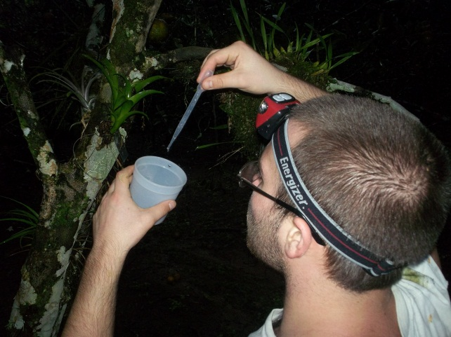
To conduct my experiment I used 7 petri dishes, a collecting pipette, cleaning water, a microscope and a Ph. meter. To do this experiment I found 7 bromeliads that were large enough to provide 10 ml of water. I labeled each plant in my notes and made a data table that would contain the invertebrate organisms and the Ph. of each plant. I then made petri dishes labeled accordingly so I would be able to take my samples back to the lab to collect data. I then collected approximately 10 ml of water from each of the cristae and put it into the appropriate petri dish. Now, I take my samples to the lab and use the Ph. meter to collect the data about Ph. Finally, I would take the petri dishes and put them under the microscope so I could count and record the number of invertebrate organisms in each of the samples.
Data Table
Plant # | Ph. | # Invertebrate organisms
1 | 6.4-6.6 | 1
2 | 7.1-7.3 | 2
3 | 6.9-7.1 | 2
4 | 7.0-7.2 | 3
5 | 7.2-7.4 | 12
6 | 7.3-7.5 | 0
7 | 6.8-7.0 | 0

Conclusion
The data that I gathered was not in support of my data. It seemed that the closer to slightly basic the water was the more organisms that it supported. The health of the plants also varied on size the smaller plants that had been transplanted to the lodge did not seem to survive as well as the large plants that had been transplanted.This data may have been askew because of the fact that it rained every day that we were in Belize and this would affect the Ph. of the plant.

Sources
BSI.org
Elmhurst.edu
mrec.ifas.ufl.edu
Dan Bitner

