Sibun River Water Quality Research
Lincoln Land Community college
Atrazine and E-Coli
Faulkner, Jennifer M
2014
Sibun River Water Quality Research
Introduction
In 2010 student Justin Bradley conducted research on the water quality of the Sibun River and its tributaries. In his report he tested the water for nitrates, oxygen, pH, and phosphates. Abnormal levels of nitrates, pH, and phosphates can be an indicator of pollution from agricultural runoff, human and animal waste, and industrial pollution. His findings were that the river and its streams were healthy and all levels were in acceptable range. Now, 4 years later, the purpose of my research is to test the water quality again by testing for two new contaminates; atrazine, an herbicide typically found in runoff of row crops, coffee bean crops, and citrus groves; and E-Coli, a bacteria from human and animal waste. Contamination of the river by either of these substances can be potentially harmful or fatal to human beings and wildlife that live in or around it and depend on its resources.
Hypothesis
My hypothesis is that the water I am testing could contain these contaminates due to the presence of nearby cattle farms, orange groves, cocoa bean fields, and increased human population (according to countryeconomy.com the population of Belize has increased by 34,405 from 2010 when Justin Bradley conducted his research, to 2012 when population was last reported). Furthermore, by testing the water in several locations, I should be able to pinpoint the source, if any, of the pollutants and/or contaminates. My null hypothesis is that none of the testing sites will show either atrazine or E-Coli. My alternative hypothesis is that the water near the cattle will have the highest counts of E-Coli, the water closest to the orange groves and cocoa bean fields will test positive for unsafe levels of atrazine, the stream closest to the lodge will have fewer counts of E-Coli and will test positive for unsafe levels of atrazine, and the portion if the river that intersects Hummingbird Highway will have the fewest counts of E-Coli and negative results for atrazine. I will be using a type of statistical testing called One Way Analysis of Variance.
Atrazine
The effects of Atrazine on the environment have been studied extensively as it is one of the most widely used herbicides in the United States and is the second largest selling herbicide in the world. It has been banned in Europe as studies have clearly linked it to harm of wildlife and to humans (“Atrazine”). It is, however, legal to use atrazine in Belize and the use of atrazine in Belize has been reported and verified in the United Nations Environment Programme Regionally Based Assessment of Persistent Toxic Substances.
According to the National Resources Defense Council, “The adverse reproductive effects of atrazine have been seen in amphibians, mammals, and humans-even at low levels of exposure. Concentrations as low as 0.1 ppb have been shown to alter the development of sex characteristics in male frogs. When exposure coincides with the development of the brain and reproductive organs, that timing may be even more critical than the dose” (“Atrazine-Poisoning the Well”).
Some of the most common species of frogs in Belize are the Red Eyed Tree Frog, the Strawberry Dart Frog, and the Broad Headed Rain Frog. If atrazine is found in the Sibun River, it can have a negative impact on these water dependent amphibians as well as smaller mammals that live in and around the river and its tributaries.
E-Coli
According to the EPA, coliforms and streptococci are two bacteria groups that are used as indicators of possible sewage contamination. Although these bacteria are not harmful in themselves, they indicate the possible presence of disease causing bacteria. If disease causing bacteria are present, swimming and eating shell fish from the infected water or stream would pose a health risk to humans (“Escherichia Coli”). Since testing for a large variety of pathogens is time consuming and expensive, water is usually just tested for coliforms and streptococci. Escherichia coli or E-Coli is a gram negative type of coliform specific to animal and human fecal material. “EPA recommends E-Coli as the best indicator of health risk from water contact in recreational waters...” (“5.11Fecal Bacteria”). While E-coli are present in all surface water to some degree, high levels can be very dangerous to humans. The EPA has set a safety limit of no higher than 126 colonies per 100ml of water because concentrations any higher has been shown to increase the chance of human infection (Goetz, Gretchen).
According to Water Missions International, safe water in Belize is limited. Although most villages have a Water Board and some even have water towers, they are little more than collections of river or rain water with insignificant amounts of chlorine added to it. The risk of a major infectious disease from polluted water is high. In addition, the region is susceptible to hurricanes and flooding that can cause outside latrines to overflow increasing the chance of E-Coli being introduced into their water sources. Sometimes villagers will boil the water before using it but this will not remove bacteria and E-coli if it is present. Below is an excerpt from the Water Missions online newsletter contributed by the WHO (World Health Organization):
“Belize possess adequate quantities of surface and groundwater BUT water contamination-coupled with lack of chlorination has become a more and more critical issue. This water contamination-a result of issues such as agricultural and industrial expansion and insufficient monitoring and quality control-threatens Belize’s population with increased incidences of Cholera and diarrheal diseases” (The Need).

Materials and Methods
I collected samples from four sites along the Sibun River and its tributaries. The first site was where the Sibun River and Hummingbird Highway intersect. At this site the river ran adjacent to cocoa bean fields on one side and an orange grove to the other although neither was in the immediate proximity as there was a large area of riverbank and over growth separating the river from both. The exact coordinates of test site number one are N 17◦ 03.576’, W 088◦ 39.498’ at 349ft. elevation. The second site was a stream just a short distance from site number one that ran directly into Sibun River and was located closest to the orange grove, coordinates N 17◦ 06.207’ W 088◦ 40.181’ at 239 ft. elevation. I learned from the guide that took me to this site that locals also used this area to wash their cloths in the water. Site number three was at intersection of the Sibun River and a small stream running down from the mountains and emptying into the river. I chose this spot specifically because this was the closest area I could get to on foot to where the cattle farm was located. When I reached this destination I discovered that there were also orange groves directly next to this stream and river intersection. The orange grove was so close in fact that some of the orange trees were hanging over the water in some areas. The coordinates of site number three are as follows: N 17◦ 06.310’W 088◦ 40.032’ at 229 ft elevation. Finally site number four was located on the grounds of the Sleeping Giant Lodge at a small stream that empties into the Sibun River. Coordinates of site number four are N 17◦ 06.488’ W 088◦ 39.937’ at 293 ft. elevation.
After I collected all of my samples I returned to the lodge to gather my materials and prepare my samples. To identify and count any colonies of E-coli present I used EMB (Eosin Methylene Blue) agar plates. EMB is a growth media that contains peptone, lactose, sucrose and the dyes eosin Y and methylene blue. I used this growth media in particular because the sugars in the media encourage bacteria that are present to grow and will differentiate them by their color reactions to the dyes. The lactose in the media supports coliforms such as E-Coli, and the sucrose supports the growth of pathogens such as Salmonella. The dyes react with vigorous lactose fermenters and turn the growth dark purple or black. This coloration is typical of E-Coli and is usually accompanied by a green metallic sheen (see figure 1). If there are other less vigorous lactose fermenters present they will typically produce colonies that range from pink to dark purple coloration in the media (see figure 2). I used the Table of Results from the text book, “Exercises for the Microbiology Laboratory”, by Michael J Leboffe and Burton E Pierce (see table 1) as the guidelines to interpret my data.
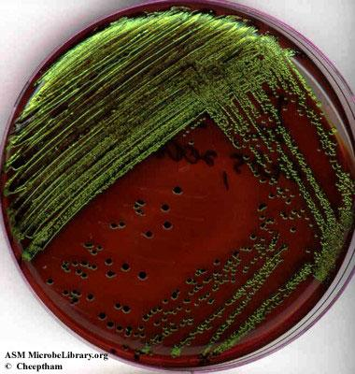
Figure 1
Figure 1 Eosin-methylene blue (EMB) agar plate inoculated with Escherichia coli (a gram-negative coliform bacterium) showing good growth of dark blue-black colonies with metallic green sheen indicating vigorous fermentation of lactose and acid production which precipitates the green metallic pigment. (Naowarat Cheeptham, Thompson Rivers University, Kamloops, BC, Canada)
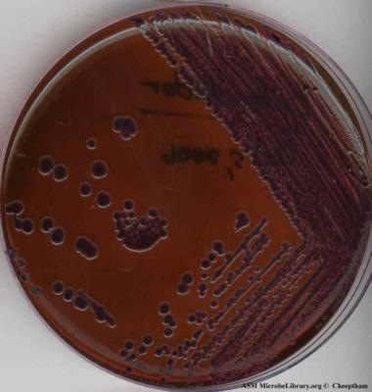
Figure 2 EMB agar plate inoculated with Enterobacter aerogenes (a gram-negative coliform bacterium) showing good growth of brown, dark-centered, mucoid colonies indicating lactose fermentation and acid production. (Naowarat Cheeptham, Thompson Rivers University, Kamloops, BC, Canada)

Result | Interpretation | Presumptive ID
Poor Growth or no growth | Organism inhibited by eosin and methylene blue | Gram-positive
Good Growth | Organism is not inhibited by eosin and methylene blue | Gram-negative
Growth is pink and mucoid | Organism ferments lactose with little acid production | Possible coliform
Growth is “dark” (purple to black, with or without green metallic sheen) | Organism ferments lactose and/or sucrose with acid production | Probable coliform
Growth is “colorless” (no pink, purple, or metallic sheen) | Organism does not ferment lactose or sucrose. No reaction | Noncoliform
Table 1 EMB Results and Interpretations

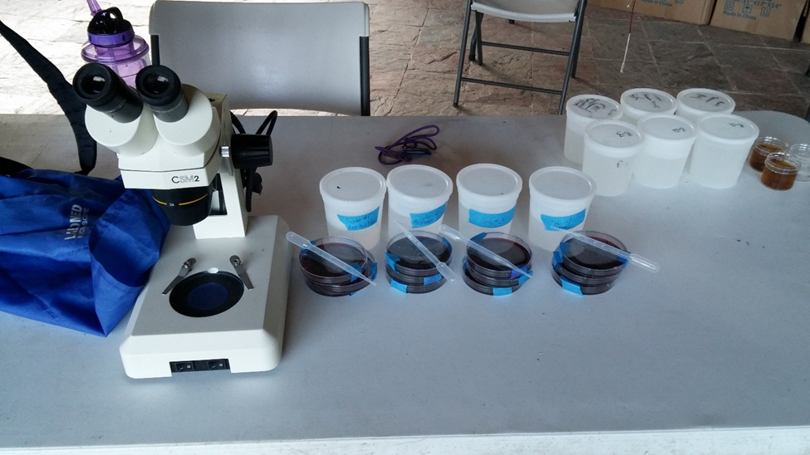
To inoculate the plates I used four clean pipettes to place 1 drop of water from each sample onto a clean EMB plate. By carefully lifting the lid at an angle to shield the agar from airborne contamination, I then streaked the drop of water with the tip of a clean sterile swab in a zigzag pattern across the plate and closed the lid. I repeated the process two more times for each site so that each sample from the four sites had three streaked agar plates. I labeled each plate and taped the lid closed (see figure 3). The plates were left for 24 hours at room temperature to incubate. I would return the next day to check for any growth. The pipettes I used had 1 ml calibration marks on them and I measured 23 drops per 1 ml for these particular pipettes. Using this information I would be able to multiply however many E-coli colonies I observed by 23 to get the number of colonies per ml. If the colonies were too numerous to count I would use a serial dilution method to thin out my cultures to a countable state.
Figure 3
To test for dangerous levels of atrazine I used test strips from Pro-Lab Total Water Quality Test Kit (see figure 4). The Total Water Quality Test uses standard guidelines of maximum contaminate levels from the EPA. The desired value according to the EPA of atrazine is less than 3ppb. If the indicator strip shows a positive result the maximum contaminant level has been met and the water is unsafe and according to the EPA, hazardous.
The test kit included a set of directions, a dropper, a test vial, and two test strips. I was only able to test one site. Following instructions, I used the dropper to place two drops of sample 1 into the test vial. I then gently swirled the sample, placed the vial on a flat surface, and placed both test strips into the vial with arrows pointing down. The directions then said to wait 10 minutes. After that time, blue lines will appear on test strips and results can be read.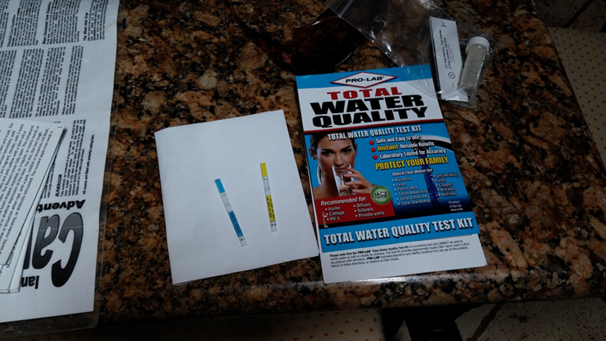
Figure 4 Total Water Quality Test Kit

Results
E-coli
After 24 hours I returned to check growth on the plates. See below for the observations I recorded of each sample and the corresponding interpretation as dictated by table 1.
Sample | Observation | Interpretation
Sample 1A | Spherical colonies present. Some in clusters, some alone. All are light pink in color. | Gram-negative bacteria present, possible coliform
Sample 1B | A few spherical colonies present in the middle of the plate and along plate wall, pink in color | Gram-negative bacteria present, possible coliform
Sample 1C | A streak present and also spherical conies present, pink in color | Gram-negative bacteria present, possible coliform

Sample | Observation | Interpretation
Sample 2A | A glob of growth in the middle of the plate, whitish and milky with circular blotch of purple in the middle | Gram-negative bacteria Probable coliform, along with noncoliform bacteria present
Sample 2B | A milky white growth present alongside of plate with 2 spherical purple growths in the middle of the plate | Gram negative bacteria Probable coliform and noncoliform bacteria present
Sample 2C | A milky streak in the middle of the plate with light purple color to it | Gram-negative bacteria present  Possible coliform

Sample | Observation | Interpretation
Sample 3A | A milky purplish growth on edges and middle of the plate and 3 dark purple spherical growths in the middle of plate | Gram-negative bacteria present  Probable coliform
Sample 3B | A milky white growth in the middle and sides of plate also some spherical light purple growths present along edges of milky growth | Gram-negative bacteria present  Possible coliform
Sample 3C | Only one growth present, smooth, milky, light purple in color | Gram-negative bacteria present  Possible coliform
Sample | Observation | Interpretation
Sample 4A | Quite a large growth present on one side of plate. Non symmetrical shape with dark purple border and dark purple rings along the inside of the growth. | Gram-negative bacteria present  Probable coliform
Sample 4B | 2 light purple streaks in center of the plate, very faint, poor growth. | Gram- positive bacteria present, also possible coliform
Sample 4C | A very large asymmetrical growth on edge of plate, milky, thick, and purple. | Gram –negative bacteria present,  Probable coliform

At this point of my data analysis I was able to interpret the success and color of the growth to either identify the possible or probable presence of E-coli but I still needed to count the number of colonies per plate to be able to say if that number fell within the safe range as dictated by the EPA (under 126 colonies per ml). However, there were a few things that prevented me from going further: 1) a positive identification of E-coli if present (because my samples could not be 100% positive but only interpreted as possible and probable E-coli, I felt the results were not definitive), and 2) no countable colonies of bacteria were present , only large growths or streaks on the plate. However, if I were to proceeded with a serial dilution method to count colonies of bacteria I would need sterile test tubes, sterile pipettes, and a sterile broth to dilute the samples with- none of which I had available to me at the time due to an oversight on my part of supplies I would need before I left the United States.
After collecting the data and entering that information on a spreadsheet, the One Way Analysis of Variance was performed by Professor Tate. The results showed that there was not enough difference in the mean values of data from each test site to be statistically significant. The P value of my data was 0.363 providing no evidence against my null hypothesis. It also showed that the power of the performed test was below the desired power which indicates you are not as likely to see a difference among the groups when one actually exists. These findings were consistent with my observations. See table 2 below.
One Way Analysis of Variance Thursday, April 10, 2014, 11:39:10 AM

Data source: Data 1 in Notebook1

Normality Test (Shapiro-Wilk) Passed (P = 0.276)

Equal Variance Test: Passed (P = 1.000)

Group Name N Missing Mean Std Dev SEM
Col 1 3 0 1.000 0.000 0.000
Col 2 3 0 1.667 0.577 0.333
Col 3 3 0 1.333 0.577 0.333
Col 4 3 0 1.667 0.577 0.333

Source of Variation DF SS MS F P
Between Groups 3 0.917 0.306 1.222 0.363
Residual 8 2.000 0.250
Total 11 2.917

The differences in the mean values among the treatment groups are not great enough to exclude the possibility that the difference is due to random sampling variability; there is not a statistically significant difference (P = 0.363).

Power of performed test with alpha = 0.050: 0.076

The power of the performed test (0.076) is below the desired power of 0.800.
Less than desired power indicates you are less likely to detect a difference when one actually exists. Negative results should be interpreted cautiously.
Table 2

Atrazine
After waiting 10 minutes I took the test strips out of the vial and compared the results to the table included in the kit. Both blue lines on each test strip were very faint, almost undetectable (see figure 5). According to the table of results included in the kit, “if no lines appear, or both lines are very light, the test did not run properly and the result is not valid.” The result of the test was inconclusive.
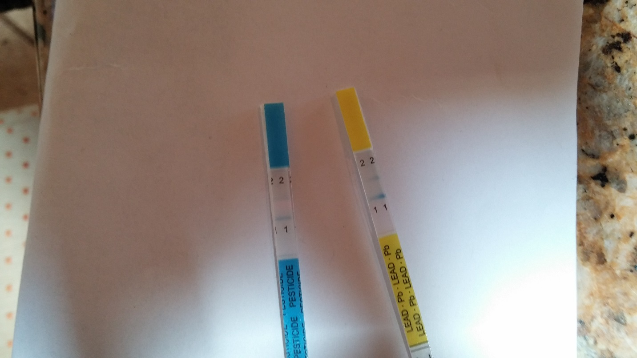
Figure 5 atrazine test strip showing results

Conclusion
Overall, my research did not go as I expected it to when I first formed my hypothesis. I did not get the clear definitive answers that I thought I would using the EMB plates. Identifying E-coli colonies was not as easy as I thought. Secondly, when I prepared my research materials before I left the United States I didn’t realize that I would need a sterile broth, sterile test tubes, and sterile pipettes to perform a serial dilution method of my samples. Since I wasn’t able to dilute my samples properly, I can’t be sure whether my results would or would not have turned out differently. Although, according to my interpretations table, there might have been E-coli present in my samples, my statistical analysis showed no evidence to support my alternative hypothesis. I was unable to say whether any of the sites tested had more E-coli present than the other or to identifying the source of E-coli because I could not prove that E-Coli was present.
As for the atrazine testing, I was not equipped with the proper testing materials. I only obtained the kit I brought with me days before leaving for Belize because all of the other test kits I looked at and tried to get either had shipping issues or were too expensive. As a matter of fact, it looked like I was going to have to delete that portion of my research due to lack of testing equipment until professor Cox found the Pro Lab kit at a local farm and home store at the last minute.
I already knew from researching the topic that atrazine is used in Belize. What I did not know was where, how much, and what harm, if any, it was doing to the environment. Therefore, it was really important to me to keep the atrazine aspect of my research because of the significant harm atrazine could cause to the precious wildlife in the Belize rain forests. My results were inconclusive because I did not have enough test kits and because the test kit I used probably wasn’t the most reliable, but the question remains and warrants further testing and research.
The purpose of this research was to determine the health of the Sibun River by testing for two harmful substances- E-coli, and atrazine. Many animals and humans depend on this water source. If these substances are present and found to be at dangerous levels, it is important to find out so that efforts can be made to correct the problem. Although aspects of my research were inconclusive, I believe further testing should be done and if I get the chance to back to Belize I will focus my time and effort to further this study. I have learned from the mistakes that I made during this research and would use that knowledge to make the collection, testing, and analysis of my data more accurate and thorough the next time.

Works Cited
"5.11 Fecal Bacteria." Home. N.p., n.d. Web. 28 Mar. 2014.
"Atrazine." Pesticide Action Network. N.p., n.d. Web. 06 Apr. 2014.
"Atrazine: Poisoning the Well." Natural Resources Defense Council – The Earth's Best Defense. N.p., n.d. Web. 04 Apr. 2014.
" Belize - Population." Countryeconomy.com. Country Economy, n.d. Web. 28 Mar. 2014.
"Eosin-Methylene Blue." Eosin-Methylene Blue. American Society of Microbelibrary, 29 Sept. 2007. Web. 06 Apr. 2014.
"Escherichia Coli O157:H7." Home. United States Department of Agriculture, n.d. Web. 06 Apr. 2014.
Goetz, Gretchen. "Dangerous Waters: E. Coli Threaten Swim Areas." Food Safety News. Food Safety News, 18 Aug. 2011. Web. 28 Mar. 2014.
"The Need." Water Missions in Belize RSS. N.p., N.d. Web. 28 Mar. 2014.
Pierce, Burton E., and Michael J. Leboffe. Exercises for the Microbiology Laboratory. Englewood, CO: Morton Pub., 1999. Print.
United Nations Environment Programme--Regionally Based Assessment of Persistent Toxic Substances (Arctic). Rep. N.p.: Global Envrinment Facility, n.d. United Nations Envrionment Programme Chemicals. United Nations, Dec. 2002. Web. 11 Apr. 2014.

