Diurnal Fluctuations of the B.O.D. Levels in the Sibun River

Lauren Crocker | Bio 209 | Spring of 2014

Table of Contents
Page
Introduction…………………………………………………………………………………..2-3
Materials and Methods………………………………………………………………………………………….4-9
Results……………………………………………………………………………………………10-12
Conclusion…………………………………………………………………………………….13-14
Works Cited…………………………………………………………………………………….15

_____________________ Introduction__________________________
The purpose of this experiment is to evaluate the B.O.D levels, or Biological Oxygen Demand, in the Sibun River. A B.O.D test measures the strength of the wastewater based on the amount of oxygen needed to stabilize the organic material in the wastewater. It is imperative to constantly be testing and evaluating the D.O, or dissolved oxygen, and contamination levels. I was testing to see if there was a diurnal fluctuation in the Sibun River. I predicted that there would be a higher BOD level during the day than during the night because of pollution occurring during the day.
Dissolved oxygen analysis measures the amount of gaseous oxygen (O2) dissolved in an aqueous solution. Oxygen gets into water by diffusion from the surrounding air, by aeration (rapid movement), and as a waste product of photosynthesis. Due to constant changes in our world, it is essential that we continue to monitor these bodies of water to ensure overall public health. There are numerous contributing factors that have a crucial environmental impact. Such as, discharge of wastewater, runoff from agricultural sites, fecal contamination, airborne contaminants, human waste that is improperly sanitized, and many other factors. From this project we need to utilize the results to determine if corrective action is need for the overall public health.

Materials and Methods Utilized When Testing for B.O.D

Materials
Hach Water Ecology Testing Kit (Model AL-36DT) containing:
- 20 Stoppered Bottles
- 40 Dissolved Oxygen 1 Reagent Powder Pillows
- 40 Dissolved Oxygen 2 Reagent
- 40 Dissolved Oxygen 3 Reagent Powder Pillows
- 100 mL Bottle of Sodium Thiosulfate Standard Solution
- 25 mL flask
- Clippers
- Foil
Method
Having a large sample size is crucial to having good precision and accuracy. A total of 40 samples were collected. The purpose of this experiment is to not only test the B.O.D levels of the Sibun River but to see if there is a fluctuation in the levels between day and night.
Step 1: (Do during the day when the sun is present) Collect water samples in 10 stoppered bottles at random throughout the Sibun River. The stoppered bottle must be held under the water for at least 30 seconds allowing the water to flow into it. You MUST cap the bottle with the sample in it immediately. By doing so, this ensures that no oxygen escapes the sample.
Step 2: One must test the immediate D.O. of the river. Take the stopper off the bottle and quickly pour in the Dissolved Oxygen 1 Reagent Powder Pillow. Cap it and shake well. This will turn the sample a cloudy yellow color.
Step 3: Next quickly pour in the Dissolved Oxygen 2 Reagent Powder. Cap it and shake well. This will turn the sample into a dark-yellowish tan.
Step 4: After a minute has passed the dark-yellowish tan will settle towards the bottom of the stoppered bottle.
Step 5: The next step is to add the Dissolved Oxygen 3 Reagent Power Pillows. Cap the bottle, and shake the sample well. This will cause the sample to turn a bright clear yellow.
Step 6: Pour a 10 mL sample into the flask. Immediately start adding drops of the Sodium Thiosulfate, keeping track of how many drops applied.
Step 7: The number of drops applied until the sample turns completely clear is the Immediate D.O. of the Sibun River. Place a white piece of paper underneath the flask if you’re unsure if the sample is completely clear.
Step 8: Repeat steps 2-7 for all 10 stoppered bottled samples.
Step 9: Collect 10 new samples in the stoppered bottles. These will be the ones incubated for 24 hours. Immediately cap the bottle and wrap foil around it. The samples MUST be kept at 20 degrees Celsius (68 degrees Fahrenheit). After these samples have been incubated for 24 hours, follow steps 2-7 to get the D.O. final.
Step 10: (Do after sun fall) Follow Steps 1-9. This is done at night to see if there are fluctuations in the B.O.D. level of the Sibun River.
Step 11: The D.O. is the number of drops of Sodium Thiosulfate it took to turn the sample clear. To Calculate the B.O.D., take the final dissolved oxygen minus the initial.

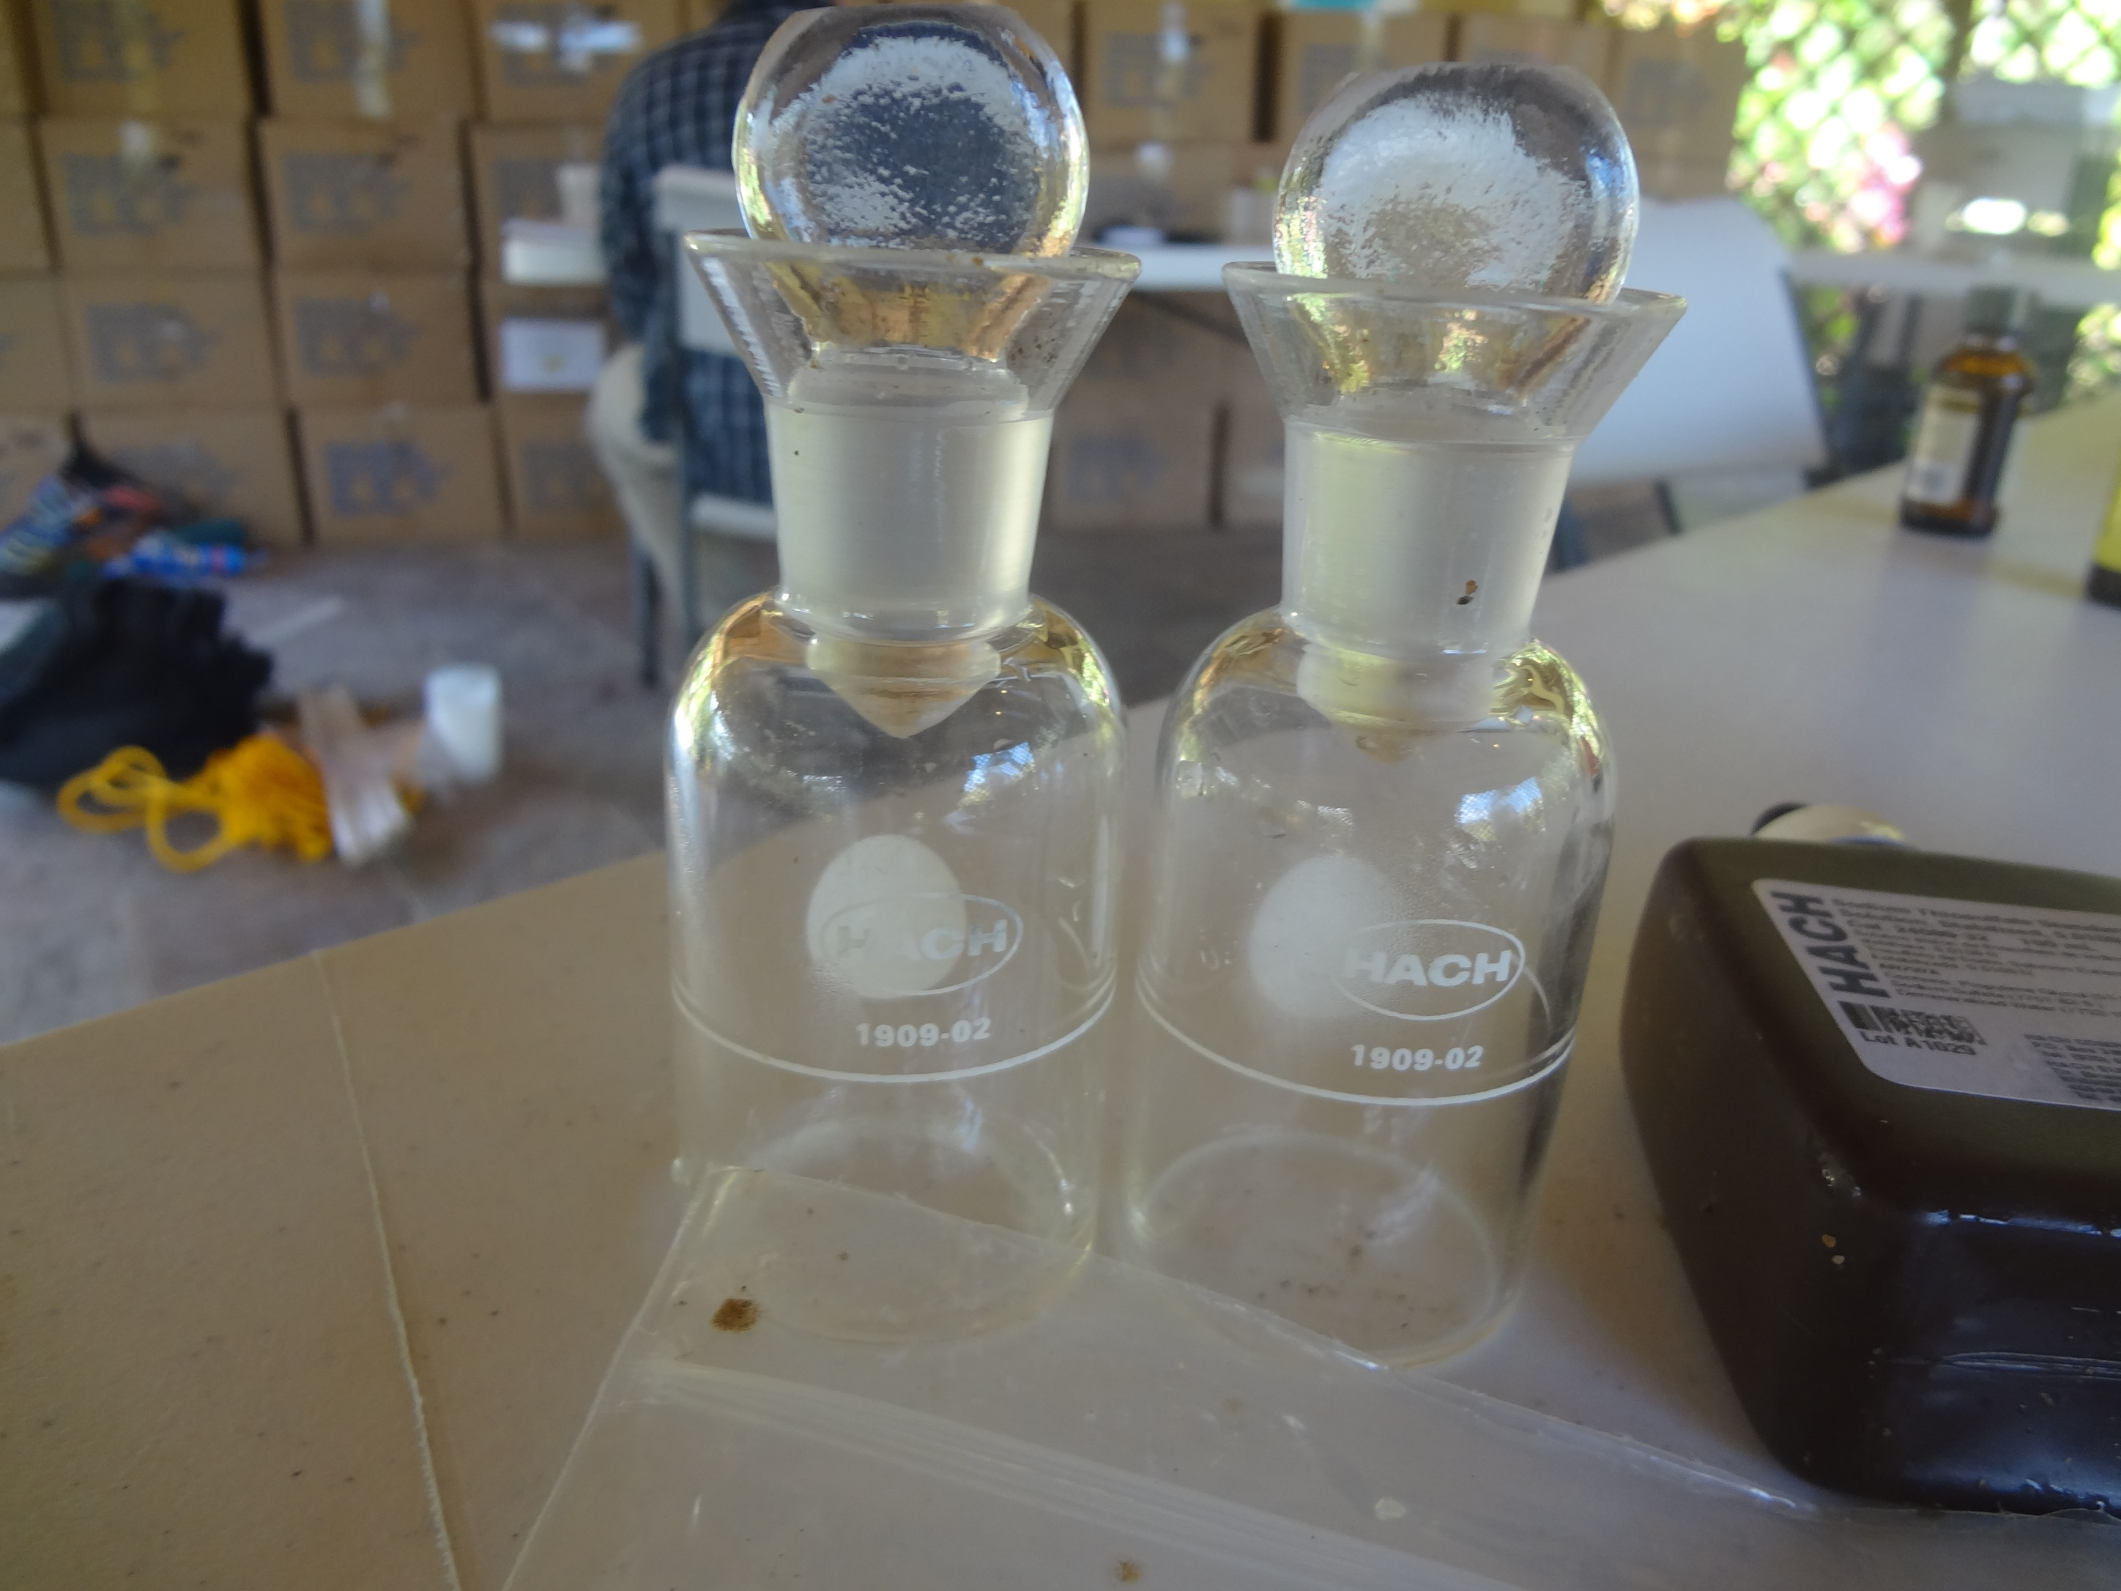
Stoppered bottles
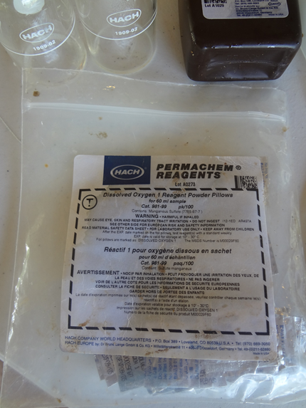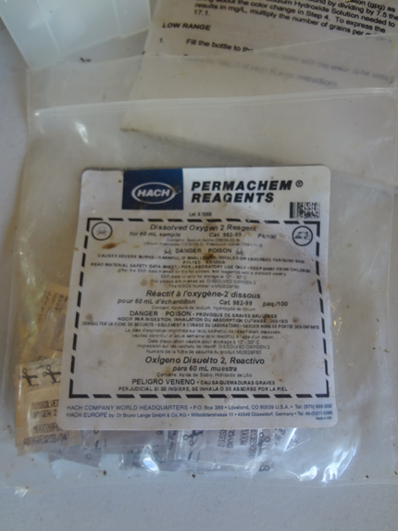
Dissolved Oxygen 1 and 2 Reagent Powder Pillows that are used in steps 1-3

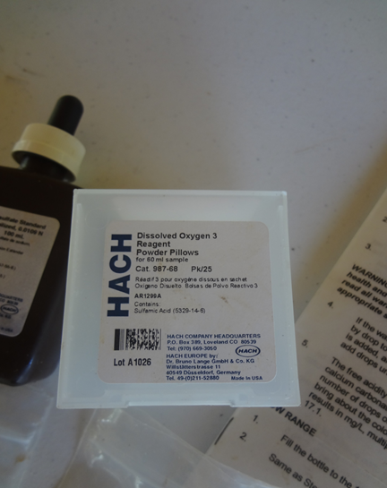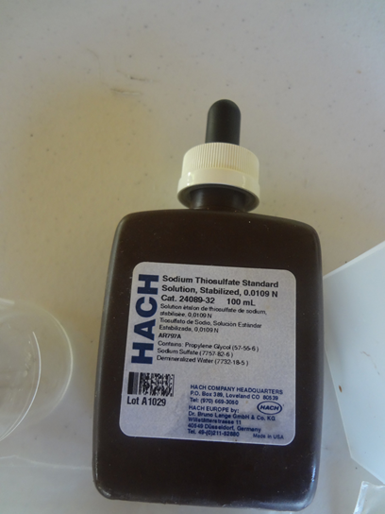
Dissolved Oxygen 3 Reagent Powder Pillows and Sodium Thiosulfate Solution that are used in steps 5-7
Dissolved Oxygen 3 Reagent Powder Pillows (Pictured on the left) and the Sodium Thiosulfate Standard Solution (Pictured on the right) Used in steps 5-7
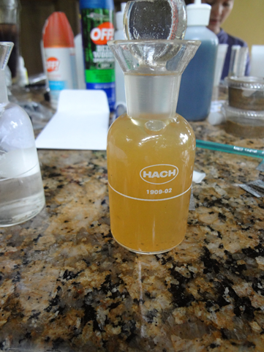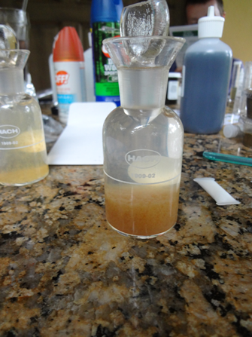
The Sample after adding the Dissolved Oxygen 2 Reagent (Step 3-4)
What the sample looked like after adding the Dissolved Oxygen 1 Reagent Powder Pillow (Step 1-2)

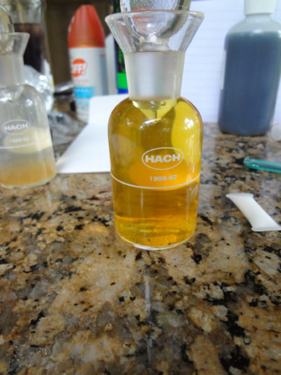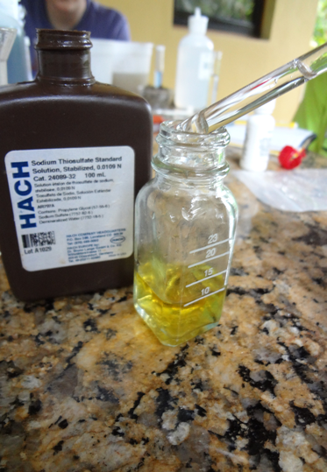
The 10mL flask used when adding the Sodium Thiosulfate Standard Solution ( Step 6-7)
After adding Dissolved Oxygen 3 Reagent Powder Pillow (Step 5)

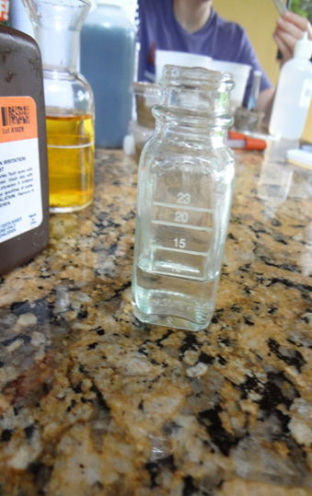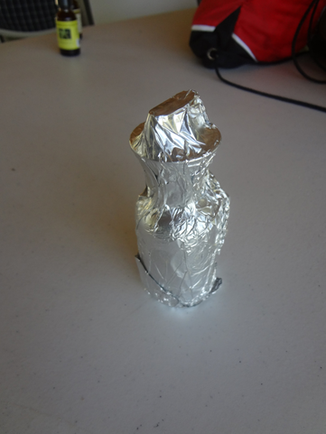
The incubated stoppered bottle. Foil should be completely covering the bottle so that no light can get in.
The sample in the flask after adding drops of Sodium Thiosulfate Standard Solution

Location
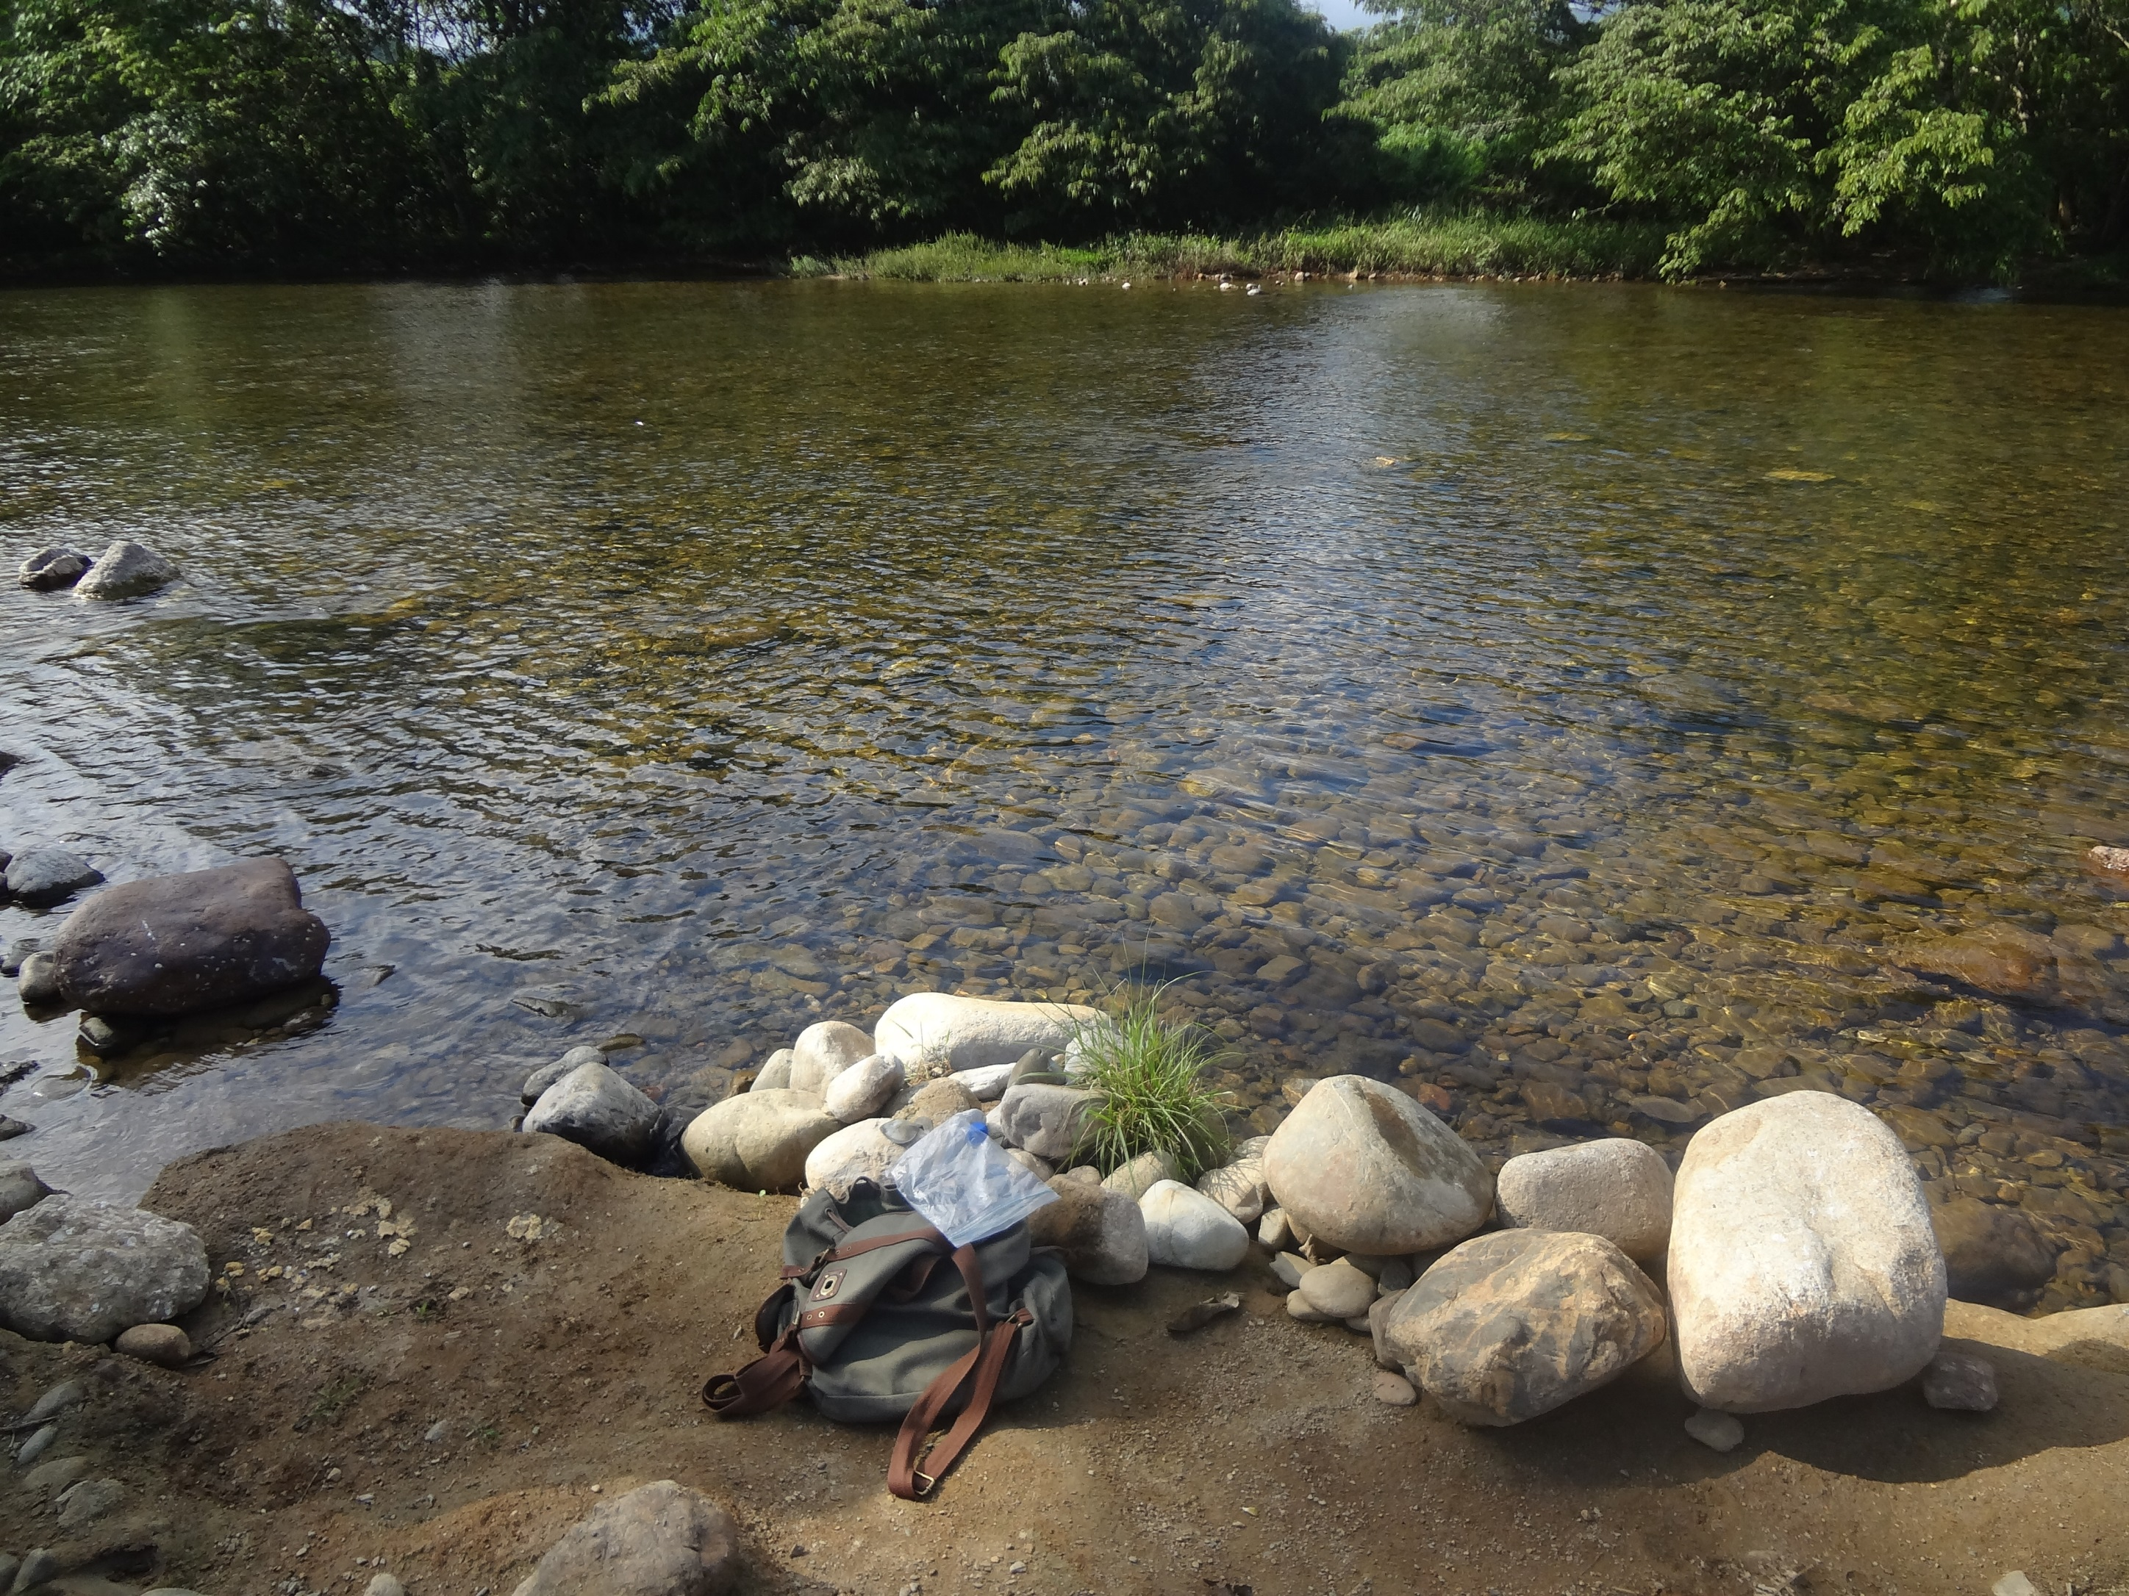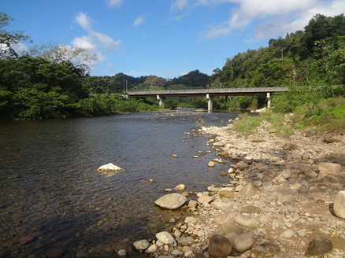
The location at which the river was tested was near where the Sibun River and Hummingbird Highway Intersect
All 40 samples of D.O. were collected randomly throughout the Sibun River

____________________________ Results___________________________

Calculations:

B.O.D. = [(Initial D.O.) - (Final D.O.)]

Ex: [(25)-(9)] = 16ppm

Average B.O.D. = [(D.O. from bottles 1-10 added)/10 samples)]

Ex: [(25+26+23+20+23+27+24+20+24+27)/10 samples] = 23.9ppm

Difference in B.O.D. levels = [(Avg B.O.D. for the day) – ( Avg B.O.D. for the night)]

Ex: [(16.5 ppm) – (13.2ppm)] = 3.3 ppm fluctuation
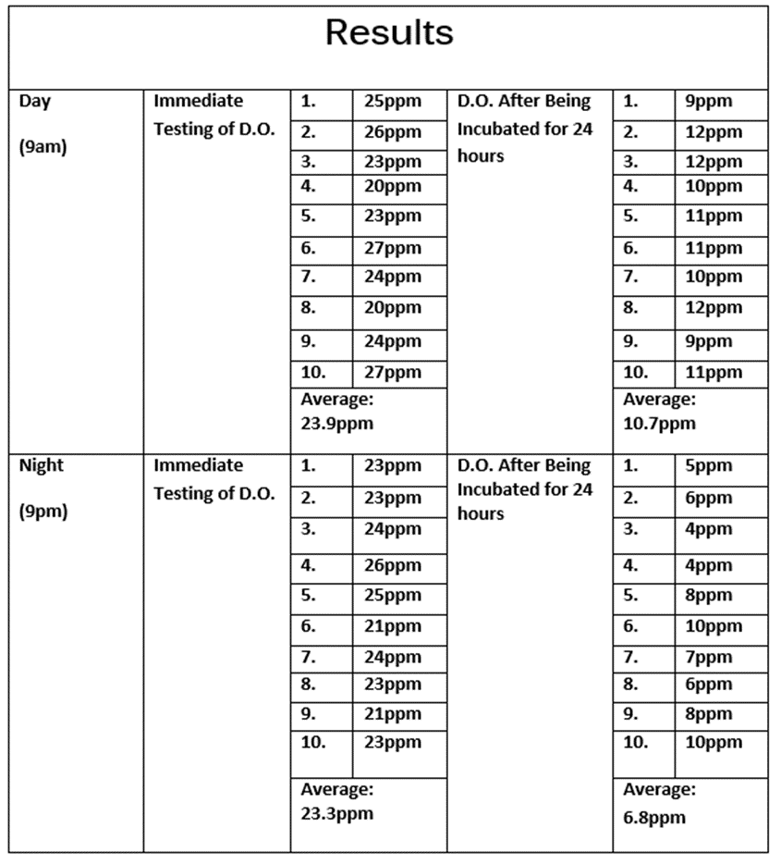

B.O.D. Results
Day | Average: 13.2 ppm
Night | Average: 16.5 ppm
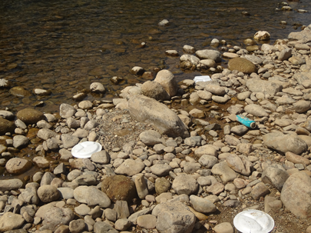
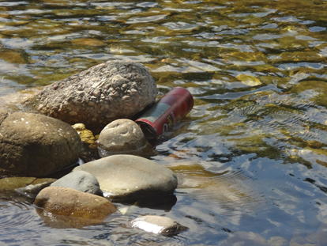
Pollution found at the location where the Sibun River was tested

Conclusion
After all 40 samples were tested and calculated, the B.O.D. levels were compared to the ideal levels. The results attained from the Sibun River, did not match the ideal levels. In fact, the results were relatively high. The ideal level of B.O.D. is less than 3ppm. My B.O.D. levels averaged 14.84ppm. The B.O.D. readings could have been enormously high due to all of the trash that was floating in the Sibun River. Belize is notorious for poor waste management.
My results did however show fluctuations in the B.O.D. levels in terms of the diurnal testing. The average B.O.D. reading for the day was 13.2 ppm, where it was 16.5 ppm at night. A difference of 3.3 ppm was shown between tested time periods. I hypothesized that there would be a fluctuation, but I predicted that there would be a higher BOD reading during the day rather than during the night. I was correct about there being a fluctuation, however, I was incorrect about the direction of the fluctuation: the BOD reading was higher during the night than during the day.
A further study should be performed to re-evaluate the B.O.D. levels. Studies should always be re-visited to ensure good water quality. Sites further down the river could be tested for B.O.D. and compared to my results and the ideal levels. If the results still showed a high B.O.D. level, one could then go down to the tributaries to pinpoint where the pollution is coming from. In addition to that, one could further this experiment by testing the coliform in the Sibun River. By doing so we would be able to decide if the water is hazardous.

Works Cited

Bradley, Justin. Sibun River Water Quality Monitoring Project, Lincoln Land Community

College, January 2010
Loftus, Tim. "BOD Test Requirements." BOD Test Requirements. Lagoons Online, n.d. Web. 22 Feb. 2014. <http://www.lagoonsonline.com/laboratory-articles/bodtest.htm>.
Methods for Chemical Analysis of Water and Wastes, U.S. EPA 600/479020, March 1979, Method 405.1.
Standard Methods for the Examination of Water and Wastewater, APHAAWWAWEF, 18 Edition, 1992, Method 5210
"Water Quality." Water Quality. N.p., n.d. Web. 22 Feb. 2014. <http://www.cees.iupui.edu/education/Workshops/Project_Seam/water_quality.htm>.
"What Is Biological Oxygen Demand and How Does It Affect Water Quality?" What Is Biological Oxygen Demand and How Does It Affect Water Quality? N.p., n.d. Web. 22 Feb. 2014. <http://www.freedrinkingwater.com/water_quality/quality1/1-bod-effects-on-water-quality.htm>.

