The Effect Common Cleansers Have Upon
Bio Indicators in the Sibun River, Belize
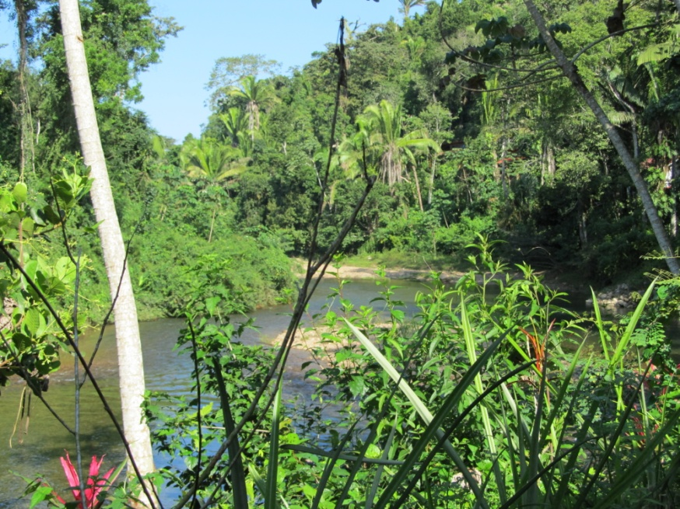
January 2013

Wendy Allan
Lincoln Land Community College
Contents
Introduction 3
Common Cleansers Used Along the Sibun River 3
Flash 4
Disicin 5
Organisms 5
Materials / Methods 6
Specimen and Solutions 7
Data Sheet TRIAL # 1 8
Results 9
Conclusion 9
Pictures 10
Examples of Common Cleansers in Belize 10
Invertebrates Used 11
Invertebrate Sampling 12
Work Cited 14

Introduction
The Sibun is one of Belize’s major river systems. It provides local residents with many of the resources they are dependent upon to live. From the essential crops of the flood plains to the drinking water of the river, The Sibun supplies all of the plants, animals and humans surrounding it with a majority of their needs. With the dependencies of this immense amount of life in mind, cleaning agents that seep into the Sibun bring up the question of safety. Is the ecosystem safe from the potential effects that the local cleaning agents could bring? How high does the concentration of a particular cleaning agent need to be to have a negative effect upon the environment?
With the smallest creatures having such an immense effect upon the larger ones in our complex ecosystem, studies of bio indicators like damselflies, mayflies and hellgrammites will help to produce results all can benefit from. This research project will reflect the effects of common cleaning agents used by The Sibun River residents upon their environment. Are the current cleaning agents in use causing harm to the stream and the environment now? Could dilution of these cleaning agents still provide sanitary conditions without causing harm to the flora and fauna, or does total elimination need to be enforced?

Common Cleansers Used Along the Sibun River
Through previous visits and research along the Sibun River, several local cleansers were shown to be used. Fabuloso, Disicin, Bleach and Flash cleansers were the most commonly mentioned and witnessed. Flash was unattainable due to its extensive usage throughout the last visit and research, so the second most often used cleanser, Bleach, was tested. In this segment of study, Flash will be used with the same bio indicators as before, except for the freshwater fish due to their high sensitivity.

Flash
In previous visits and research in Belize, with Flash cleanser unattainable, this left no product to test on, nor a label to determine the active ingredients. No research could be done at the time on this product. After much investigation, Flash All Purpose Cleaner proved to also not be sold in The United States. Proctor & Gamble of Europe manufactures Flash, and distributes to strictly European retailers. Local non-scholarly searches brought back numerous results stating that Flash cleaners are simply Mr. Clean from America, but under a different name. Mr.Clean is also manufactured by Proctor & Gamble, but stationed in The United States.
Despite repeated attempts to confirm this statement, Proctor & Gamble refused to confirm that it was the same product. Through exploration of the M.S.D.S. (Material Safety Data Sheets) from both Mr. Clean All Purpose Cleaner in Lemon and Flash All Purpose Cleaner, both contain the active ingredient of Alcohol ethoxylates in 1 – 5% concentration. Mr. Clean All Purpose Cleaner‘s other ingredients were listed as follows, “Cleaning agents (anionic and nonionic surfactants), quality control agents, perfume, colorant and water.” (Proctor, 2). The M.S.D.S. for the Flash, however, did not provide any list of additional ingredients for comparison.
Our station in The Sleeping Giant Rainforest Jungle Lodge sits on 58,000 acres of private Belizean property. The guides and staff utilize Flash for a variety of uses. First and for most, Flash is readily used to clean the floors, walls, and any surfaces needing disinfected. Keeping the property sanitary is one of The Sleeping Giant’s major concerns. Every day, while out experiencing more exciting attractions of Belize, The Sleeping Giant staff is busy cleaning up from the day before, everything the visitors have disturbed. Dishes, laundry, every surface, and every piece of soiled linen is dutifully being cleaned for their next use soon to come.
Considering Flash was used so frequently, The Sleeping Giant’s property had depleted their entire supply. The effect it that may have had upon the environment is of definite interest. On this most recent visit, January 2013, once again, the entire Flash supply was depleted, but local staff stated Disicin is what they primarily use now. They had made an unknown change throughout the year, and Disicin is what this year’s research became focused on.

Disicin
Disicin, despite its common availability throughout Belize, is unable to be found under that name in The United States. The label there stated the only active ingredient in Disicin is Dimethyl Benzyl Ammonium Chloride 2%, also known as Alkyl Dimethyl Benzyl Ammonium Chloride or ADBAC. This chemical compound is commonly found within such well-known cleansers throughout North America such as Lysol and Clorox. (M.S.D.S. Rbn. Lysol, 1). PAN’s chemical database offered the closest description of ADBAC at 5% and various other levels. It states that water quality standards and physical properties affecting water contamination have potential, and it is toxic to aquatic organisms. Without more thorough information though, Disicin is left inconclusive in need of more research (PAN.) The various bottles provided to us by Sleeping Giant staff were either not original, or the labels were almost completely unreadable. Only the name was barely visible this time.
Future investigation into the details of their current cleansers would be most beneficial. Unfortunately there were no other bottles available to investigate on this trip

Organisms
Bio indicators are organisms on earth that help indicate the status of the local environmental health. Local organisms commonly found in the Sibun River will be used for our research on this water quality project. Lack of a bio indicator commonly found in a certain area indicates that the health of the surrounding environment has been damaged in some way. On this trip to the Sibun, there was a significant drop in the amount of bioindicators found in comparison to last year’s trip.
Due to the constant rainfall and flooding, there cannot be a definite conclusion of health decline, but future research could help if allowed to return to either locations. With the level of the river increasing so rapidly, the location of sampling was effected greatly. The location we were at in our previous research was unattainable do to the rapid current. The locations searched had been dry prior to the rainfall, leaving the aquatic organisms scarce unless caught in a net or found under a buried rock. Due to these variables, health decline in this ecosystem will remain inconclusive. Measuring the effect of local cleaning agents against the bio indicators found will assist us in deciding what the next step should be in advising the locals and farmers about proper usage of their cleaning agents.
Damselfly larva (Agriocnemis femina), hellgrammites (Corydalus cornutus), and Mayfly larva (Ephemeroptera) {Or Water Penny, (Psephenidae ) depending on availability} are commonly found in the Sibun River system and used as bio indicators of such. We will be using three different concentrations of Disicin against these bio indicators to determine if current practices could potentially damage the ecosystem.

Materials / Methods
Our proposed research was to be with the Mayfly larva (or Water Penny depending on the numbers collected), Damselfly Larva, and Hellgrammites. Five or six specimen each was to be tested each trial, depending on availability. 18, 75 ml petri dishes with lids, 50 specimen contatiners,1 large pipette, 4 beakers various sizes, tweezers, Stopwatch, and camera, microscope and Dell laptop will be used.
After excessive rain and flooding, only a group of six damselfly larva, and five hellgrammite larva were found plentiful enough to be used. The prime areas to capture specimens for this test were replaced with rapid current proving to be very dangerous to retrieve specimen from. A kick net was still used on the edge of the river at a lower current. Others found specimen by hand under tributing into the Sibun River were utilized to find the remainder of the specimen. A kick net and hand picking was also used at this time. Unfortunately, with the rapid rise of waters, the natural habitat for the specimen we were searching for had fallen into the rapid and dangerous part of the river. Due to this, we were unable to obtain the amount we were intending upon.
After obtaining the organisms from their perspective habitats each were put in their own specimen covers with lids. Once back at the place of research, each specimen was separated and identified. They were each placed in a petri dish, viewed under the microscope that was in turn connected to the laptop for viewing. After thorough identification, each was labeled alphabetically in their own petri dish awaiting prepared solutions. The specimen and solutions were prepared as follows.

Specimen and Solutions
Organism | 5% Solution | 10% Solution | 20% Solution
Damselfly A |  |  | 50 ml
Damselfly B |  |  | 50 ml
Damselfly C |  | 50 ml
Damselfly D |  | 50 ml
Damselfly E | 50 ml
Damselfly F | 50 ml
Hellgrammite A |  |  | 50 ml
Hellgrammite B |  |  | 50 ml
Hellgrammite C |  | 50 ml
Hellgrammite D |  | 50 ml
Hellgrammite E | 50 ml
Total Solution Prepared | 150 ml | 200 ml | 200 ml

Each organism was to be observed under 5% concentration of Flash, a 10% solution of Flash, and a 20% solution of Flash for the effects upon each for duration of 30 minutes. Due to the unavailability of the product, Disicin, a cleanser the locals utilized instead was used. Each solution will consist of only the designated concentration of Disicin and water taken from stream. The containers and volume of solution were uniform throughout the entire experiment. This trial was not repeated due to the lack viable organisms available to test. The trial was the duration of 30 minutes due to time restraints. All of this research was done on the Sibun River and connecting streams in the Cayo District, Belize.

Data Sheet TRIAL # 1
DATE: 1/06/2013 DURATION: 30 minutes
BIOINDICATOR SPECIES  DAMSELFLY LARVA | [5%]  START TIME/END TIME | [10%]  START TIME/END TIME | [20%]  START TIME/END TIME
DAMSEL A |  |  | 21:20/ 21:50  30 min RELEASED
DAMSEL B |  |  | 21:24/ 21:54  30 min RELEASED
DAMSEL C |  | 21:21/ 21:41  FATALITY
DAMSEL D |  | 21:24/ 21:54  30 min RELEASED
DAMSEL E | 21:21/ 21:51  30 min RELEASED
DAMSEL F | 21:25/ 21:55  30 min RELEASED

BIOINDICATOR SPECIES  HELLGRAMMITE LARVA | [5%]  START TIME/END TIME | [10%]  START TIME/END TIME | [20%]  START TIME/END TIME
HELLGRAMMITE A |  |  | 21:26/ 21:56  30 min RELEASED
HELLGRAMMITE B |  |  | 21:28/ 21:58  30 min RELEASED
HELLGRAMMITE C |  | 21:27/ 21:57  30 min RELEASED
HELLGRAMMITE D |  | 21:30/ 22:00  30 min RELEASED
HELLGRAMMITE E | 21:27/ 21:57  30 min RELEASED

Results
In result of this experiment, one specimen was mishandled with tweezers, damselfly larva C. This specimen didn’t show much activity after being placed in the petri dish. Its demise followed twenty minutes later with barely any movement during these twenty minutes, unlike the rest of its group. The conclusion was made that the harm made to this specimen resulted from mishandling, and not the solution, considering none of the other specimens in his group or the other were harmed. All other specimen appeared unharmed and unaffected by their solutions. There were as viable as the beginning of the test.

Conclusion
There is a drastic change from this experiment and that of last year’s bleach solution; Disicin proved to be much less lethal than bleach, providing a positive outlook on the change of usage amongst the staff. The uncertainties of Flash may have to be left unknown if the staff sticks to its decision to switch to Discin. Further studies could be made on longer durations, and larger specimen groups if possible. Secondary trials, once again could have also proved very useful. Besides the accident with one specimen, this study’s results of almost no harm, leaves many questions to whether the specimens received harm that went unnoticed. Would examination of the specimens microscopically result in damage left unseen in this study? Would a longer duration of time prove to show different results?

Pictures

Examples of Common Cleansers in Belize

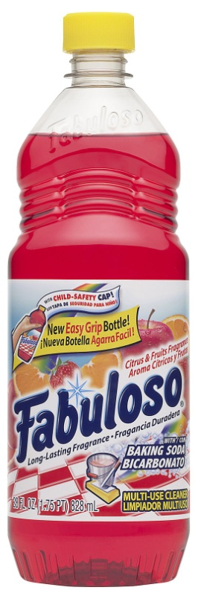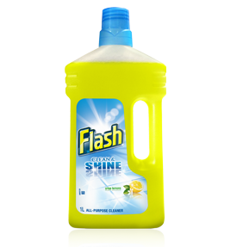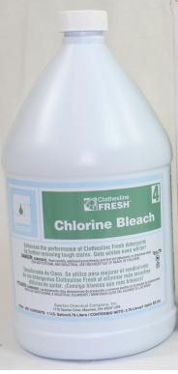

Disicin unavailable

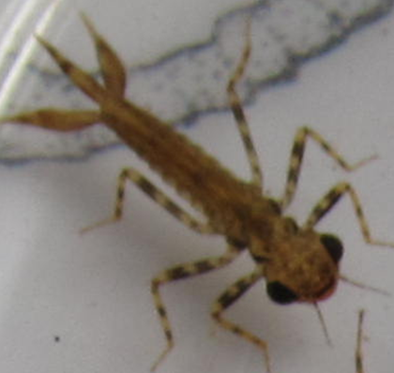
Invertebrates Used
Hellgrammite / Dobson Fly Larva

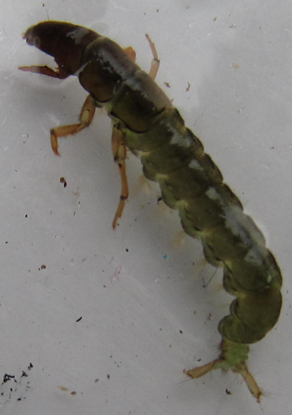
Damselfly Larva

Invertebrate Sampling
Professor Cox instructing on the use of a kick net. Students being told to go farther downstream to kick up more invertebrates
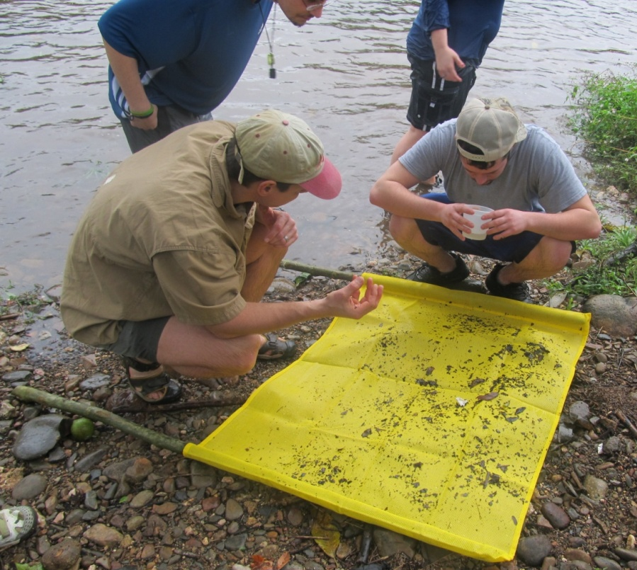
Inspection of kick net after invertebrate collection at Sibun River, Belize

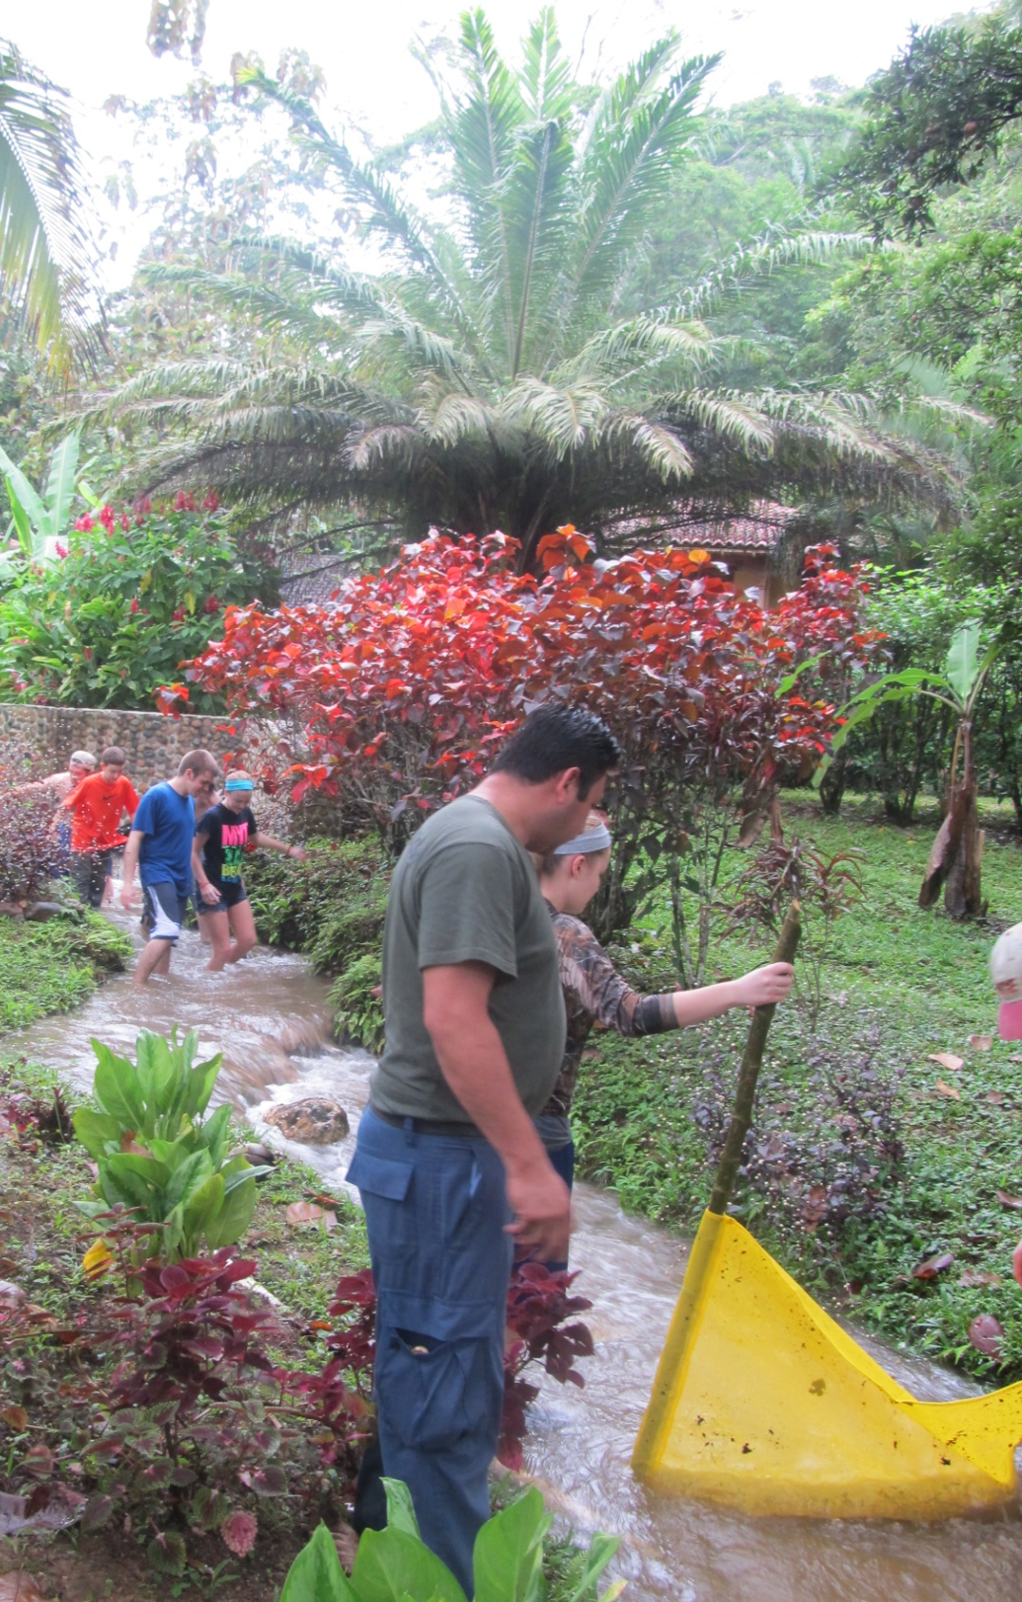
Kick net in stream on Sleeping Giant Property

Work Cited
“Disinfectants.” www.lenntech.com. n.p., Web. 30 Nov. 2011
“Materials and Safety Data Sheet.” www.msds.com. n.p., Web. 3, Feb. 2010.
“Materials and Safety Data Sheet.” http://www.rbnainfo.com/MSDS/US/Lysol_IC_Quat_366519.pdf. n.p., Web. 17, Oct. 2007.
“PAN Pesticides Database – Chemicals”, www.pesticideinfo.org. n.p., Web
“Proctor & Gamble Household Care Products- Europe, Safety Data Sheet” www.scienceinthebox.com/en_uk/product/prodcomp_english_en.html. n.p., 2001., Web. Nov. 2012
“Proctor & Gamble Material Safety Data Sheet Mr. Clean Multi-Surfaces” www.pg.com/productsafety. n.p. Sep. 24 2010., Web. Nov. 2012

